Economics: A Mathematical Introduction
Lecture notes for A-Level & IB Economics
Adam Butlin (University of Oxford)
Version 1

Contents
Part I. Households and firms
- Consumer choice
- Behavioural economics
- Production and diminishing returns
- Costs in the short run
- The long run and economies of scale
- Revenue
- Profit maximisation
Part II. Markets
- Demand
- Supply
- Equilibrium and the price mechanism
- Elasticity
- Welfare, surplus and efficiency
- Perfect competition and monopoly
- Oligopoly and monopolistic competition
- Labour markets
- Market failure
- Government intervention in markets
Part III. Economies
- Scarcity, choice and opportunity cost
- National income and the circular flow
- Aggregate demand and the multiplier
- Aggregate supply
- Equilibrium, output gaps and the cycle
- Inflation and unemployment
- Money and banking
- Monetary policy
- Fiscal policy
- Inequality and redistribution
- Supply-side policy and growth
- Exchange rates and the balance of payments
- Trade and comparative advantage
- Protection and integration
- Growth and development
- Back to the frontier

Notation
Each symbol has one meaning throughout. Where an exam paper uses a different symbol, the table says so.
Symbol | Meaning | Section
$x$, $y$ | quantities of two goods; in Part III, consumer goods and capital goods | 1, 18
$p_{x}$, $p_{y}$, $B$ | prices of the two goods, and the household’s budget | 1
$U$, $MU_{x}$ | utility, and the marginal utility of $x$ | 1
$∂$​ | a derivative taken with every other variable held fixed | 1
$D(t)$, $δ$ | value today of £1 in $t$ periods; discount factor, the value today of £1 next period | 2, 14
$Q$, $K$, $L$, $K_{0}$ | output, capital, labour, and capital held fixed in the short run | 3
$MP_{L}$, $AP_{L}$ | marginal and average product of labour | 3
$w$, $R$ | the money wage, and the rental price of capital | 4
$TC$, $TFC$, $TVC$, $MC$, $AFC$, $AVC$, $ATC$, $LRAC$ | total, fixed, variable, marginal and average costs | 4, 5
$P$, $a$, $b$ | price; intercept and slope of a single firm’s inverse demand curve | 6
$TR$, $AR$, $MR$ | total, average and marginal revenue | 6
$PED$, $YED$, $XED$, $PES$ | price, income and cross elasticities of demand, and price elasticity of supply | 1, 11
$Π$​ | profit | 7
$v(x)$​ | value in pounds of consuming $x$ units | 8
$α$, $β$, $γ$ | market demand: intercept, response to price, response to income | 8
$μ$, $λ$ | market supply: intercept, response to price | 9
$Q_{D}$, $Q_{S}$, $P^{*}$, $Q^{*}$ | quantity demanded and supplied; equilibrium (or efficient) price and quantity | 10
$MPB$, $MPC$, $TS$ | marginal private benefit and cost, and total surplus. $MPC$ always means marginal private cost; the marginal propensity to consume is $c$ | 12
$P_{m}$, $Q_{m}$, $P_{c}$, $Q_{c}$ | monopoly price and output, and the competitive comparison | 13
$MRP_{L}$, $MCL$ | marginal revenue product of labour, and marginal cost of labour | 15
$MSB$, $MSC$, $MEB$, $MEC$, $Q_{mkt}$ | marginal social and external benefit and cost, and the quantity an unregulated market produces | 16
$t$, $s$ | a specific tax and a subsidy, per unit | 17
$P_{D}$, $P_{S}$ | with a tax, the price buyers pay and the price sellers keep | 17
$C$, $I$, $G$, $X$, $M$ | consumption, investment, government spending on goods and services, exports, imports | 19
$S$, $T$ | saving, and taxes net of transfers and subsidies | 19
$c$, $τ$, $m$ | marginal propensity to consume, tax rate, marginal propensity to import. Exam papers write MPC, MPT and MPM | 20
$A$, $k$, $z$ | autonomous spending, the multiplier, the fraction of each pound respent at home | 20
$Y$, $Y_{FE}$ | income (national income in Part III), and full-employment output | 8, 21
$π$, $π^{e}$, $u$, $u_{n}$, $ω$ | inflation, expected inflation, unemployment rate, the NAIRU, and the slope of the Phillips curve | 23
$M_{S}$, $M_{D}$, $V$ | money supply, money demand, and velocity | 23, 25
$ρ$, $D$ | reserve ratio, and bank deposits | 24
$i$, $i_{B}$, $r$, $θ$, $ϕ$ | nominal interest rate, Bank Rate, real interest rate, and the responses of money demand to income and to $i$ | 25
$b$, $g$, $ψ$ | public debt as a share of GDP, growth rate of real GDP, primary surplus as a share of GDP | 26
$ε$, $τ^{*}$ | elasticity of the tax base, and the revenue-maximising tax rate | 26
$ℓ(p)$​ | the Lorenz curve: share of income received by the poorest fraction $p$ | 27
$g_{Y}$, $g_{A}$, $g_{K}$, $g_{L}$ | growth rates of output, productivity, capital and labour | 28
$e$, $P_{X}$, $P_{M}^{*}$, $TB$ | exchange rate in dollars per pound, sterling price of exports, dollar price of imports, trade balance | 29
$P_{w}$​ | world price | 31

Part I. Households and firms

1. Consumer choice
DEFINITIONS.
Utility: the satisfaction a consumer gets from consuming goods, which matters only as a ranking and not as a quantity.
Total utility: the satisfaction obtained from the whole quantity consumed.
Marginal utility: the addition to total utility from consuming one more unit.
Law of diminishing marginal utility: beyond some point, each extra unit of a good adds less to utility than the unit before it.
Budget constraint: the combinations of goods a consumer can just afford at given prices and income.
Consumer equilibrium: the affordable combination that gives the highest utility.
Equimarginal principle: utility is highest when the last pound spent on each good buys the same amount of utility.
Normal good: one whose demand rises with income; an inferior good is one whose demand falls.
Price elasticity of demand (PED): the percentage change in quantity demanded divided by the percentage change in price.
A household chooses quantities of two goods, $x$ and $y$. Its utility is
$$U(x,y)=\sqrt{xy}=x^{1/2}y^{1/2} ⇒ MU_{x}=\frac{∂U}{∂x}=\frac{1}{2}x^{−1/2}y^{1/2}=\frac{1}{2}\sqrt{\frac{y}{x}} (1)$$
$U$ is a number standing for how satisfied the household is with a bundle of $x$ units of one good and $y$ of the other. The marginal utility of $x$ is the extra satisfaction one more unit of $x$ brings. Because $U$ depends on two variables, it is found by differentiating with respect to $x$ while holding $y$ still, and the curly $∂$ in place of $d$ is the signal that the other variable is being held fixed. The square root makes the satisfaction from another unit of $x$ depend on how much $x$ the household already has:
$$\frac{∂MU_{x}}{∂x}=−\frac{1}{4}x^{−3/2}y^{1/2}<0 (2)$$
The second derivative is negative at every quantity, so each extra unit of $x$ adds less than the one before it. That is the law of diminishing marginal utility, obtained here from the shape of the function, and section 3 meets its counterpart on the production side.
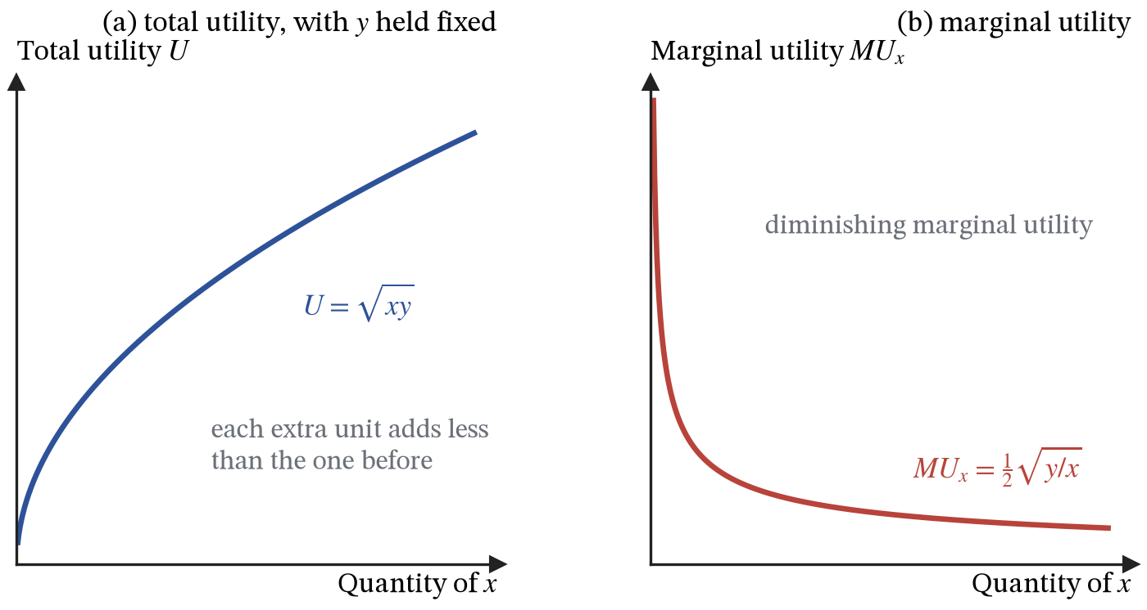
Figure 1. Utility and marginal utility for one good, with the quantity of the other held fixed.
What the household can afford is the other half of the problem. With prices $p_{x}$ and $p_{y}$ and a budget of $B$ to spend:
$$p_{x}x+p_{y}y=B ⇒ y=\frac{B}{p_{y}}−\frac{p_{x}}{p_{y}}x (3)$$
Making $y$ the subject turns the budget into a straight line. The vertical intercept $B/p_{y}$ is how much $y$ the household could have if it bought no $x$ at all, and the gradient $−p_{x}/p_{y}$ is the rate at which the market lets it swap $x$ for $y$: the opportunity cost of $x$, expressed in units of $y$.
The constraint states exactly what $y$ must be once $x$ has been chosen, so substituting it into the utility function removes $y$ altogether and leaves an ordinary maximisation in one variable. One further step makes the algebra easy. Utility numbers carry no meaning beyond the order in which they rank bundles, so replacing $U$ with any increasing function of $U$ describes the same household and produces the same choice. Maximising $\sqrt{xy}$ and maximising $xy$ are therefore the same problem, and the second is far easier to differentiate. Write $V=U^{2}$ and substitute (3) into it:
$$V(x)=xy=x\left(\frac{B}{p_{y}}−\frac{p_{x}}{p_{y}}x\right)=\frac{Bx−p_{x}x^{2}}{p_{y}} (4)$$
Every combination this function describes is affordable, because affordability was built in by the substitution.
$$\frac{dV}{dx}=\frac{B−2p_{x}x}{p_{y}}=0 ⇒ x^{*}=\frac{B}{2p_{x}}, \frac{d^{2}V}{dx^{2}}=−\frac{2p_{x}}{p_{y}}<0 (5)$$
The second derivative is negative everywhere, so the turning point is a maximum. Putting $x^{*}$ back into the budget line gives $y^{*}=B/2p_{y}$ by the same arithmetic, and the firm in section 7 will solve its problem in exactly this way.
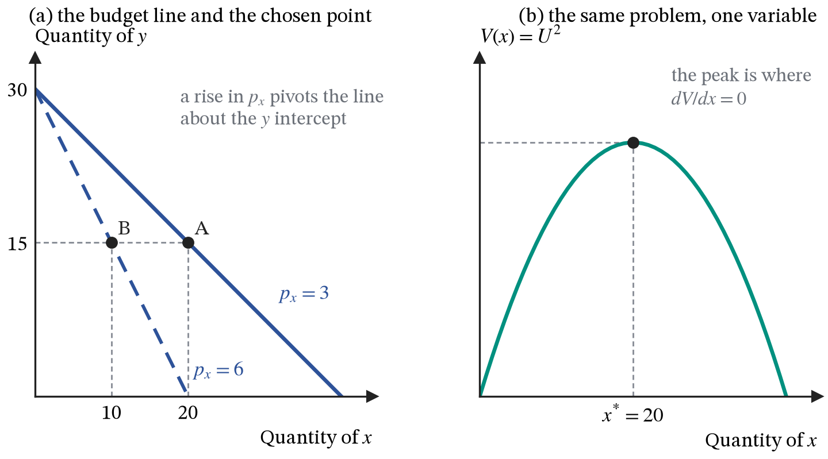
Figure 2. The budget line with the chosen point on it, and the same problem after substitution, reduced to one variable with a single peak.
Spending on $x$ is $p_{x}x^{*}=B/2$ whatever the price, so this household splits its budget evenly between the two goods. The even split comes from the square root; a different utility function would divide the budget differently. Differentiating the answer gives the demand curve:
$$\frac{dx^{*}}{dp_{x}}=−\frac{B}{2p_{x}^{2}}<0, \frac{dx^{*}}{dB}=\frac{1}{2p_{x}}>0 (6)$$
The first derivative is negative at every price, which is the law of demand, here a conclusion rather than a starting point. The second is positive, so $x$ is a normal good. And because spending on $x$ stays at $B/2$ however the price moves, a 1 per cent rise in price must cut quantity by exactly 1 per cent: the price elasticity of demand is $−1$ at every point on this curve, a property called unit elasticity that section 11 develops.
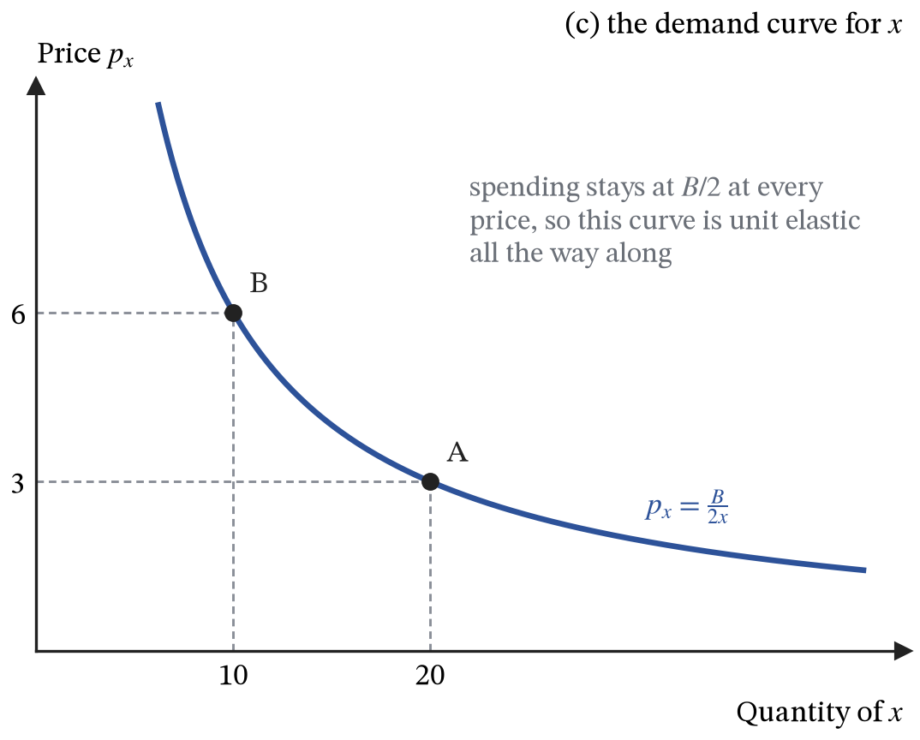
Figure 3. The demand curve traced out by the chosen quantity as the price varies. A and B are the two budget lines of the previous figure.
The particular answer depends on the particular utility function, but the condition behind it does not. At the best affordable point the household cannot gain by moving a pound from one good to the other, so the last pound spent must buy the same utility in each:
$$\frac{MU_{x}}{p_{x}}=\frac{MU_{y}}{p_{y}} (7)$$
Each side is the utility bought by the last pound spent on that good. If the two differed, the household could move a pound from the good with the lower figure to the other and be better off, so it was not at the best point to begin with. Substituting the answers already found, where $y^{*}/x^{*}=p_{x}/p_{y}$, both sides collapse to the same expression:
$$\frac{MU_{x}}{p_{x}}=\frac{1}{2p_{x}}\sqrt{\frac{p_{x}}{p_{y}}}=\frac{1}{2\sqrt{p_{x}p_{y}}}=\frac{1}{2p_{y}}\sqrt{\frac{p_{y}}{p_{x}}}=\frac{MU_{y}}{p_{y}}$$
ASSUMPTIONS.
The household can rank any two bundles, and ranks them consistently: preferring A to B and B to C means preferring A to C.
More is preferred to less, which is why the budget is spent in full and the constraint holds as an equality.
Utility is ordinal. Only the ranking carries meaning, which is what allows $U$ to be replaced by $U^{2}$ without changing the answer.
Prices and the budget are given, the household is too small to move either, and there are only two goods, with everything else folded into $y$.
The function $\sqrt{xy}$ produces the even split of the budget. What survives any sensible choice of function is the downward-sloping demand curve and the equimarginal condition, not the halves.
Tastes are fixed and the household calculates correctly. Section 2 looks at what happens when it does not.

2. Behavioural economics
DEFINITIONS.
Bounded rationality: decision-making limited by the information, time and mental effort available, so that people settle for a good choice rather than the best one.
Bounded self-control: knowing what is best and failing to do it, typically by favouring the present over the future.
Bounded selfishness: caring about other people’s outcomes and about fairness, not only one’s own consumption.
Heuristic (rule of thumb): a shortcut that saves effort at the cost of occasional error.
Anchoring: judging a value by adjusting from an initial number, even an irrelevant one.
Availability bias: judging how likely something is by how easily examples come to mind.
Framing: a choice changing with the way identical options are described.
Loss aversion: a loss weighing more heavily than a gain of the same size.
Choice architecture: the way options are presented, including default choices (what happens if nobody acts), restricted choice (fewer options) and mandated choice (people must actively decide).
Nudge: a change in choice architecture that alters behaviour without forbidding any option or changing prices.
Section 1 built demand on a household that ranks bundles consistently, knows what it wants, and calculates its best choice. Each of those is an assumption that can be tested, and behavioural economics is the study of where they fail and what follows. It does not replace the model of section 1. It identifies which of that model’s assumptions breaks in a particular setting, and so which of its predictions should not be trusted there.
Consistency over time is the cleanest case, because it can be written down. A household that discounts the future at a constant rate values £1 received $t$ days from now at $δ^{t}$ pounds today, for some $δ$ just below one. Its preference between two dated payments never depends on when it is asked. Experiments repeatedly find something different. Offered £100 today or £110 tomorrow, many people take the £100; offered £100 in 30 days or £110 in 31 days, the same people wait for the £110. The two choices are the same one-day trade, moved a month into the future. A discount function that treats the present as special reproduces the pattern:
$$D(0)=1, D(t)=0.7×{0.99}^{t} \text{for }t≥1 (8)$$
$D(t)$ is the value today of £1 received in $t$ days. Today against tomorrow, £100 beats $110×0.7×0.99=£76$. A month ahead, $100×0.7×{0.99}^{30}=£52$ loses to $110×0.7×{0.99}^{31}=£56$. The household plans to wait, and when day 30 arrives and the earlier payment has become “today”, it changes its mind. That is bounded self-control expressed as a single number: the factor 0.7 that applies to every future date and to none of the present. It explains under-saving for retirement, unused gym memberships and the appeal of commitment devices, which are ways for the planning self to bind the self that will later face the choice.
Loss aversion is the second case with a precise shape. People evaluate outcomes as gains and losses relative to a reference point, usually what they already have or expect, rather than as final levels of wealth, and losses count for roughly twice as much as gains of the same size. Figure 4 draws a value function with that property. Its kink at the reference point is what the smooth utility function of section 1 cannot produce, and it explains why people refuse a fair bet of winning or losing £100, why sellers ask more for an object than they would have paid for it, and why the same policy described as “avoiding a loss” wins more support than when it is described as “securing a gain”, which is framing.
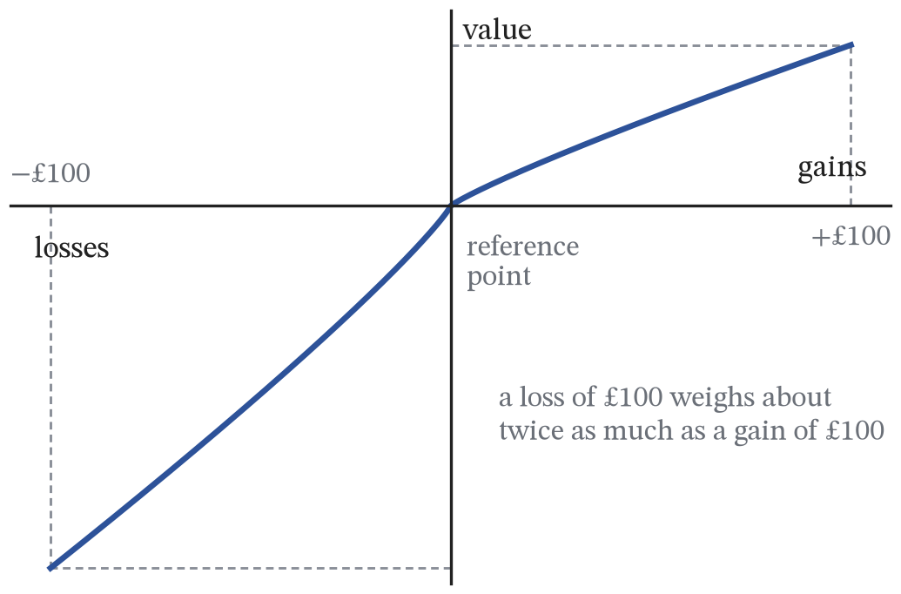
Figure 4. A value function with loss aversion. Outcomes are measured as gains and losses from a reference point, the curve is steeper for losses than for gains, and it is kinked at the reference point.
The remaining failures are documented more than modelled. Heuristics save effort and are usually sensible, but they leave fingerprints: a shop’s “was £80, now £40” sets an anchor that makes £40 look cheap whatever the good is worth, and vivid news of plane crashes makes flying seem more dangerous than driving, which is availability. Bounded selfishness shows up when people give to charity, punish unfairness at a cost to themselves, or refuse a low but positive offer in a bargaining experiment.
If behaviour depends on how choices are presented, then presentation is a policy instrument. The best-known example is automatic enrolment into workplace pensions in the UK, introduced in 2012: employees are enrolled unless they opt out, rather than left out unless they opt in. Nothing about the pension changed except the default, and participation rose sharply. Restricted choice (removing confusing tariffs), mandated choice (organ donation registers that require a yes or no) and well-timed information (energy bills that compare a household with its neighbours) work the same way. A nudge leaves every option open and every price unchanged, which is why it is attractive to governments, and it acts only on people whose behaviour was driven by the presentation in the first place.
ASSUMPTIONS.
The discount function (8) and the factor of two in loss aversion are typical experimental findings, not constants of nature, and both vary between people and settings.
Behavioural findings are departures from a benchmark. Without the model of section 1 there would be nothing to depart from, so the two are complements rather than rivals.
A nudge assumes the designer knows better than the person nudged which choice serves that person. Governments are subject to the same biases they set out to correct, and choice architecture can be used by firms to exploit biases as easily as by governments to offset them.

3. Production and diminishing returns
DEFINITIONS.
Production function: the relationship between the quantities of inputs used and the maximum output obtainable from them.
Short run: a period in which at least one input cannot be varied.
Long run: a period in which every input can be varied.
Marginal product of labour: the extra output produced by one more worker, capital held fixed.
Average product of labour: output divided by the number of workers.
Law of diminishing marginal returns: with at least one factor fixed, the marginal product of the variable factor eventually falls.
The cost of making one more unit depends first on technology, which the production function describes:
$$Q=F(K,L) (9)$$
$Q$ is output per period, $K$ is capital (premises, machines, land), $L$ is labour, and $F$ is the recipe that turns the two into output. In the short run, take capital as the fixed input and write $K=K_{0}$, where the subscript marks a level that is held still rather than chosen, so that $Q=F\left(K_{0},L\right)$ and output depends on labour alone. The long run, when every input can vary, is the subject of section 5.
Two measures describe the technology:
$$MP_{L}=\frac{∂Q}{∂L}, AP_{L}=\frac{Q}{L} (10)$$
The marginal product of labour $MP_{L}$ is the extra output the next worker adds, holding capital fixed; the average product $AP_{L}$ is output per worker across the whole workforce. The first is about the last person hired, the second about everybody.
Diminishing marginal returns means that with $K$ fixed, beyond some level of $L$ the marginal product falls: $∂^{2}Q/∂L^{2}<0$. Take a bakery with one oven. The first extra baker is a large gain because one person cannot mix, shape, bake and serve at once. The fourth still helps. The tenth is queueing for oven space. Nothing has changed about the workers; what has changed is the capital each of them has to work with, which is why the law applies only in the short run.
The two products are linked by the quotient rule:
$$\frac{d}{dL}\left(\frac{Q}{L}\right)=\frac{L \frac{dQ}{dL}−Q}{L^{2}}=\frac{MP_{L}−AP_{L}}{L} (11)$$
The numerator compares the new worker’s contribution with what the existing workers were producing on average, and since $L$ is positive the whole expression has the sign of $MP_{L}−AP_{L}$. So $AP_{L}$ rises while $MP_{L}$ is above it, falls while $MP_{L}$ is below it, and is stationary exactly where the two are equal: marginal cuts average at the average’s maximum. The result is arithmetic rather than economics. It holds for any pair of marginal and average quantities, and it will settle the shape of the cost curves in section 4 and the meaning of a progressive tax in section 27.
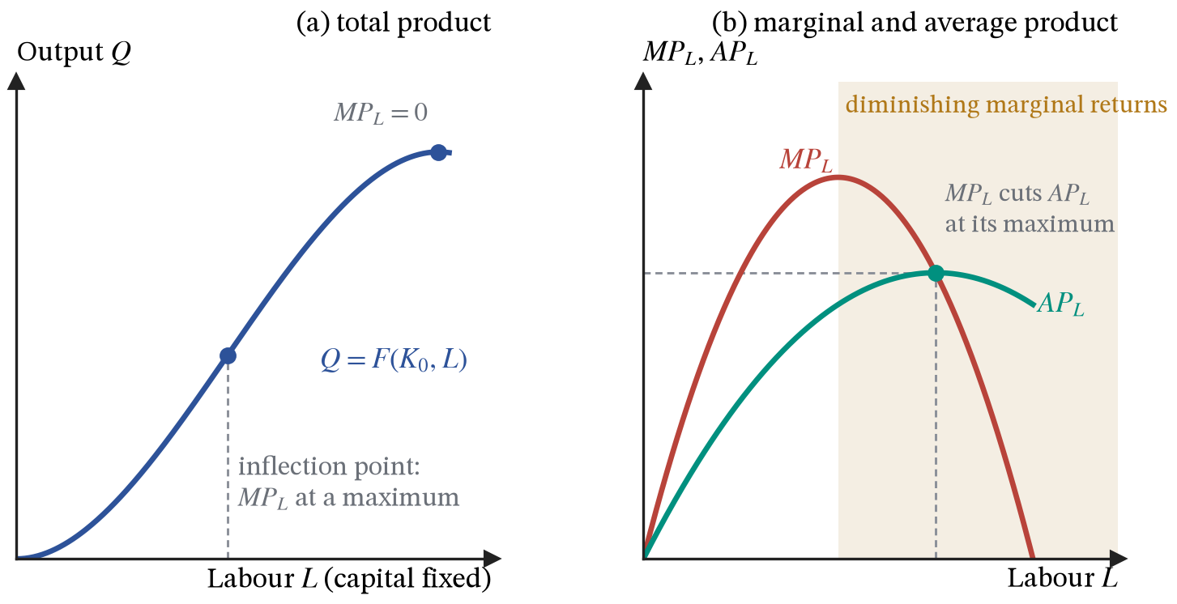
Figure 5. Total product with capital fixed, and the marginal and average product curves implied by it.
ASSUMPTIONS.
At least one factor fixed.
Workers identical and interchangeable.
Technology unchanged.
Output measured in physical units.
Diminishing returns is not a claim that later workers are lazier or less skilled. The tenth baker is as able as the first; what has fallen is the oven space each of them has.

4. Costs in the short run
DEFINITIONS.
Fixed cost: a cost that does not vary with output.
Variable cost: a cost that does.
Total cost: the two added together.
Marginal cost: the addition to total cost from making one more unit.
Average total cost: total cost per unit, equal to average fixed cost plus average variable cost.
Average fixed cost: fixed cost divided by output, which falls continuously and never turns back up.
Costs are technology valued at input prices. With the wage $w$ and the rental price of capital $R$ both given to the firm, and capital fixed at $K_{0}$,
$$TC(Q)=TFC+TVC=RK_{0}+wL(Q) (12)$$
Total fixed cost $TFC$ is the bill for capital, $RK_{0}$, the same whether output is zero or enormous. Total variable cost $TVC$ is the wage bill $wL(Q)$, where $L(Q)$ is the number of workers needed to make $Q$ units: the production function read backwards. Differentiate total cost with respect to output:
$$MC=\frac{dTC}{dQ}=w \frac{dL}{dQ}=\frac{w}{MP_{L}}, AVC=\frac{wL}{Q}=\frac{w}{AP_{L}} (13)$$
The only way to make one more unit is to hire more labour, so the chain rule splits its cost into the wage and the extra labour each unit requires, $dL/dQ$. That last quantity is the reciprocal of the marginal product: if a worker adds 40 loaves, a loaf needs one fortieth of a worker. Average variable cost follows the same logic for the whole workforce rather than the last hire.
Marginal cost is the wage divided by marginal product, so the shape of the cost curves is the shape of the product curves upside down. While $MP_{L}$ is rising, $MC$ is falling; once diminishing marginal returns set in and $MP_{L}$ falls, $MC$ rises. The U-shape of $MC$ is derived from technology, not assumed. In the bakery: when each extra baker adds 40 loaves, the marginal cost of a loaf is $w/40$; when congestion around the oven cuts that to 10 loaves, the same wage buys a quarter as much output and marginal cost quadruples.
Dividing (12) through by $Q$ splits average total cost into two components that behave quite differently:
$$ATC=\frac{TFC}{Q}+\frac{TVC}{Q}=AFC+AVC (14)$$
$AFC$ falls continuously towards zero, because a fixed number is being divided by a rising one, and it never turns up. $AVC$ is U-shaped for the reason just given. And (11) applies to costs as it did to products: average cost falls while marginal cost is below it and rises while marginal cost is above it. So $MC$ passes through the minimum of $ATC$, and by the same argument through the minimum of $AVC$.
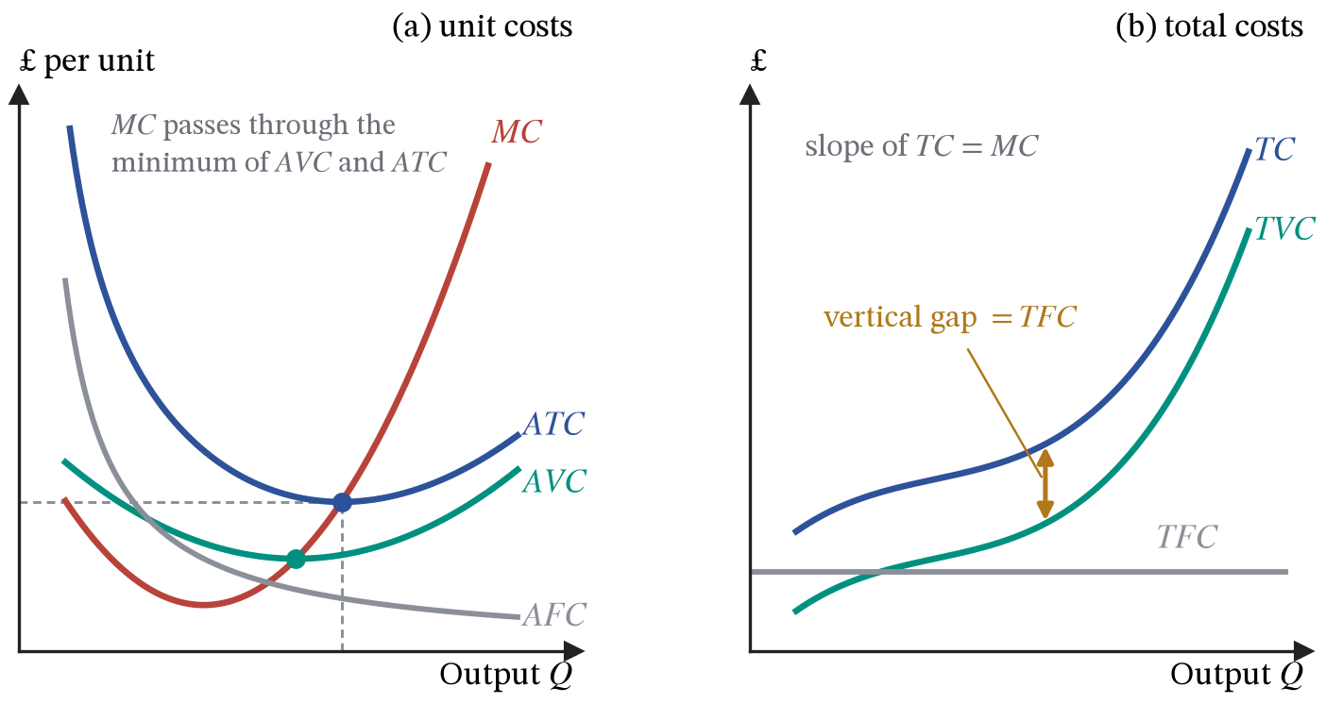
Figure 6. Unit costs and total costs for the same firm. The vertical gap between $TC$ and $TVC$ is the fixed cost, and the gradient of $TC$ at any point is marginal cost.
Three separate forces move unit costs, and they are constantly confused with one another:
 | What happens | Why | When it applies
Spreading fixed costs | $AFC$ falls | a fixed number divided by a rising one | every output, and it never reverses
Diminishing marginal returns | $MC$ then $AVC$ rise | a fixed factor, so $MP_{L}$ eventually falls | short run only
Economies of scale | $LRAC$ falls | a larger plant is cheaper per unit | long run only, when every factor varies
Writing “economies of scale” on a short-run diagram, or explaining falling $ATC$ by economies of scale when it is really $AFC$ being spread, is the most common error in this part of the course.
ASSUMPTIONS.
The firm buys labour at a given wage and rents capital at a given price, so it is too small to move either.
Capital is fixed, which is what makes this the short run and what makes diminishing returns possible at all.
Every cost is an economic cost, including the opportunity cost of the owner’s own time and money, which is why these curves are not an accountant’s cost curves.

5. The long run and economies of scale
DEFINITIONS.
Returns to scale: what happens to output when every input is increased in the same proportion.
Economies of scale: falling long-run average cost as the scale of production rises.
Diseconomies of scale: rising long-run average cost, usually from coordination and motivation problems.
Minimum efficient scale: the lowest output at which long-run average cost stops falling.
Natural monopoly: an industry in which minimum efficient scale is so large relative to demand that one firm produces more cheaply than several could.
In the long run nothing is fixed, so there are no fixed costs and there is no law of diminishing returns to appeal to. If doubling $K$ and $L$ more than doubles $Q$, the firm has increasing returns to scale and long-run average cost falls; if it exactly doubles $Q$, constant returns and flat $LRAC$; if less, decreasing returns and rising $LRAC$.
Each conceivable plant size generates its own short-run $ATC$ curve. The firm choosing optimally will always sit on the lowest one available, so the long-run curve is the lower envelope of all of them.
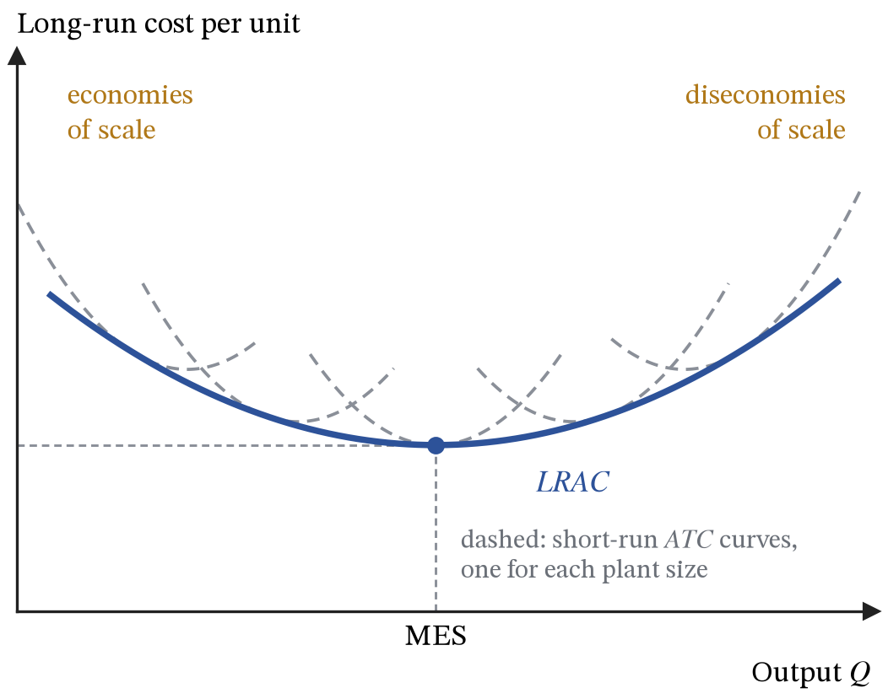
Figure 7. Long-run average cost as the envelope of short-run average cost curves, one for each plant size.
Economies of scale come from identifiable sources: indivisible equipment that only pays at volume (technical), bulk discounts on inputs (purchasing), specialised managers whose salary is spread over more output (managerial), cheaper borrowing for large and safer firms (financial), and advertising whose cost per unit sold falls with sales (marketing). Diseconomies come mostly from coordination and motivation: more layers of management, slower information, weaker individual accountability.
A supermarket and a corner shop sell similar goods with sharply different unit costs. The supermarket runs a distribution centre, negotiates directly with manufacturers, and spreads a single logistics system over thousands of stores. The corner shop cannot do any of this at its volume. When minimum efficient scale, MES for short, is large relative to total market demand, the market cannot support many firms at efficient size, and the structure of the industry is decided by the cost curve rather than by anybody’s strategy. In the extreme, where MES exceeds the whole market, one firm is the cheapest possible arrangement and the industry is a natural monopoly.
ASSUMPTIONS.
Every input can be varied, and the firm picks whichever plant size makes each output cheapest, which is what places it on the lower envelope.
Technology and input prices are held fixed while scale changes.
The sources of economies of scale are empirical claims about particular industries rather than consequences of the model, and the upturn of the long-run curve is an assumption about where diseconomies eventually set in.

6. Revenue
DEFINITIONS.
Total revenue: price multiplied by quantity sold.
Average revenue: revenue per unit, which is the price, so the average revenue curve and the demand curve facing the firm are the same line.
Marginal revenue: the addition to total revenue from selling one more unit.
Price taker: a firm too small to move the market price, for which marginal revenue, average revenue and price are all equal.
A firm large enough to affect its own price faces a downward-sloping demand curve. Write it with price as the subject, $P(Q)=a−bQ$: the price the firm can charge if it wants to sell $Q$ units. Here $a$ is the price at which sales would dwindle to nothing and $b$ is the number of pounds the firm must knock off the price to sell one more unit.
$$TR(Q)=P(Q) Q=aQ−bQ^{2}, AR=\frac{TR}{Q}=P(Q) (15)$$
Total revenue is the price multiplied by the number of units sold, and dividing it by quantity returns the price, so average revenue and demand are the same line. Differentiating $TR$:
$$MR=\frac{dTR}{dQ}=a−2bQ (16)$$
Marginal revenue starts at the same height as demand and falls twice as steeply, so it hits the horizontal axis at exactly half the quantity that demand does. The factor of two has an economic reason: selling one more unit earns the firm the price of that unit, but to sell it the firm had to cut the price on every unit it was already selling. Applying the product rule to $TR=P(Q)×Q$, rather than to the expanded quadratic, separates the two effects:
$$MR=P+Q\frac{dP}{dQ}=P\left(1+\frac{Q}{P}⋅\frac{dP}{dQ}\right)=P\left(1+\frac{1}{PED}\right) (17)$$
The first term $P$ is the money the new unit brings in. The second, $Q dP/dQ$, is the money lost on the units already being sold: $dP/dQ$ is the price cut needed to shift one more, and $Q$ is how many units suffer it. Factorising out $P$ turns the bracket into an expression in the price elasticity of demand defined in section 1, since $PED=(dQ/dP)(P/Q)$ is the reciprocal of $(Q/P)(dP/dQ)$.
$MR=0$ exactly when $|PED|=1$, which is where total revenue peaks. A firm with any price-setting power will therefore never knowingly operate where demand is inelastic, because cutting output there would raise revenue and cut costs at the same time.
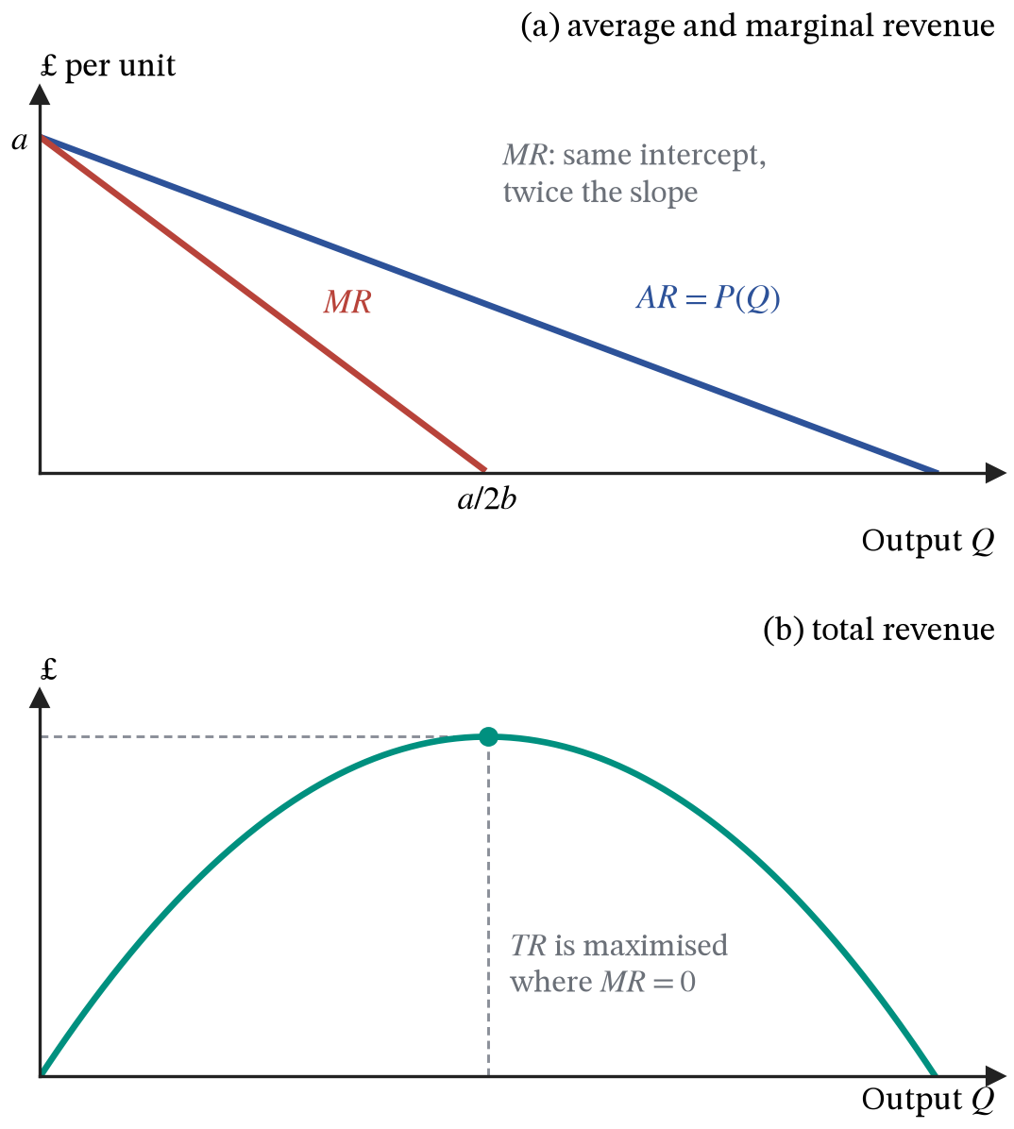
Figure 8. Marginal revenue derived from linear demand, and the total revenue curve that goes with it.
A firm in perfect competition is too small to move the market price, so $dP/dQ=0$, and (17) collapses to $MR=P=AR$: a horizontal line at the market price.
ASSUMPTIONS.
The firm charges one price to every buyer, so cutting the price to sell one more unit means cutting it on all the others. Price discrimination, in section 13, is what happens when that assumption is dropped.
The demand curve facing the firm is known and straight, which is what makes the factor of two in marginal revenue exact rather than approximate.

7. Profit maximisation
DEFINITIONS.
Opportunity cost: the value of the best alternative given up when a choice is made.
Economic profit: total revenue minus total cost, where cost includes the opportunity cost of every resource used.
Normal profit: the return just sufficient to keep the owner’s resources in this use, which is counted as a cost and already sits inside total cost.
Supernormal profit: profit above normal profit.
Shutdown point: the price below which a firm stops producing in the short run, which is minimum average variable cost.
Exit: leaving the industry altogether, which a firm does in the long run if price stays below minimum average total cost.
Profit is the difference between two functions already derived. Writing it as capital $Π$ keeps the lower-case $π$ free for inflation in Part III:
$$Π(Q)=TR(Q)−TC(Q) (18)$$
The first-order condition for a maximum is
$$\frac{dΠ}{dQ}=MR−MC=0 ⇒ MR=MC (19)$$
Differentiating (18) gives the extra revenue from the last unit minus its extra cost. If $MR>MC$, the next unit adds more to revenue than to cost, so making it raises profit and the firm should expand. If $MR<MC$, that unit is destroying profit and the firm should contract. Only where the two are equal is there nothing left to gain in either direction.
A turning point can be a maximum or a minimum, so the second-order condition checks which:
$$\frac{d^{2}Π}{dQ^{2}}=\frac{dMR}{dQ}−\frac{dMC}{dQ}<0 (20)$$
At the crossing, marginal cost must be rising faster than marginal revenue, so $MC$ must cut $MR$ from below. If marginal cost starts above marginal revenue and falls through it before rising back, there are two crossings, and the left-hand one, where $MC$ is still falling, satisfies $MR=MC$ but is a profit minimum.
A worked example makes the conditions concrete, and section 13 returns to the same firm. It faces demand $P=14−0.06Q$, so $MR=14−0.12Q$, and has marginal cost $MC=6−0.12Q+0.00105Q^{2}$, which falls to a minimum of £2.57 at $Q=57$ and rises after that. Its fixed cost is £150. Setting $MR=MC$:
$$14−0.12Q=6−0.12Q+0.00105Q^{2} ⇒ 8=0.00105Q^{2} ⇒ Q^{*}=\sqrt{\frac{8}{0.00105}}≈87.3 (21)$$
The $−0.12Q$ terms cancel, which is a feature of these numbers rather than a general result. The second-order condition holds: $dMR/dQ=−0.12$ while $dMC/dQ=−0.12+0.0021×87.3=0.063$, so marginal cost is rising through marginal revenue. The firm sells 87.3 units at $P=14−0.06×87.3≈£8.76$, average total cost there is £5.15, and profit is $(8.76−5.15)×87.3≈£316$.
The two curves in Figure 9(a) have the shapes they do for economic reasons. Total revenue is price times quantity along a straight-line demand curve:
$$TR(Q)=(14−0.06Q) Q=14Q−0.06Q^{2} (22)$$
The negative coefficient on $Q^{2}$ makes it an upside-down parabola. At low output each extra unit adds almost its full price to revenue, but every extra unit sold needs a price cut on all the units already sold, and that loss grows with the number of units it applies to. Marginal revenue, $14−0.12Q$, therefore falls steadily: total revenue rises ever more slowly, peaks where $MR=0$ at $Q=116.7$, which by (17) is where $|PED|=1$, and falls beyond it, where each further sale loses more on the existing units than it earns itself. The curve is symmetric about its peak because the loss term is a pure square, which in turn is because demand is a straight line.
Total cost is the fixed cost plus a variable cost whose slope is marginal cost:
$$TC(Q)=150+6Q−0.06Q^{2}+0.00035Q^{3}, \frac{d^{2}TC}{dQ^{2}}=−0.12+0.0021Q (23)$$
The curve starts at £150, the fixed cost paid even at zero output. Its gradient is marginal cost, which section 4 showed is the wage divided by the marginal product of labour. While extra workers make each other more productive, marginal cost falls, so total cost rises ever more slowly and the curve bends downward. Once diminishing returns set in, marginal cost rises, total cost rises ever more steeply, and the curve bends upward. The switch is the inflection point, where the second derivative is zero: $Q=0.12/0.0021=57$, the output at which marginal cost is at its minimum. The S-shape of total cost is the U-shape of marginal cost seen in total form, and both are the product curves of section 3 turned upside down.
Profit is the vertical distance between the two curves, and the firm wants the output at which that distance is greatest. At that output the two curves must be parallel. If total revenue were steeper than total cost there, a little more output would add more to revenue than to cost and widen the gap; if total cost were steeper, a little less output would widen it. Only where the gradients are equal is there no direction in which the gap grows. The gradient of $TR$ is $MR$ and the gradient of $TC$ is $MC$, so parallel tangents are the condition $MR=MC$ drawn in totals. In Figure 9(a) the tangents to both curves at $Q^{*}=87.3$ have a slope of £3.53 per unit, which is the height at which $MR$ and $MC$ cross in panel (b).
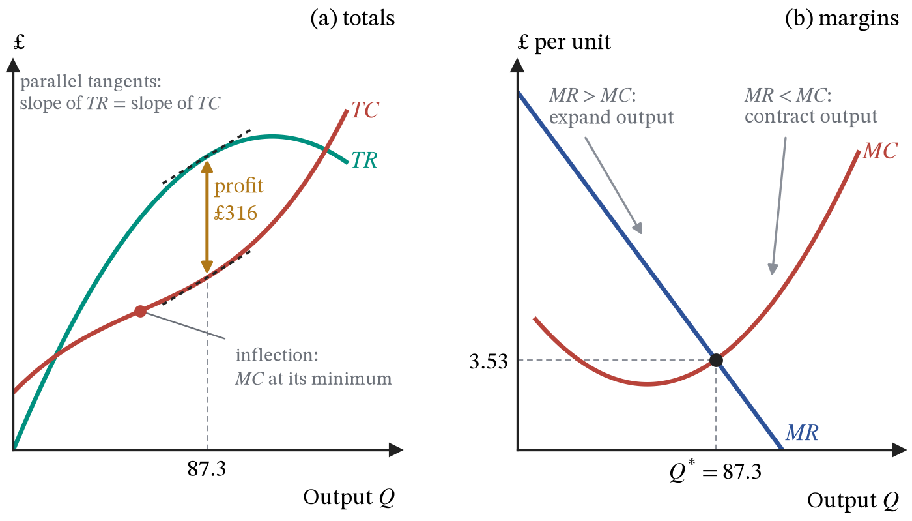
Figure 9. Profit maximisation for the worked example, seen twice. On the left, profit is the vertical gap between $TR$ and $TC$; it is largest where the tangents to the two curves are parallel, and the inflection point of $TC$ marks the minimum of $MC$. On the right, the same output appears as the crossing of $MR$ and $MC$, $Q^{*}=87.3$.
Whether to produce at all is a separate question from how much. In the short run the fixed cost is sunk: it is paid whether or not the firm opens, so it cannot influence the decision. The firm should produce if revenue covers variable cost, $P≥AVC$, and shut down if not. In the long run nothing is sunk, so a firm that cannot cover average total cost, $P<ATC$, exits the industry.
Firms also pursue other objectives. Revenue maximisation sets $MR=0$, which in the example means $Q=116.7$ at a price of £7: higher output and a lower price than profit maximisation. Managers may satisfice, or pursue growth, when ownership and control are separated.
ASSUMPTIONS.
The firm maximises profit, knows its own demand and cost functions, and chooses a single output.
Because normal profit sits inside total cost, a firm making zero economic profit is doing exactly as well as its next best alternative, not failing.

Part II. Markets

8. Demand
DEFINITIONS.
Demand: the quantity buyers are willing and able to buy at each price in a given period.
Law of demand: quantity demanded falls as price rises, other things equal.
Ceteris paribus: the assumption that everything not named in the model is held still.
Willingness to pay: the most a buyer would pay for a unit, measured in pounds.
Movement along a demand curve is caused by a change in the good’s own price; a shift of it is caused by a change in anything else.
The household of section 1 has a demand curve, but not one that can be read as a measure of value. Its utility is a ranking, not a quantity of pounds; it spends half its budget on $x$, so any change in the price of $x$ changes its real income substantially; and it buys $x^{*}=B/2p_{x}>0$ at every price, however high, so it never reaches a price at which it would stop. The area under that curve, which section 12 will use to measure what buyers gain from a market, is infinite.
Most goods are not like that. A household that spends a small share of its budget on a good can treat the money left over as a single amount, worth £1 per pound, and its utility as
$$U=v(x)+(B−p_{x}x) ⇒ \frac{dU}{dx}=v^{′}(x)−p_{x}=0 ⇒ v^{′}(x)=p_{x} (24)$$
Here $v(x)$ is the value in pounds of consuming $x$ units and $B−p_{x}x$ is what is left to spend on everything else. The household keeps buying while the value of the next unit, $v^{′}(x)$, is at least its price, and stops where the two are equal. Because $v^{′}$ falls as $x$ rises, a lower price brings more units over that line. The demand curve is now the marginal-benefit curve, its height at any quantity is the willingness to pay for the last unit, and that is the reading every later diagram in these notes relies on. The step that justifies it is the small budget share: a change in price then barely changes real income, so the demand curve reflects value rather than the household’s changing ability to pay.
Adding up all buyers at each price gives market demand, which we write as a function:
$$Q_{D}=α−βP+γY (25)$$
$Q_{D}$ is the quantity demanded per period; $P$ is the good’s own price; $Y$ is consumer income; $α$ is the intercept, one number standing in for everything else that moves demand (tastes, population, the prices of related goods, expectations); $β>0$ is how many units demand falls by for each £1 on the price; and $γ≠0$ is how many units it changes by for each extra £1 of income. Greek letters are used for the market demand and supply parameters throughout, so that they can never be confused with the firm’s own $a$ and $b$ in section 6, with cost symbols, or with the differentiation symbol $d$.
$$\frac{∂Q_{D}}{∂P}=−β<0, \frac{∂Q_{D}}{∂Y}=γ (26)$$
With income held fixed, each £1 added to the price cuts the quantity demanded by $β$ units, which is the law of demand. With the price held fixed, each extra £1 of income changes the quantity demanded by $γ$ units, and the sign of $γ$ classifies the good: positive for a normal good, negative for an inferior one.
The distinction between the two derivatives is the distinction between a shift and a movement. A rise in $Y$ raises $Q_{D}$ at every price, because $P$ is held fixed while we differentiate, so the whole curve moves. A change in $P$ changes nothing inside the function, so it only moves the buyer along the curve already there.
Diagrams put $P$ on the vertical axis, so plot the inverse demand function obtained by rearranging (25):
$$P=\underset{\text{vertical intercept}}{\underset{⏟}{\frac{α+γY}{β}}}+\underset{\text{gradient}}{\underset{⏟}{\left(−\frac{1}{β}\right)}}Q_{D} (27)$$
The height of the curve above any quantity is the willingness to pay of the buyer of that last unit. The vertical intercept $(α+γY)/β$ is the price at which the very first unit would be bought, and the gradient $−1/β$ says how fast willingness to pay falls as more units are sold. A rise in income raises the intercept and leaves the gradient alone, so the whole line moves up by $γΔY/β$, parallel to itself. Buyers will now pay that much more for each unit than they would before.
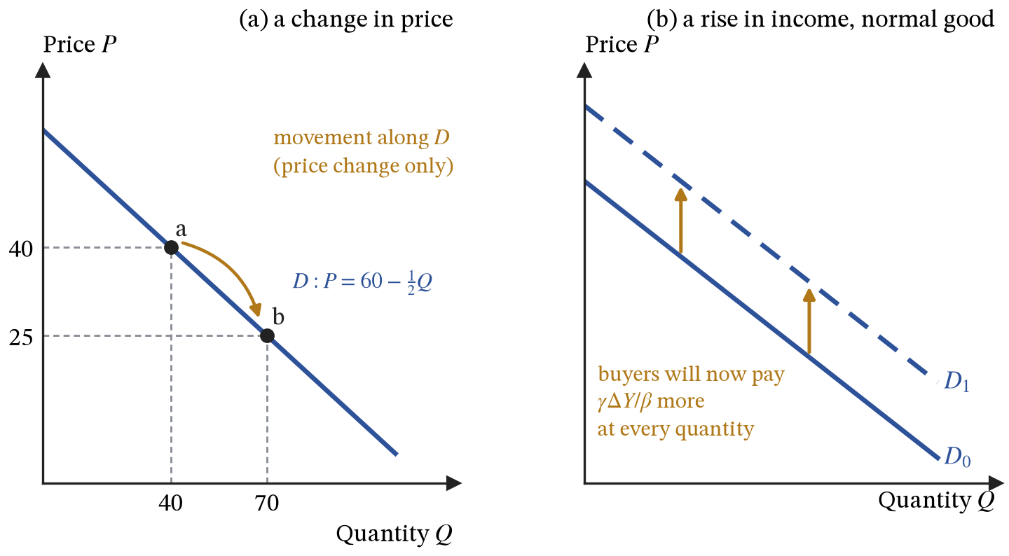
Figure 10. Movement along demand versus a shift of demand. In (a) only price changes. In (b) income rises, so at every quantity buyers will pay $γΔY/β$ more than before.
For concert tickets, a fixed venue means a fixed number of seats. If an artist becomes suddenly famous, $α$ rises, the curve moves up, and at the old face value far more people want tickets than there are seats. Nothing about the seats has changed; the willingness to pay has.
ASSUMPTIONS.
Buyers are assumed to respond to price on average and at a point in time, which is not the same as assuming that anybody is a calculating machine.
Everything inside $α$ and $Y$ is held still, so the curve is a schedule of intentions at one moment rather than a forecast of what will happen.
Reading the curve as willingness to pay in pounds assumes the good takes a small share of buyers’ budgets, as in (24). For housing or energy, where a price change alters real income substantially, it is an approximation.

9. Supply
DEFINITIONS.
Supply: the quantity sellers are willing and able to sell at each price in a given period.
Law of supply: quantity supplied rises with price, other things equal.
Firm’s supply curve: the part of its marginal cost curve above minimum average variable cost.
A price-taking firm sets $MR=MC$, and for a price taker $MR=P$, so it produces where $P=MC$. Read the other way round, its marginal cost curve tells us how much it will offer at each price: that is its supply curve. The qualification is section 7’s shutdown rule. Below minimum average variable cost the firm produces nothing, so its supply curve is the part of $MC$ above minimum $AVC$. Section 4 explained why that part slopes upward: marginal cost is the wage divided by the marginal product, rising once diminishing returns set in.
Adding up firms gives market supply, written in linear form:
$$Q_{S}=μ+λP, \frac{∂Q_{S}}{∂P}=λ>0 (28)$$
$Q_{S}$ is the quantity supplied per period; $λ>0$ is how many extra units firms offer for each £1 added to the price; and $μ$ is the intercept, one number standing in for everything other than price that moves supply, principally input costs, technology, taxes on production, the number of firms and expectations.
$μ$ is not the level of costs, and it moves the opposite way: cheaper inputs mean more is offered at any given price, so lower costs mean a higher $μ$. Seen vertically, if each unit now costs £$h$ less to make, firms will accept £$h$ less for any given quantity, so the supply curve drops by exactly £$h$.
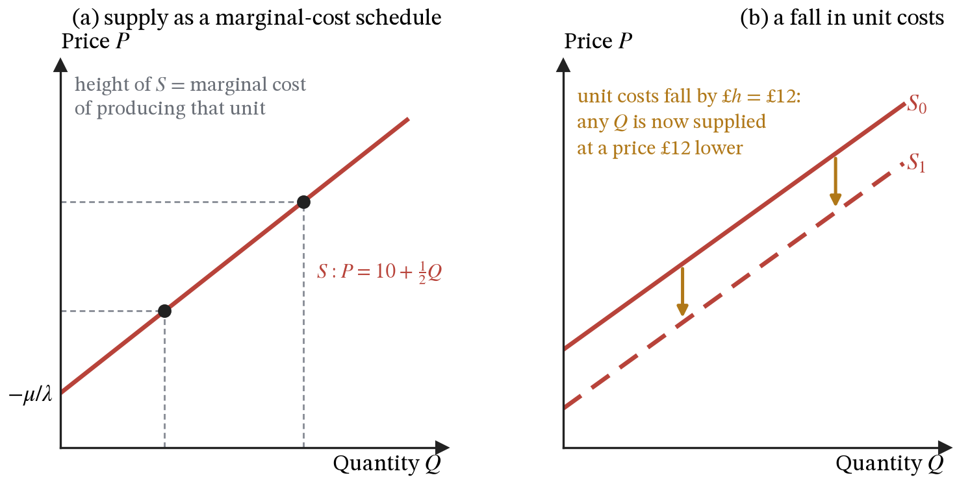
Figure 11. Supply as a marginal cost schedule, and a fall in unit costs of £$h$ = £12, which moves the curve down by the size of the saving.
ASSUMPTIONS.
Many firms, each taking the price as given.
Input prices and technology fixed.
Firms maximising profit.
Drop the first assumption and there is no supply curve at all, as section 13 shows for monopoly.

10. Equilibrium and the price mechanism
DEFINITIONS.
Market equilibrium: the price at which quantity demanded equals quantity supplied, so no buyer or seller has reason to change their plans.
Excess demand: the shortfall of quantity supplied below quantity demanded at a price below equilibrium.
Excess supply: the surplus at a price above it.
Functions of the price mechanism: signalling where value is, incentivising producers to move resources there, and rationing what exists among competing buyers.
Equilibrium is the price at which plans are consistent: $Q_{D}=Q_{S}$. Using (25) and (28),
$$α−βP+γY=μ+λP ⇒ P^{*}=\frac{α−μ+γY}{β+λ} (29)$$
The equilibrium price rises with anything that raises demand ($α$, or $γY$ for a normal good), falls with anything that raises supply ($μ$), and is divided by $β+λ$, the two sides’ responsiveness to price added together. Substituting it back into either equation gives the quantity traded, and getting the same answer from both is a check on the algebra:
$$Q^{*}=μ+λP^{*}=\frac{αλ+βμ+λγY}{β+λ} (30)$$
Unlike the diagram, the pair can be differentiated. Differentiating (29) with respect to income and with respect to the supply intercept:
$$\frac{dP^{*}}{dY}=\frac{γ}{β+λ}, \frac{dP^{*}}{dμ}=−\frac{1}{β+λ} (31)$$
A rise in income moves the price by the income sensitivity of demand divided by the combined responsiveness of both sides; an increase in supply lowers it by one pound per unit of $μ$, divided by the same total. The common denominator is the result. Shocks on either side of the market move the price more when $β$ and $λ$ are small, that is, when demand and supply respond weakly to price. A good harvest raises supply in a market where demand for food barely responds to price, which is why it can crash food prices; a surge in demand for houses meets a supply of housing that responds slowly, which is why it mostly raises prices rather than the number of houses.
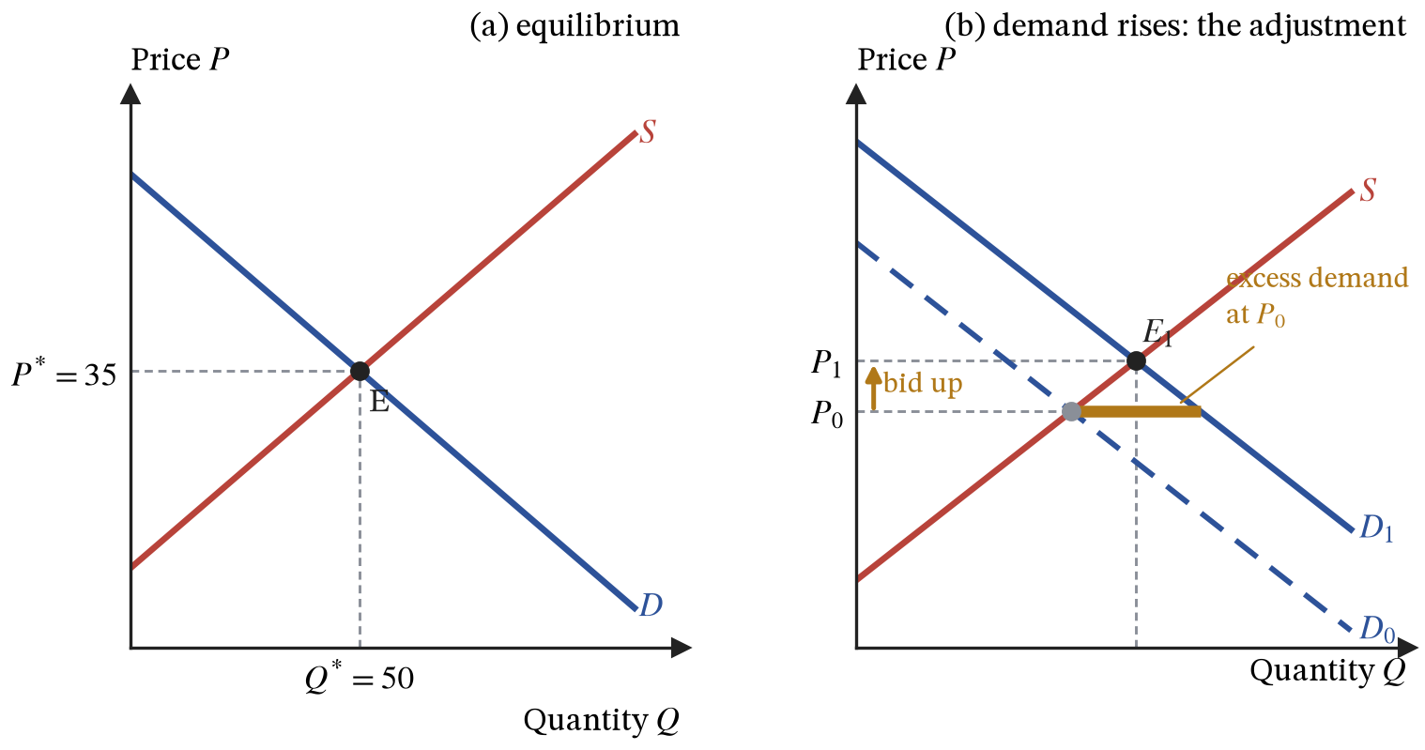
Figure 12. Equilibrium, and the adjustment to a rise in demand. At the old price $P_{0}$ there is excess demand.
The algebra gives the destination and says nothing about the journey. Demand rises at every price, so at the old price $P_{0}$ the quantity demanded exceeds the quantity supplied. Buyers compete for a limited quantity while sellers watch stocks run down, so sellers raise their prices. The higher price rations demand, because the buyers who valued the good least drop out first. It also rewards supply, because output that was not worth making at $P_{0}$ becomes worth making. Excess demand shrinks as both happen, and the process comes to rest at $P_{1}$, where $Q_{D}=Q_{S}$ once more.
The adjustment shows the three jobs prices do, which OCR calls the functions of the price mechanism: prices signal where value is, they incentivise producers to move resources there, and they ration what exists among competing buyers.
ASSUMPTIONS.
Every step of that adjustment is a claim about behaviour rather than a fact. It assumes sellers respond by raising prices rather than by rationing informally, that buyers drop out rather than queue, and, strongest of all, that the process settles rather than overshooting back and forth indefinitely.
Equilibrium is assumed to be a destination rather than a permanent condition. The model supplies a force pushing towards it and nothing more. Where prices are slow to move (wages, rents under contract) the disequilibrium can last, which is the seed of unemployment in Part III.

11. Elasticity
DEFINITIONS.
Elastic means $|PED|>1$, inelastic means $|PED|<1$, and unit elastic means $|PED|=1$, which is where total revenue peaks.
Income elasticity (YED), cross elasticity (XED) and price elasticity of supply (PES) are the same construction as PED with income, another good’s price, or the supply curve in place of the original terms.
Equation (31) said that shocks move price further when $β$ and $λ$ are small. Price elasticity of demand puts that sensitivity in proportional terms:
$$PED=\frac{dQ_{D}}{dP}⋅\frac{P}{Q_{D}}=− \frac{βP}{Q_{D}} (32)$$
The gradient on its own would depend on whether petrol is measured in litres or in barrels; multiplying by $P/Q_{D}$ converts it into one percentage divided by another, and percentages have no units. Substituting $∂Q_{D}/∂P=−β$ from (26) gives the version on the right.
Elasticity is therefore a property of a point, not of a whole curve. On a straight line $β$ is constant but $P/Q_{D}$ is not: near the vertical intercept $Q_{D}$ is small and $|PED|$ is large, near the horizontal intercept $P$ is small and $|PED|$ tends to zero, and somewhere between them $|PED|=1$. Gradient and elasticity are different objects, so “steeper means more inelastic” is only a rough guide and breaks down whenever two curves are compared at different quantities.
Raising the price does two opposing things to total revenue, $TR=PQ_{D}$, and the product rule separates them:
$$\frac{dTR}{dP}=Q_{D}+P\frac{dQ_{D}}{dP}=Q_{D}(1+PED) (33)$$
The first term is the gain from charging more on every unit still sold; the second is the loss from selling fewer units. Since $PED<0$, the bracket is positive when $|PED|<1$ and negative when $|PED|>1$. Raising price raises revenue on inelastic demand and destroys it on elastic demand, and revenue peaks where $|PED|=1$, the same fact that appeared in section 6 as $MR=0$.
The two terms are two areas on the diagram. Raise the price from $P_{0}$ to $P_{1}$ and quantity falls from $Q_{0}$ to $Q_{1}$. The seller gains the extra price on every unit still sold, a rectangle of height $P_{1}−P_{0}$ and width $Q_{1}$. The seller loses the old price on every unit no longer sold, a rectangle of width $Q_{0}−Q_{1}$ and height $P_{0}$. Revenue rises if the first rectangle is the larger.
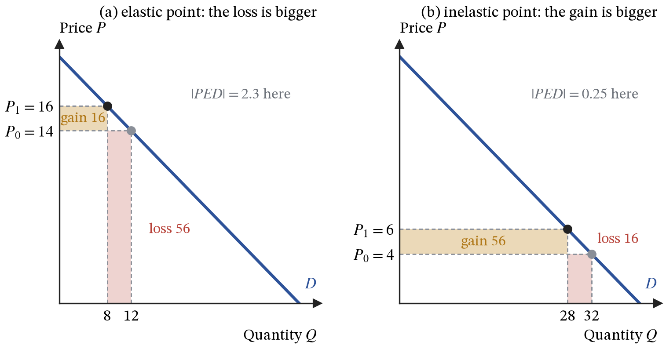
Figure 13. The two rectangles behind equation (33). One price rise of 2 is applied at two points on the same demand curve: the gain is the shaded band above the old price, the loss is the block of units no longer sold.
Both panels use the same demand curve, so only the point on the curve differs, and with it the ratio $P/Q_{D}$ in (32). High on the curve there are few units to gain on and many to lose, so the loss wins. Low on the curve there are many units to gain on and few to lose, so the gain wins.
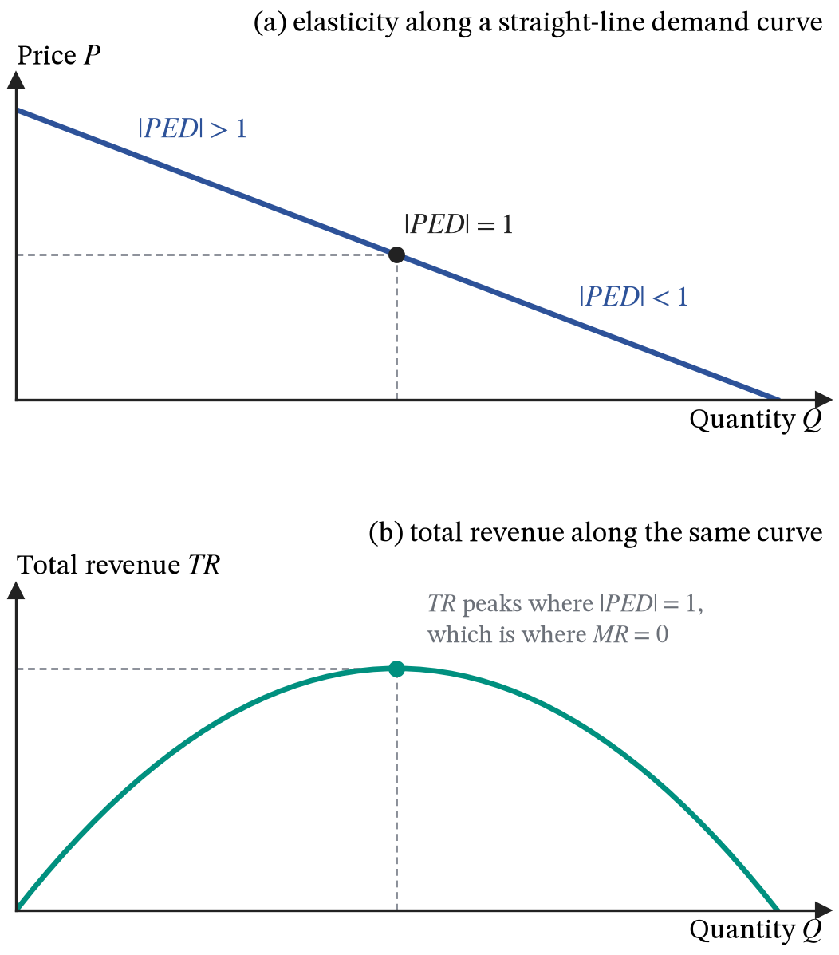
Figure 14. Elasticity varies along a straight-line demand curve, and total revenue peaks where $|PED|=1$.
The same construction applied to other variables gives the rest of the family:
$$YED=\frac{∂Q_{D}}{∂Y}⋅\frac{Y}{Q_{D}}=\frac{γY}{Q_{D}}, XED=\frac{∂Q_{D}}{∂P_{j}}⋅\frac{P_{j}}{Q_{D}}, PES=\frac{dQ_{S}}{dP}⋅\frac{P}{Q_{S}}=\frac{λP}{Q_{S}} (34)$$
$P_{j}$ is the price of some other good $j$, so cross elasticity measures how demand for our good responds to it.
Elasticity | Response of | To a change in | Reading the number
$PED$​ | quantity demanded | the good’s own price | below $−1$ elastic, between $−1$ and $0$ inelastic
$YED$​ | quantity demanded | consumer income | above $0$ normal, above $1$ luxury, below $0$ inferior
$XED$​ | quantity demanded | the price of another good $j$ | above $0$ substitutes, below $0$ complements
$PES$​ | quantity supplied | the good’s own price | larger with spare capacity and with time
Demand is more elastic when close substitutes exist, when the good takes a large share of the budget, and when buyers have had time to adjust. Supply is more elastic when firms hold spare capacity, when inputs can be bought quickly, and again when there is time, which is the short-run and long-run distinction of sections 4 and 5 seen from the market’s side.
Petrol has no close substitute for most journeys in the short run, so $β$ is small and $|PED|$ is well below one. Figure 15 shows what that implies when supply moves: with inelastic demand, a supply shift produces a large price change and a small quantity change, so almost the whole adjustment happens in price. With elastic demand the reverse holds.
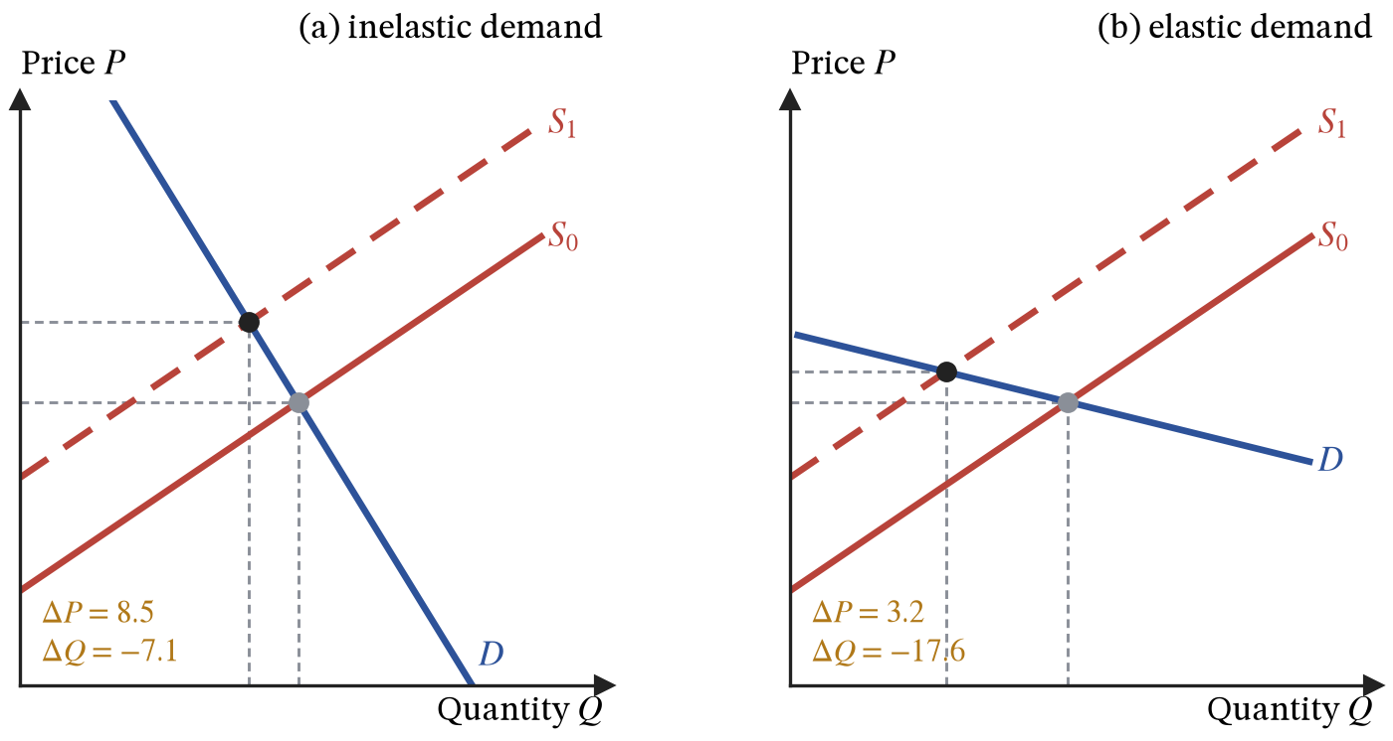
Figure 15. The same upward shift in supply, a rise of 12 in unit costs, under inelastic and elastic demand. Elasticity decides how a shock splits between price and quantity.
ASSUMPTIONS.
Elasticities are local. Quoting a single PED for a good is really quoting an average over the range of prices actually observed, and extrapolating it far outside that range is not legitimate.

12. Welfare, surplus and efficiency
DEFINITIONS.
Consumer surplus: the difference between what buyers would have paid and what they did pay, summed over all units bought.
Producer surplus: the difference between the price received and marginal cost, summed the same way.
Allocative efficiency: output at the quantity where price equals marginal cost, so total surplus is at a maximum.
Productive efficiency: production at minimum average total cost.
Welfare loss: the surplus destroyed when output differs from the efficient quantity.
Section 8 established that, for a good taking a small share of the budget, the height of the demand curve is the willingness to pay for the last unit, in pounds. The demand curve therefore measures the marginal private benefit ($MPB$) of each unit, and the supply curve, as section 9 showed, the marginal private cost ($MPC$). That turns areas on the diagram into quantities of value: consumer surplus is the area between the demand curve and the price, and producer surplus is the area between the price and the supply curve.
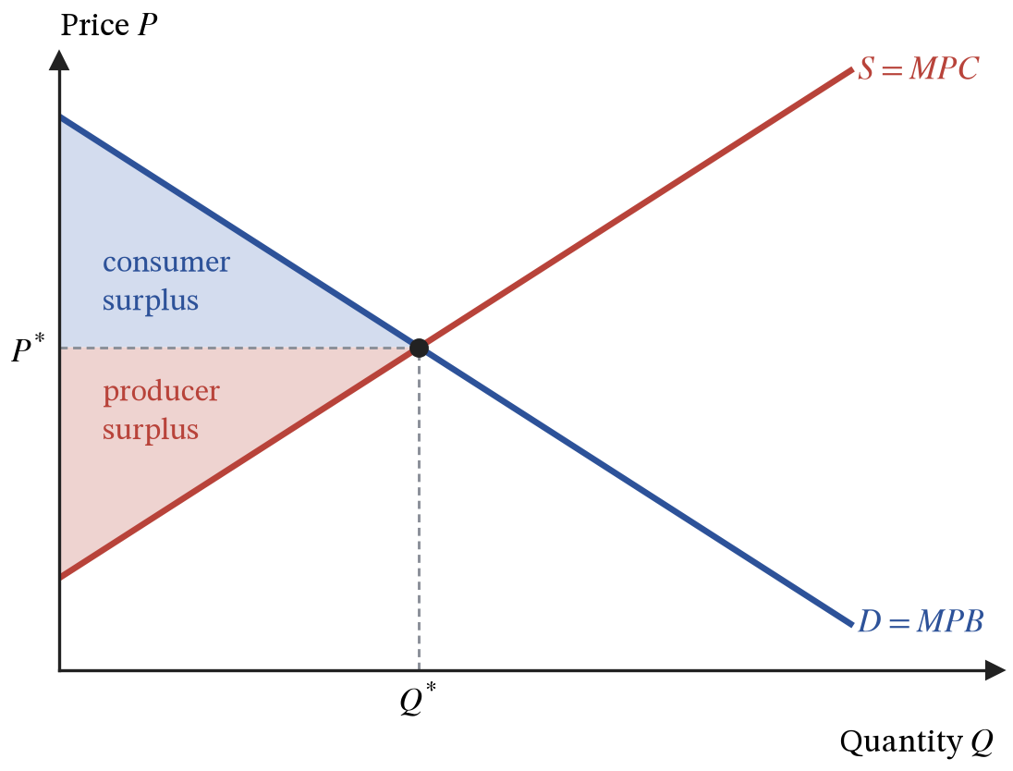
Figure 16. Consumer and producer surplus at the competitive equilibrium.
Why is $Q^{*}$ the best quantity rather than merely the equilibrium one? Define total surplus as the accumulated excess of benefit over cost:
$$TS(Q)=\int_{0}^{Q}{\left[MPB(q)−MPC(q)\right]}dq, \frac{dTS}{dQ}=MPB(Q)−MPC(Q) (35)$$
$TS(Q)$ is the total value the market has created by the time $Q$ units have been made. For each unit $q$ along the way, the integral subtracts what it cost to make from what it was worth to whoever bought it, and adds those gaps up from the first unit to the last. Differentiating undoes the adding up, so the value added by the very next unit is the gap between its benefit and its cost.
Setting the derivative to zero gives $MPB=MPC$, which is the condition $D=S$. Below $Q^{*}$ the next unit is worth more to somebody than it costs to make, so not making it wastes value. Above $Q^{*}$ the resources used are worth more elsewhere. The competitive equilibrium therefore achieves allocative efficiency, which OCR states as $P=MC$: price measures what the marginal buyer values the unit at, and marginal cost measures what society gives up to make it. Productive efficiency is a separate condition, and section 13 shows which market structures deliver it.
ASSUMPTIONS.
Surplus is measured by adding up willingness to pay, which assumes that ability to pay is an acceptable yardstick for value. A pound of surplus gained by a millionaire counts exactly as much here as a pound gained by someone on benefits.
Willingness to pay is measured in pounds only because the good is a small share of buyers’ budgets (section 8). For the household of section 1, which spends half its budget on $x$ and buys some at any price, the area under demand is infinite and has no meaning as a sum of value.
Efficiency is a statement about the size of the pie and says nothing about its distribution, and it holds only when private benefit equals social benefit and private cost equals social cost. Section 16 removes that assumption and the conclusion collapses.

13. Perfect competition and monopoly
DEFINITIONS.
Perfect competition: many firms, an identical product, free entry and perfect information, so every firm is a price taker.
Monopoly: a single seller protected by barriers to entry.
Barrier to entry: anything that stops new firms competing supernormal profit away.
Mark-up: the share of the price not accounted for by marginal cost, $(P−MC)/P$.
Price discrimination: charging different prices to different buyers for the same good, for reasons other than differences in cost.
Dynamic efficiency: improvement in products and processes over time.
Sections 3 to 7 apply to any firm. Industries differ in the demand curve each firm faces, which is set by the number of rivals, the height of barriers to entry, how similar the products are, and how well informed buyers are. This section takes the two extremes.
In perfect competition no firm can move the price, so it faces a horizontal demand curve and, by (17), $MR=AR=P$. Profit maximisation $MR=MC$ therefore becomes $P=MC$. If the price is above average total cost the firm makes supernormal profit, but free entry means new firms arrive, market supply moves down, and the price falls. Entry stops only when the profit that attracted it has gone:
$$P=MC=minATC (36)$$
Price has been driven down to the bottom of the average cost curve, and the firm just covers its costs, including the normal profit buried inside them. $P=MC$ is allocative efficiency, and producing at $minATC$ is productive efficiency. That is the benchmark against which every other structure is judged, which is the reason for studying a model whose assumptions are never all satisfied.
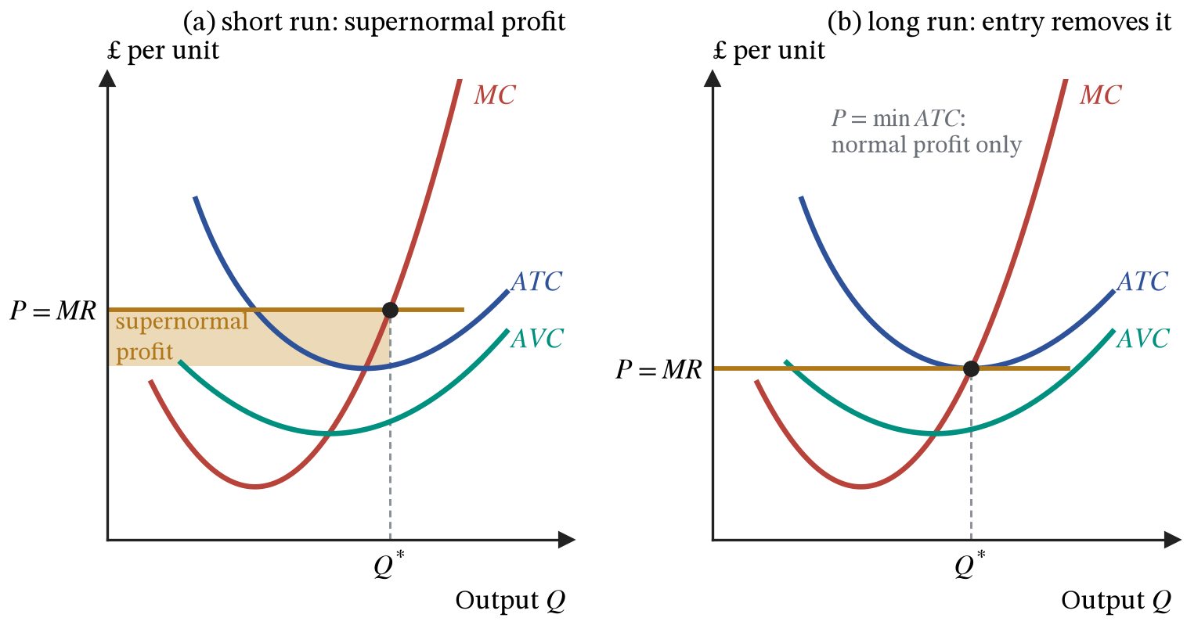
Figure 17. A competitive firm in the short run and after entry has driven price down to minimum average cost.
The barriers that protect a monopoly can be legal (patents, licences), structural (a natural monopoly as in section 5), or strategic. Because the firm is the industry, it faces the whole market demand curve, so $MR$ lies below $AR$. The firm of section 7 is such a firm. It sets $MR=MC$ at $Q_{m}=87.3$ by (21) and reads its price off the demand curve, not off $MR$: $P_{m}=£8.76$, while marginal cost at that output is £3.53. Units worth more to buyers than they cost to produce are not made.
How much value is lost depends on what the alternative would have been. If the same marginal cost curve were instead the supply curve of many price-taking firms, output would rise to where demand meets it, $Q_{c}=120.4$ at $P_{c}=£6.78$, and the triangle between demand and marginal cost from 87.3 to 120.4 units, about £93, is the welfare loss in Figure 18. The comparison assumes a competitive industry could produce at the monopolist’s costs, which is exactly what economies of scale may rule out.
The general statement comes from setting $MR=MC$ and substituting the elasticity form of marginal revenue from (17):
$$P\left(1+\frac{1}{PED}\right)=MC ⇒ \frac{P−MC}{P}=−\frac{1}{PED} (37)$$
The mark-up equals one over the elasticity of demand, with a minus sign because that elasticity is negative. In the example, demand at the chosen point has $PED=−1.67$, so the mark-up is $1/1.67=0.60$, and indeed $(8.76−3.53)/8.76=0.60$. A monopolist facing highly elastic demand, because of good substitutes or the threat of entry, prices close to marginal cost despite having no rivals today.
Two limits confirm that (37) behaves as it should. As demand becomes perfectly elastic, $PED→−∞$, the mark-up goes to zero and $P→MC$, which is the competitive result. And since the mark-up cannot exceed one, $|PED|$ must be at least one at the chosen output: no price setter operates on the inelastic part of its demand curve.
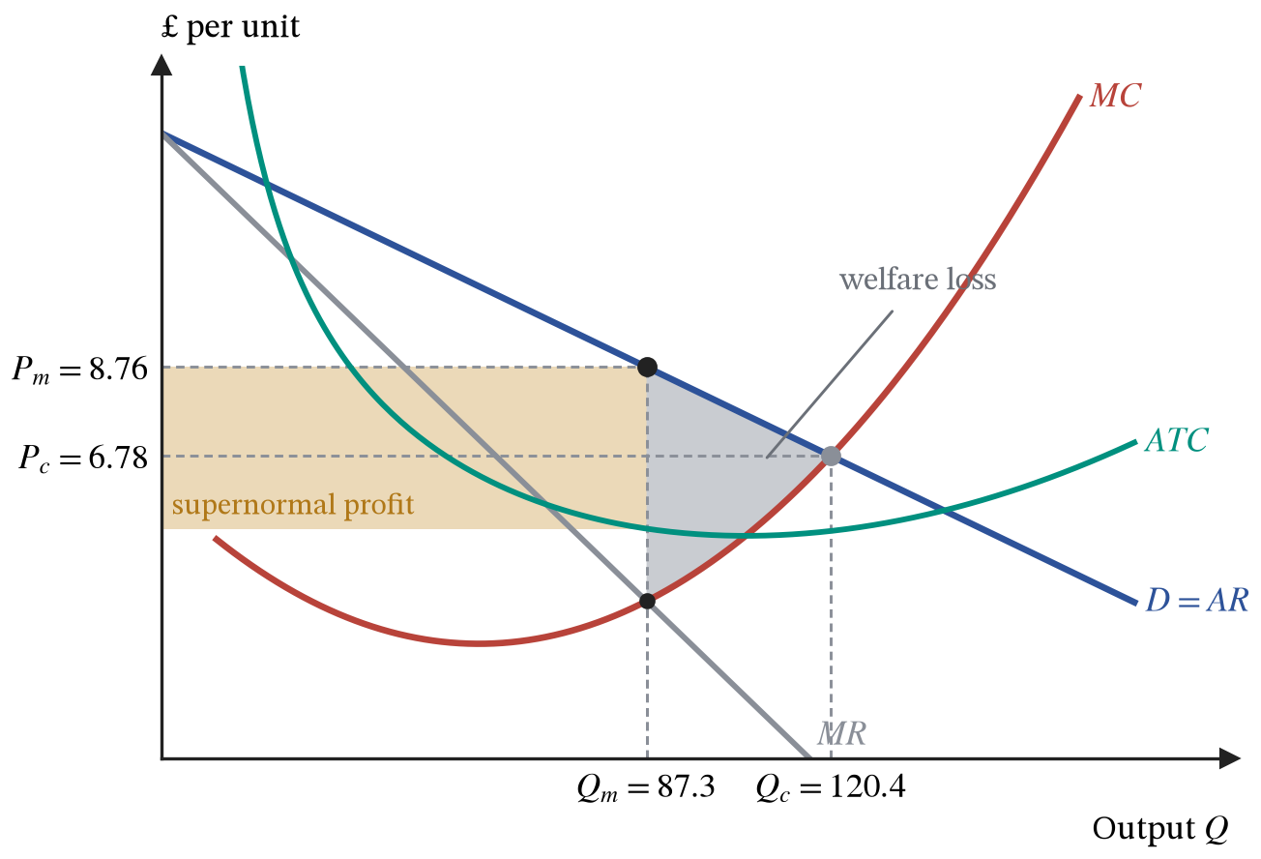
Figure 18. Monopoly, drawn for the firm of section 7. Output is set where $MR=MC$ and price is read off the demand curve above it. $Q_{c}$ and $P_{c}$ mark the outcome if the same marginal cost curve were a competitive industry’s supply.
A monopolist has no supply curve: its chosen quantity depends on the slope of demand as well as on marginal cost, so there is no single relationship between price and quantity supplied. Nor is monopoly simply worse. A protected profit stream can fund research, and economies of scale may make one large firm genuinely cheaper than many small ones.
Price discrimination drops the assumption of section 6 that every buyer pays the same price. It requires market power, buyer groups that can be told apart and that differ in elasticity, and no resale between them. With two groups, the firm chooses a quantity for each, and profit is
$$Π=P_{1}(Q_{1})Q_{1}+P_{2}(Q_{2})Q_{2}−TC(Q_{1}+Q_{2}) ⇒ MR_{1}=MC=MR_{2} (38)$$
Differentiating with respect to each quantity in turn gives one first-order condition per market: the last unit sold in each must add the same to revenue as it adds to cost. If $MR_{1}$ were higher than $MR_{2}$, moving a unit of sales from market 2 to market 1 would raise revenue at no extra cost. Applying (37) market by market, each price carries the mark-up its own elasticity allows, so the less elastic group pays more.
Take marginal cost constant at £4, a student market with demand $P_{1}=12−Q_{1}$ and an adult market with $P_{2}=20−2Q_{2}$. Setting $MR_{1}=12−2Q_{1}=4$ and $MR_{2}=20−4Q_{2}=4$ gives four units in each market, sold to students at £8 and to adults at £12. At those points $PED_{1}=−2$ and $PED_{2}=−1.5$, and the mark-ups are $4/8=1/2$ and $8/12=1/1.5$, as (37) requires. Charging one price instead, the firm would face the combined demand, sell the same 8 units at £9.33, and earn £42.67 rather than £48. With straight-line demands and both groups served, discrimination leaves total output unchanged and works purely by moving surplus from buyers to the firm. It raises output only when a single price would leave one group unserved altogether, which is the case usually made for it in markets such as medicines priced differently in rich and poor countries.
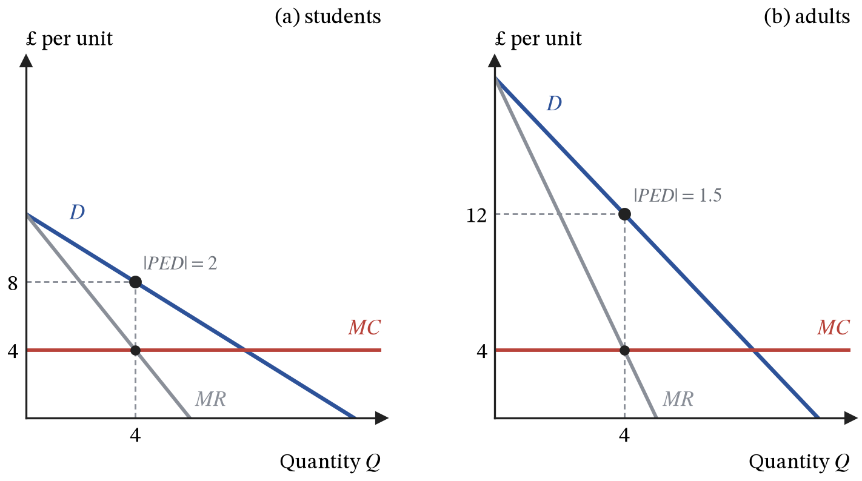
Figure 19. Third-degree price discrimination with marginal cost of £4. Each market’s quantity is set where its own marginal revenue equals marginal cost, and the less elastic adult market pays the higher price.
ASSUMPTIONS.
Both structures use the same profit-maximising firm of section 7 and differ only in the demand curve that firm faces, so each conclusion is only as good as that shared assumption.
Perfect competition assumes identical products, free entry and perfect information, none of which holds anywhere; its value is as the benchmark the others are measured against.
The welfare loss from monopoly is measured against a competitive industry with the monopolist’s costs. Where economies of scale are large, that industry could not exist.

14. Oligopoly and monopolistic competition
DEFINITIONS.
Oligopoly: a few firms large enough that each must anticipate the others’ reactions.
Monopolistic competition: many firms selling differentiated products with free entry.
Concentration ratio: the combined market share of the largest $n$ firms.
Collusion: firms agreeing, formally or tacitly, to restrict competition; a formal agreement is a cartel.
Dominant strategy: a choice that is best whatever rivals do.
Nash equilibrium: a set of choices in which no firm can do better by changing its own choice, given the others’.
Contestable market: one in which entry and exit are cheap, so conduct is competitive whatever the number of firms.
In oligopoly the demand curve a firm faces depends on what its rivals do, so the firm cannot work out its best price without forming a view of their response. Interdependence rather than concentration alone is the defining feature.
The kinked demand model makes one assumption about that response: rivals match price cuts, to avoid losing customers, but ignore price rises, happy to take customers from the firm that raised its price. Above the current price the firm’s demand is then much more elastic than below it, and marginal revenue jumps downward at the kink. Marginal cost can move anywhere within that gap without changing the profit-maximising price, which is the model’s prediction of sticky prices and of competition through branding, quality and advertising instead. The lower segment is less elastic than the upper one, not inelastic: by (37), a firm maximising profit never sits where $|PED|<1$, and in Figure 20 marginal revenue just to the right of the kink is still positive.
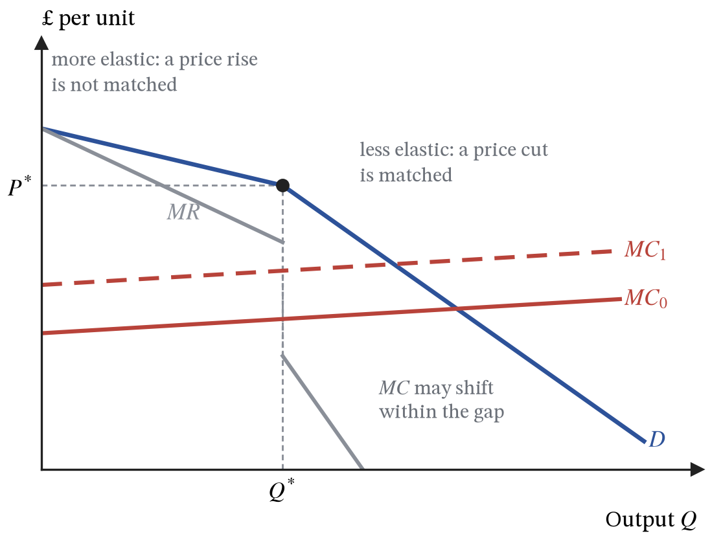
Figure 20. Kinked demand. Demand is more elastic above the current price than below it, and marginal cost can shift anywhere within the gap in marginal revenue without changing $P^{*}$.
Game theory treats the interdependence directly. Two firms each choose a high or a low price, and each cell of the table gives their weekly profits in £m, firm A’s first:
 | Firm B: high price | Firm B: low price
Firm A: high price | 10, 10 | 4, 14
Firm A: low price | 14, 4 | 6, 6
Whatever B does, A earns more by pricing low: 14 rather than 10 if B prices high, 6 rather than 4 if B prices low. Low is a dominant strategy for A, and by symmetry for B, so both price low and earn 6 each. That outcome is a Nash equilibrium, since neither can gain by changing its own price alone, and it is worse for both than the 10 each they would earn by pricing high. This structure, in which individually rational choices produce a jointly bad result, is the prisoners’ dilemma, and it is why collusion is both tempting and unstable.
Repetition changes the calculation. Suppose the game is played every week and each firm prices high for as long as the other does, but switches to low for ever once the other cheats. Cheating earns 14 once and 6 every week after; cooperating earns 10 every week. If a firm values £1 next week at $δ$ pounds today, cooperation pays when
$$\frac{10}{1−δ}≥14+\frac{6δ}{1−δ} ⇒ 10≥14(1−δ)+6δ ⇒ δ≥0.5 (39)$$
The left-hand side sums $10+10δ+10δ^{2}+⋯$; the right-hand side is 14 now plus 6 in every later week. Collusion survives when firms care enough about the future relative to the one-off gain from cheating, and when cheating is quickly detected. That is why cartels need monitoring, why they form in markets with few firms and transparent prices, and why competition authorities offer leniency to whichever member confesses first: the offer turns the cartel itself into a prisoners’ dilemma.
Monopolistic competition sits between monopoly and perfect competition. Differentiation gives each firm a downward-sloping demand curve, so $P>MC$, but free entry competes supernormal profit away in the long run. Each firm ends where its demand curve just touches its average cost curve, on the falling part of that curve, so it produces less than the output that would minimise average cost: the industry carries excess capacity.
 | Perfect competition | Monopolistic competition | Oligopoly | Monopoly
Firms | Very many | Many | Few | One
Product | Identical | Differentiated | Either | Unique
Entry barriers | None | Low | High | High
Firm’s demand | Horizontal | Elastic, downward | Interdependent | Market demand
Long-run profit | Normal | Normal | Can be supernormal | Supernormal
Allocative efficiency | Yes, $P=MC$ | No, $P>MC$ | No, $P>MC$ | No, $P>MC$ by the mark-up in (37)
Productive efficiency | Yes, at $minATC$ | No, excess capacity | Not guaranteed | No
Dynamic efficiency often runs the opposite way to the static measures in the table: the protected profits that make monopoly inefficient are also what can fund research. The number of firms can also mislead. A contestable market behaves competitively however few firms are actually in it, because the threat of entry does the work that rivalry would otherwise do.
ASSUMPTIONS.
The kinked demand curve assumes rivals match cuts and ignore rises, which explains why a price is sticky once set but not how it was set in the first place.
The game assumes each firm knows the payoffs and that the other is rational. The repeated version also assumes the game has no known last week; if it did, cheating would pay in the last week, and so, working backwards, in every week.

15. Labour markets
DEFINITIONS.
Derived demand: demand for an input that exists because of demand for what it produces.
Marginal revenue product of labour ($MRP_{L}$): the extra revenue from employing one more worker, equal to marginal revenue times the marginal product of labour.
Marginal cost of labour ($MCL$): the addition to the wage bill from employing one more worker.
Monopsony: a market with a single buyer, here a single employer.
National Minimum Wage: a legal floor on hourly pay; the National Living Wage is its rate for workers aged 21 and over.
Wage differentials: differences in pay between jobs or workers, reflecting differences in productivity, skill, the attractiveness of the work, and bargaining power.
Section 7 chose output to maximise profit. Choosing employment is the same problem seen through the input. With capital fixed at $K_{0}$, output is $F(K_{0},L)$, and profit as a function of the number of workers is
$$Π(L)=TR\left(F(K_{0},L)\right)−wL−RK_{0} ⇒ \frac{dΠ}{dL}=MR×MP_{L}−w=0 ⇒ MRP_{L}=w (40)$$
The chain rule splits the revenue from one more worker into the extra output that worker produces, $MP_{L}$, and the revenue each extra unit brings, $MR$. The firm hires until the last worker adds as much to revenue as to costs. For a price taker $MR=P$, and the condition $P×MP_{L}=w$ is (13)’s $P=MC=w/MP_{L}$ rearranged: hiring the right number of workers and producing the right quantity of output are one decision, not two.
Diminishing returns make $MP_{L}$, and so $MRP_{L}$, fall as employment rises, so the $MRP_{L}$ curve is the firm’s demand curve for labour and slopes downward. It shifts with anything that changes either factor: a higher price for the product, or better capital and training that raise each worker’s marginal product. Demand for labour is derived demand. Labour supply slopes upward because a higher wage draws people into the labour force, into longer hours and away from other occupations. In a competitive labour market the wage settles where the two meet, and differences in wages between occupations reflect differences in the marginal revenue product of the work and in how many people are able and willing to do it.
A minimum wage set above that competitive wage is a price floor of the kind section 17 analyses. Employers move up their demand curves and hire fewer workers, while more people want work at the higher wage; the gap between the two is unemployment.
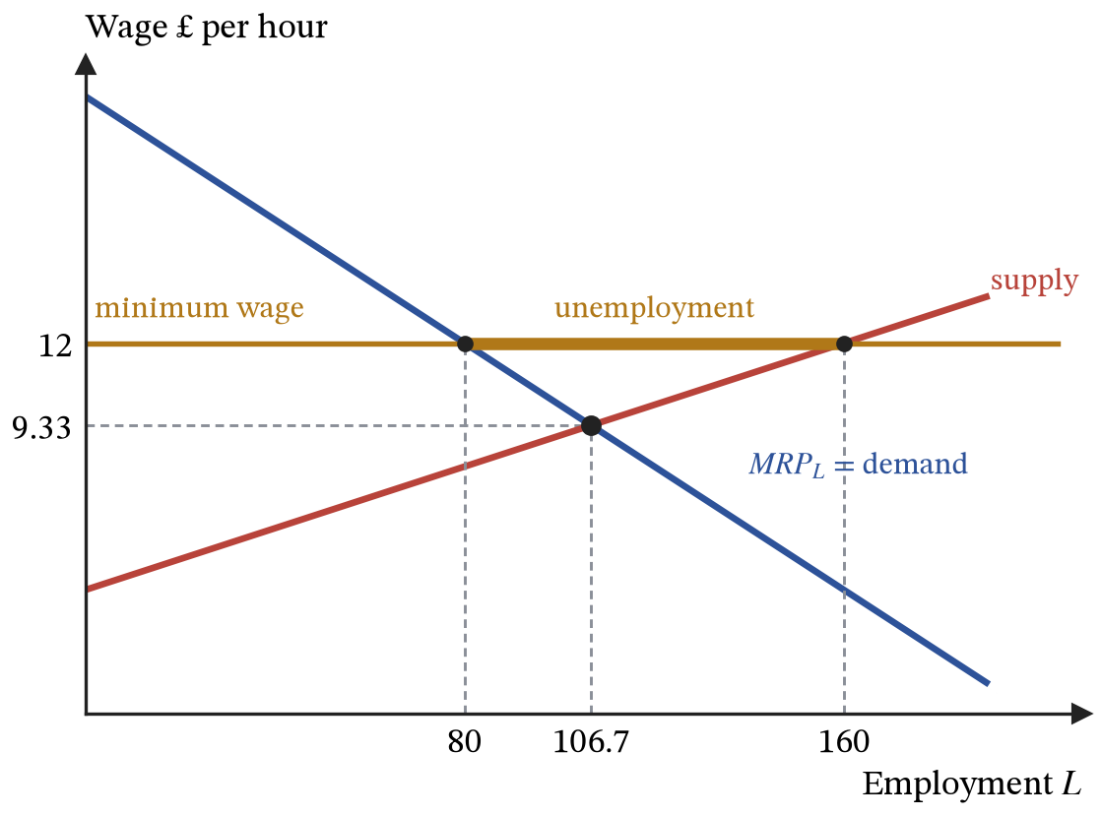
Figure 21. A competitive labour market. The wage settles where the marginal revenue product curve meets labour supply; a minimum wage above that level reduces employment and creates unemployment.
That prediction depends on the employer being a wage taker. A monopsonist, the only significant employer in a town, faces the whole upward-sloping supply curve, so hiring one more worker means raising the wage for everyone already employed. Suppose labour supply is $w=4+0.05L$ (pounds per hour) and $MRP_{L}=20−0.1L$. The wage bill is $wL=4L+0.05L^{2}$, so
$$MCL=\frac{d(wL)}{dL}=4+0.1L (41)$$
This is section 6’s marginal revenue argument run on the buying side: the extra worker costs their own wage plus the rise paid to everyone else. Setting $MRP_{L}=MCL$ gives $20−0.1L=4+0.1L$, so the monopsonist employs 80 workers and pays only what the supply curve requires for 80, $w=4+0.05×80=£8$. A competitive market would have set $MRP_{L}$ equal to the supply price: $20−0.1L=4+0.05L$, giving 106.7 workers at £9.33. The monopsonist hires fewer people and pays them less.
A minimum wage now has the opposite effect to the competitive case. At a legal floor of £9.33, the employer can hire anyone willing to work at that wage without raising pay for the others, so its marginal cost of labour is flat at £9.33 up to the supply curve, and it hires 106.7 workers: employment and pay both rise. Any floor between £8 and £12, the marginal revenue product at the monopsony employment of 80, leaves employment at least as high as without it. This is why the evidence that moderate minimum wages have reduced employment little is not a puzzle: much low-wage employment is in markets where employers have some power over pay.
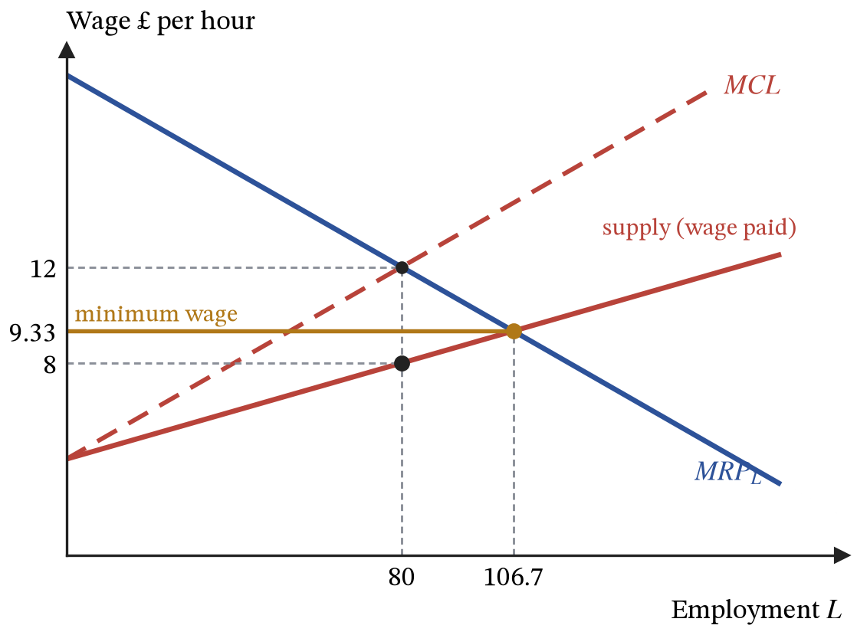
Figure 22. Monopsony. The employer sets $MRP_{L}=MCL$, hires 80 workers and pays the supply price of £8. A minimum wage of £9.33 makes the marginal cost of labour flat and raises employment to the competitive level.
ASSUMPTIONS.
Workers are paid their marginal revenue product only where the employer takes the wage as given and can measure what each worker adds.
Trade unions are a monopoly on the selling side of the labour market. Facing a monopsonist, a union can raise both pay and employment by the same mechanism as the minimum wage; facing competitive employers, it raises pay at the cost of jobs.
The figures in the monopsony example are illustrative. The range over which a minimum wage raises employment depends on how much power employers really have.

16. Market failure
DEFINITIONS.
Market failure: an allocation in which the market quantity differs from the quantity that would maximise social surplus.
Externality: a cost or benefit falling on someone who is not party to the transaction.
Marginal social cost and marginal social benefit: the private figure plus the external one.
Public good: a good that is non-rival and non-excludable, so no market forms at all.
Rival: one person’s consumption reduces what is left for others; excludable: people who do not pay can be prevented from consuming.
Club good: excludable but non-rival; common good: rival but non-excludable.
Merit good: one under-consumed because buyers underestimate its private benefit; a demerit good is the reverse.
Asymmetric information: one side of a transaction knowing more than the other.
Government failure: intervention that leaves the allocation worse than it found it.
Section 12 measured efficiency using private benefit and cost. Market failure is what happens when private and social values diverge, so that even a perfectly competitive market reaches the wrong quantity. Write the social magnitudes as the private ones plus whatever spills over onto third parties:
$$MSC=MPC+MEC, MSB=MPB+MEB (42)$$
Marginal social cost $MSC$ is the full cost to society of one more unit, marginal private cost $MPC$ is the part that lands on the producer, and marginal external cost $MEC$ is the spillover onto people with no part in the transaction. Marginal external benefit $MEB$ measures the same thing for benefits. When the external terms are zero the social and private curves coincide, which is the case section 12 quietly assumed.
The market equates $MPB$ and $MPC$; efficiency requires $MSB=MSC$. A factory whose production imposes an external cost, say emissions, has $MEC>0$, so $MSC$ lies above $MPC$ and the efficient quantity $Q^{*}$ is below the market quantity $Q_{mkt}$. The value lost is the accumulated excess of social cost over social benefit on the units that should not have been produced, the construction of (35) run over the range where benefit and cost have swapped places:
$$\text{welfare loss}=\int_{Q^{*}}^{Q_{mkt}}{\left[MSC(q)−MSB(q)\right]}dq (43)$$
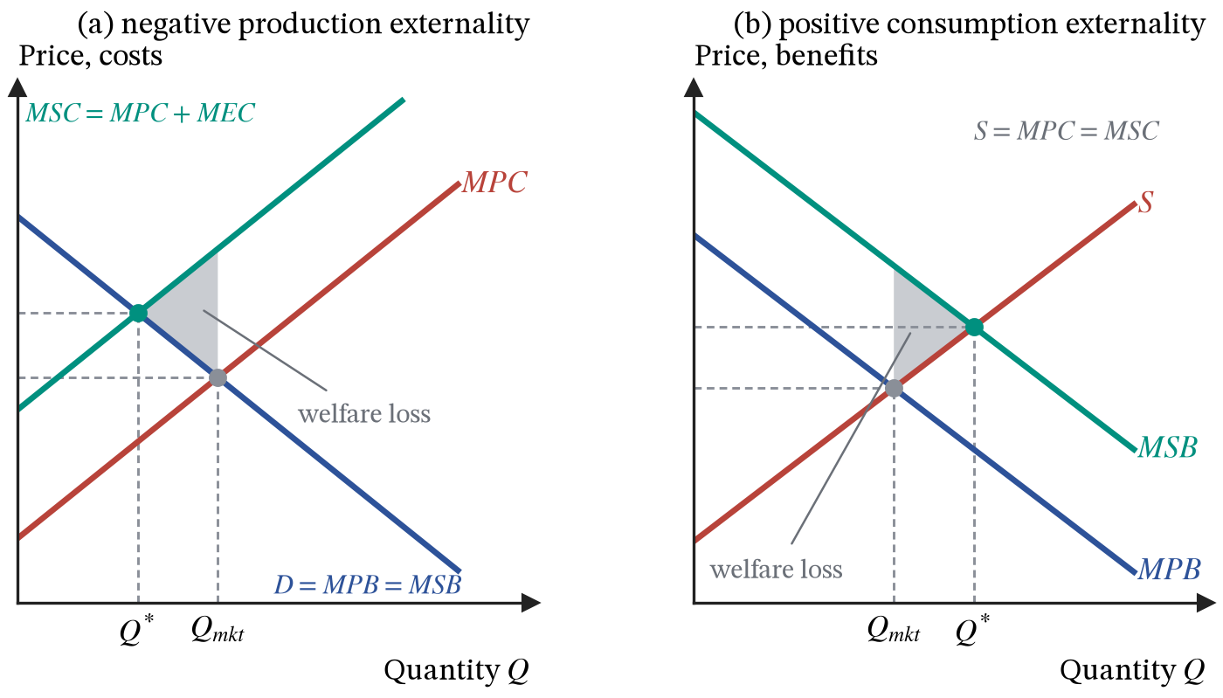
Figure 23. A negative production externality and a positive consumption externality. In both cases the market quantity $Q_{mkt}$ differs from the socially efficient quantity $Q^{*}$.
A Pigouvian tax set at $t^{*}=MEC\left(Q^{*}\right)$ raises the firm’s private marginal cost until it coincides with social marginal cost at the efficient quantity, so the profit-maximising choice and the efficient choice become the same. Carbon pricing applies the idea. Its practical difficulty is measurement: $MEC$ for a tonne of carbon is contested, and a tax set at the wrong level moves the quantity in the right direction by the wrong amount. Tradable permits fix the quantity instead and let the price emerge, which is the better instrument when hitting a quantity target matters more than the cost of doing so.
Education and vaccination generate benefits to people other than the buyer, so $MSB$ exceeds $MPB$, the market under-consumes, and a subsidy or direct provision closes the gap.
A good that is non-rival (my consumption does not reduce yours) and non-excludable (I cannot prevent you consuming it) cannot be sold, because everyone’s best response is to wait for someone else to pay: the free-rider problem. National defence and flood barriers are not under-provided by the market but not provided at all; the market is missing rather than merely inefficient.
Rivalry and excludability are separate properties, and crossing them gives four kinds of good. Only the private good, rival and excludable, is one that a competitive market handles without help, because only there does the buyer both bear the full cost of consuming and get the full benefit. A common good, such as an ocean fish stock, is rival but non-excludable: every boat’s catch leaves fewer fish for the others and nobody can be kept out, so each fisher ignores the cost their catch imposes on the rest and the stock is overused. That is the tragedy of the commons, a negative externality of the kind in Figure 23(a), and the remedies are quotas, licences or ownership rights that make the resource excludable. A club good, such as a streaming service, is excludable but non-rival: the firm can charge for access, so the market supplies it, but an extra viewer costs nothing to serve, so any positive price turns away people whose viewing would have cost society nothing.
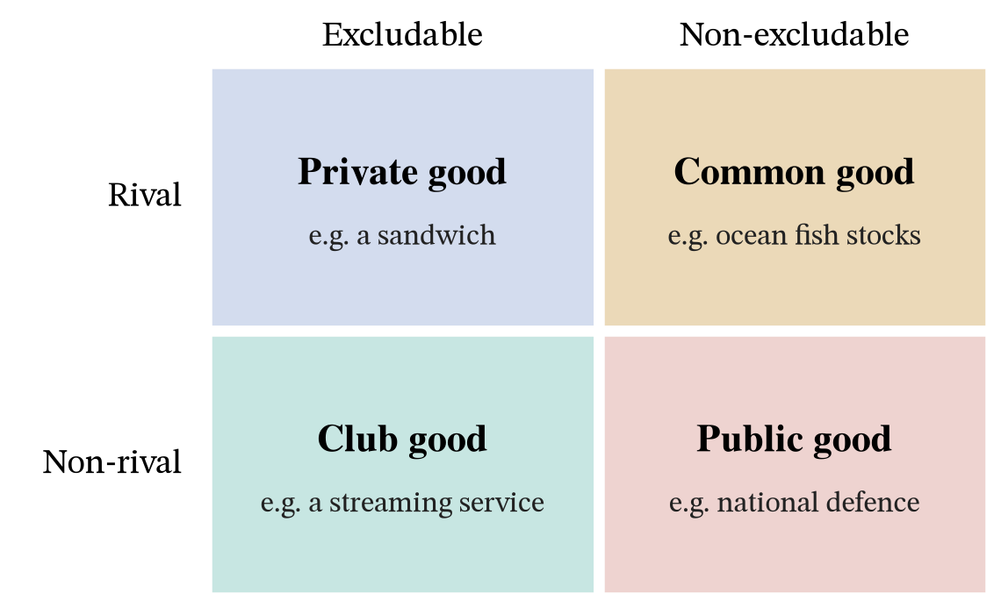
Figure 24. Four kinds of good, classified by whether consumption is rival and whether non-payers can be excluded.
Information failures arise when one side knows more than the other. Adverse selection can shrink or destroy a market: insurers who cannot tell risky from safe customers must charge an average premium, which drives the safe customers out and raises the average again. Moral hazard is the related problem of behaviour changing once insured. Merit goods are under-consumed because buyers underestimate the private benefit, and demerit goods over-consumed for the same reason in reverse; section 2 supplies several of the reasons.
Failure | What goes wrong | Market outcome | Standard remedy
Negative externality | $MSC>MPC$​ | over-production | tax set at $MEC$, tradable permits
Positive externality | $MSB>MPB$​ | under-consumption | subsidy, or direct provision
Public good | non-rival and non-excludable | no market forms at all | provision funded from taxation
Information failure | one side knows more than the other | adverse selection, moral hazard | disclosure rules, regulation, compulsion
Identifying a market failure is a diagnosis, not by itself a case for intervention. Governments face the same information problem they are trying to fix, respond to political incentives, and create their own distortions, as section 17 shows for price controls. Government failure is the relevant comparison, and the right question is never “is the market perfect” but “which imperfect arrangement is better here”.
ASSUMPTIONS.
External costs and benefits can be measured in pounds and added to private ones.
The remedies assume the government knows the size of the externality and can enforce the tax, subsidy or permit scheme at reasonable cost.

17. Government intervention in markets
DEFINITIONS.
Specific tax: a tax of a fixed amount per unit sold, which moves supply up by exactly that amount.
Ad valorem tax: a tax set as a percentage of the price, such as VAT.
Tax incidence: how the burden divides between buyers and sellers, decided by relative elasticities rather than by who hands the money over.
Subsidy: a payment per unit to producers, which moves supply down by exactly that amount.
Maximum price: a legal ceiling, which creates excess demand if it binds.
Minimum price: a legal floor, which creates excess supply if it binds.
A specific tax of $t$ per unit changes nothing about what buyers want and everything about what sellers receive. Firms respond to the price they keep, $P−t$, so supply becomes
$$Q_{S}=μ+λ(P−t) (44)$$
A seller handing £$t$ of every sale to the government decides how much to make on the basis of the amount left over. On the diagram this moves the supply curve up by exactly £$t$: to part with any given quantity, firms now need the old price plus the tax.
Two prices now have to be distinguished: $P_{D}$, the price on the demand curve that buyers pay at the till, and $P_{S}=P_{D}−t$, the price on the supply curve that sellers keep. Running the equilibrium calculation of (29) again with the taxed supply curve:
$$α−βP_{D}+γY=μ+λ(P_{D}−t) ⇒ P_{D}=\frac{α−μ+γY+λt}{β+λ} (45)$$
Comparing (45) with (29), the only change is the extra $λt$ on the top, so the price buyers pay has risen, but by less than the whole tax. Differentiating both prices with respect to the tax:
$$\frac{dP_{D}}{dt}=\frac{λ}{β+λ}, \frac{dP_{S}}{dt}=\frac{d}{dt}\left(P_{D}−t\right)=\frac{λ}{β+λ}−1=−\frac{β}{β+λ} (46)$$
For each £1 of tax, the price buyers pay rises by $λ/(β+λ)$ of a pound and the price sellers keep falls by $β/(β+λ)$ of a pound. The two shares sum to one and both lie strictly between zero and one. The side of the market that responds less to price bears more of the tax, because it has fewer alternatives to escape into. Whether the government collects the money from the seller or the buyer never enters the algebra, which is why the legal point of collection does not determine who actually pays.
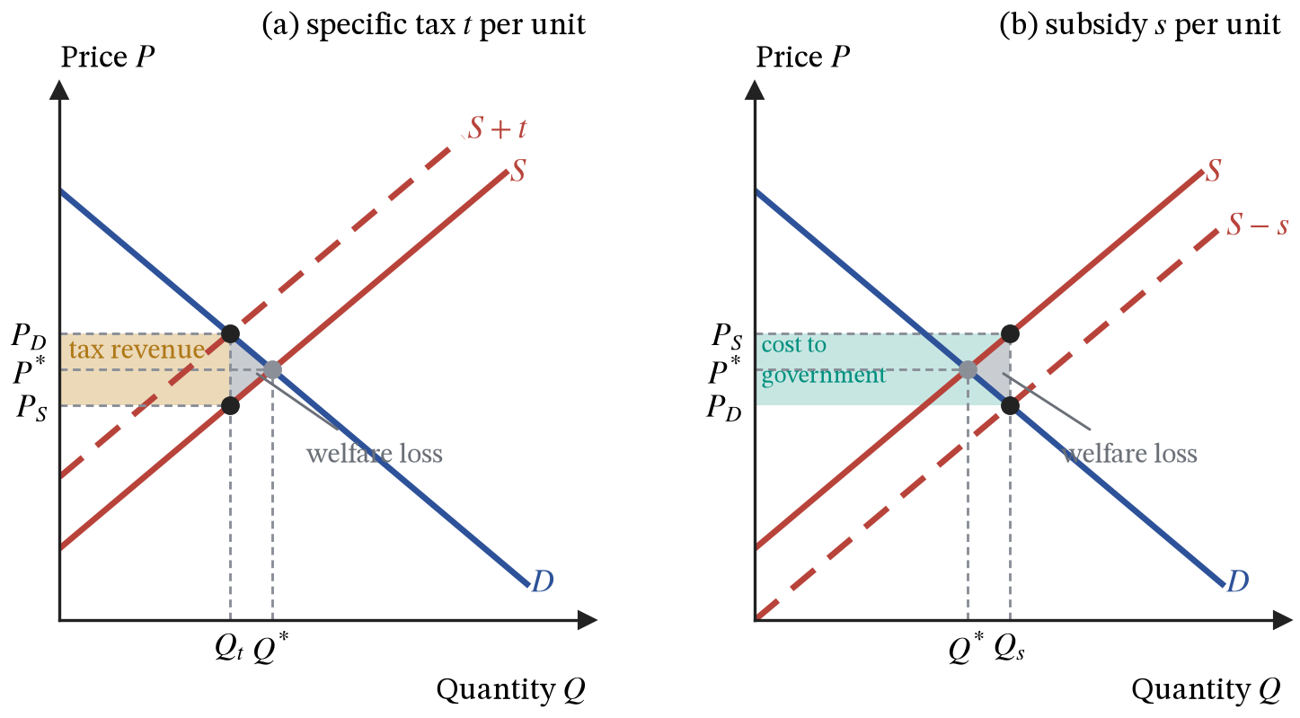
Figure 25. A specific tax drives a vertical wedge $t$ between the price buyers pay, $P_{D}$, and the price sellers keep, $P_{S}$. A subsidy drives the same wedge the other way, and both create a welfare loss.
Tax revenue is $t×Q_{t}$, the shaded rectangle. The grey triangle is the welfare loss: units that were worth more to buyers than they cost to make, and which now do not get made. Its size grows with the elasticities, because elastic curves mean the tax destroys more transactions.
Demand for petrol is inelastic, so $β$ is small, $λ/(β+λ)$ is close to one, and motorists bear nearly the whole duty. Quantity barely falls, so revenue is large and predictable, which is why governments like the tax. The same fact makes fuel duty a weak instrument if the goal is to cut consumption rather than raise money.
A subsidy of $s$ per unit is a tax of $−s$. It moves supply down by $s$, lowers the price buyers pay, raises the price sellers receive, splits its benefit between them by the same elasticity rule, and costs the government $s×Q_{s}$. It also creates a welfare loss, unless it is correcting a positive externality: the extra units between $Q^{*}$ and $Q_{s}$ cost more to make than buyers value them at, and the triangle between the supply and demand curves over that range measures the waste. The cost to the government is larger than the combined gain to buyers and sellers by exactly that triangle.
A price control does not shift a curve; it forbids the market from reaching $P^{*}$. The size of the resulting disequilibrium follows from (25) and (28) directly. Since $Q_{D}=Q_{S}$ at $P^{*}$,
$$Q_{D}−Q_{S}=(α−μ+γY)−(β+λ)P=(β+λ)\left(P^{*}−P\right) (47)$$
The gap between what buyers want and what sellers offer at any price is the distance of that price from equilibrium multiplied by the combined responsiveness of the two sides. A maximum price below $P^{*}$ creates a shortage proportional to how far below it sits; a minimum price above $P^{*}$ creates a surplus by the same formula with the sign reversed. The minimum wage of section 15 is the labour-market case.
Either way, the quantity actually traded is the smaller of the two, since nobody can be made to buy or sell more than they want. Under a maximum price only $Q_{S}$ is sold. The buyers who get the good gain the price cut on every unit they buy, a transfer from sellers; the units between $Q_{S}$ and the equilibrium quantity $Q^{*}$ are not traded at all, and the triangle on them is the welfare loss.
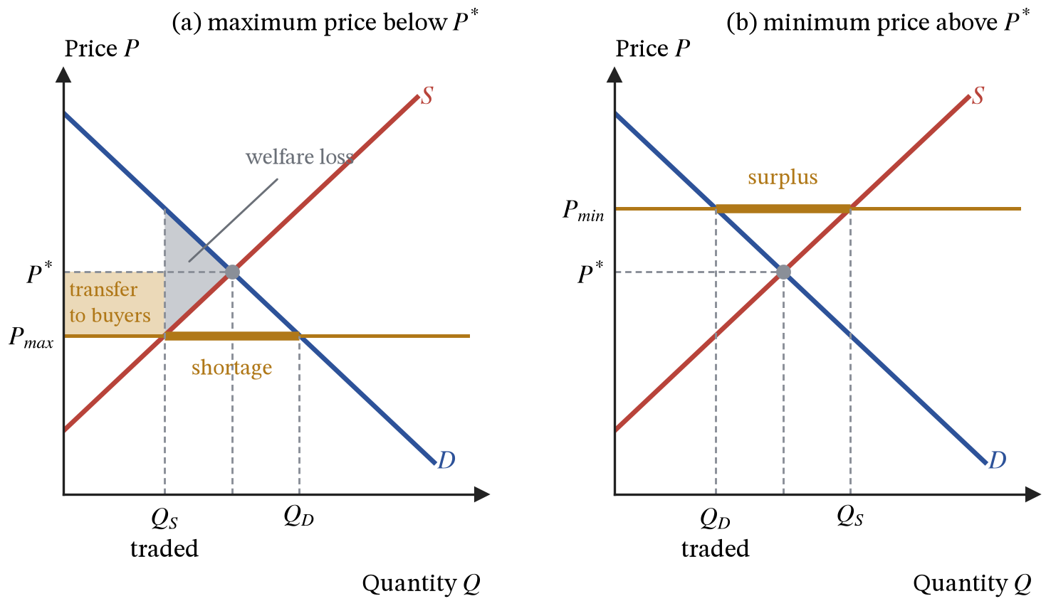
Figure 26. Price controls. The quantity traded is the short side of the market. Under a maximum price, buyers who are served gain a transfer from sellers, and the triangle is the welfare loss on units no longer traded.
A binding maximum price stops the price doing the rationing without stopping the excess demand, so something else rations instead: queues, waiting lists, allocation by landlord preference, or a black market in which the effective price exceeds $P^{*}$. Rent controls transfer income to whoever already holds a tenancy and reduce the incentive to supply new housing, so their long-run effect is usually worse than their short-run effect: supply is more elastic in the long run, so by (47) the shortage grows.
ASSUMPTIONS.
The tax and subsidy analysis assumes competitive markets with given demand and supply curves, and no externality; with an externality present, section 16 shows a tax or subsidy can raise welfare rather than lower it.
Under a maximum price, the welfare triangle assumes the scarce units go to the buyers who value them most. If they are allocated by queue or by chance, the loss is larger.

Part III. Economies

18. Scarcity, choice and opportunity cost
DEFINITIONS.
Scarcity: the gap between unlimited wants and limited resources, which is what forces choice.
Opportunity cost: the value of the best alternative given up, met at firm level in section 7 and applied here to the whole economy.
Production possibility frontier: the boundary of the combinations of two goods an economy can produce with its current resources and technology.
Economic growth: an outward shift of that frontier. Points inside it are attainable but inefficient, and points outside it are unattainable this year.
Wants are effectively unlimited; the resources available in any period are not, and the gap between the two forces every choice to carry an opportunity cost.
Put the whole economy’s choice in two goods, $x$ (consumer goods) and $y$ (capital goods). Resources and technology fix which combinations are feasible. The boundary of the feasible set is the production possibility frontier, written $y=f(x)$, and the opportunity cost of one more unit of $x$ is the gradient:
$$\text{opportunity cost of one more }x=−\frac{dy}{dx} (48)$$
The cost of one extra unit of consumer goods is the quantity of capital goods given up to release the resources for it, which is the steepness of the frontier at the current point; the minus sign makes the cost come out positive, since the frontier slopes downward.
If every resource were equally good at making both goods, the frontier would be a straight line and opportunity cost would be constant. Resources are not equally good at both, so transferring the workers and machines best suited to $y$ into $x$ costs progressively more $y$ per extra $x$. That rising sacrifice is what makes the frontier bow outwards.
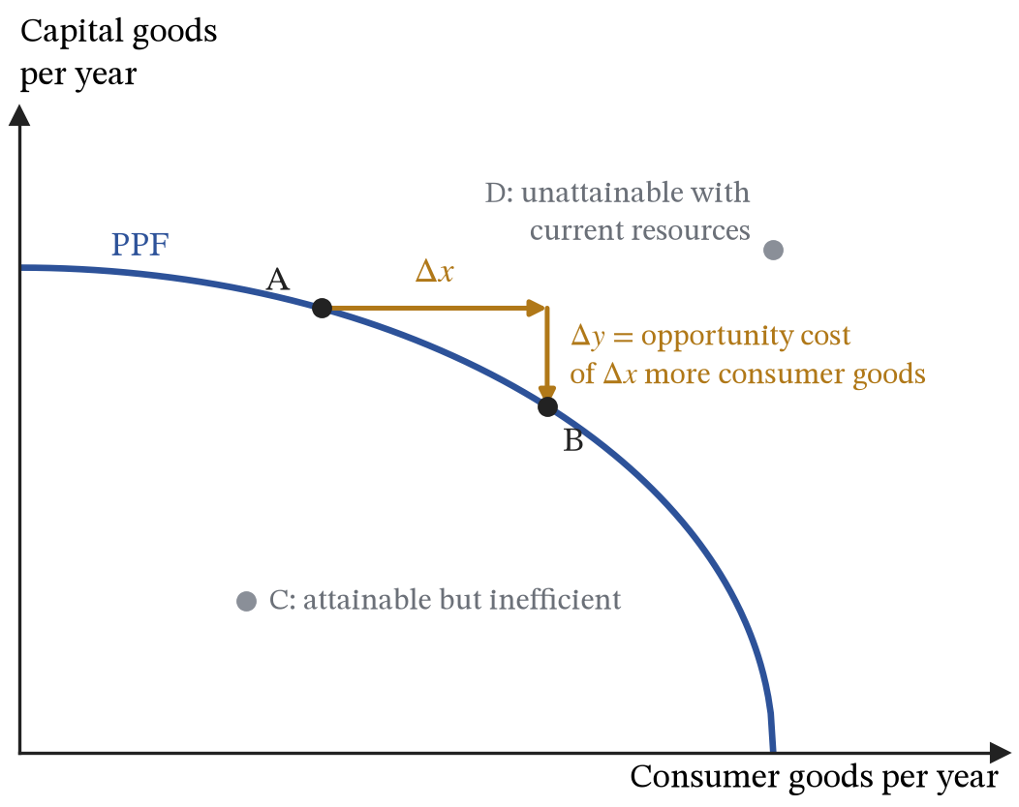
Figure 27. The production possibility frontier. The gradient at any point is the opportunity cost of consumer goods, measured in capital goods.
A point inside the frontier means resources are unemployed or badly allocated, so more of both goods is possible. A point outside is unattainable this year. Economic growth moves the frontier outwards, which is why the choice between $x$ and $y$ matters beyond this year: capital goods are the inputs that shift the frontier for next year, and consumer goods are not.
ASSUMPTIONS.
Fixed quantity and quality of resources.
Fixed technology.
Two goods.
All resources fully and efficiently used on the frontier itself.

19. National income and the circular flow
DEFINITIONS.
Gross domestic product: the value of everything produced in an economy in a period, measurable by output, by income or by expenditure.
Nominal GDP is valued at current prices and real GDP at the prices of a base year, so only real GDP measures output.
GDP deflator: nominal GDP divided by real GDP, times 100, an index of the price level.
Purchasing power parity (PPP): an exchange rate at which the same basket of goods costs the same in both countries.
Accounting identity: a statement true by the definition of its terms, which therefore predicts nothing and cannot be tested.
Gross national income: the income earned by a country’s residents, which is GDP plus income received from assets abroad minus income paid to foreign owners of domestic assets.
Consumption: household spending on goods and services.
Investment: spending on new capital goods, such as machinery, buildings and equipment, together with additions to firms’ stocks of goods.
Transfer payment: a payment by the government for which no good or service is received in return, such as a pension or unemployment benefit; transfers are not part of government spending $G$.
Withdrawals: saving, taxes net of transfers, and imports.
Injections: investment, government spending on goods and services, and exports.
Everything produced in an economy is bought by a household, a firm, the government or a foreigner, so total output equals total expenditure on it:
$$Y≡C+I+G+(X−M) (49)$$
$Y$ is national output, also called national income; $C$ is household consumption; $I$ is investment, meaning purchases of new capital goods rather than anyone buying shares; $G$ is government spending on goods and services; $X$ is exports, what foreigners buy from us; and $M$ is imports, what we buy from abroad. The three-bar sign marks (49) as an accounting identity: it holds in every year, in every economy, under every policy, and it could not be false, so it predicts nothing. Imports are subtracted not because imports are bad but because $C$, $I$ and $G$ already include spending on foreign goods, which is not domestic output. $G$ excludes pensions and benefits, because paying them buys nothing: they move income from taxpayers to recipients, who then spend it as part of $C$.
The same total can be counted three ways, which is why GDP has an output measure, an income measure and an expenditure measure that agree by construction. The circular flow makes this visible: households supply factors and receive incomes, firms supply goods and receive spending, and the same money goes round. Not all income returns directly. Drawn in full, the economy has five sectors: households and firms form the core loop, and the financial sector, the government and the rest of the world each take money out of it and put money back in. National income is unchanging when
$$S+T+M=I+G+X (50)$$
Money leaves the circular flow when households save it ($S$), when the government takes it in tax ($T$), or when it is spent abroad ($M$), and money enters when firms invest ($I$), the government buys goods and services ($G$), or foreigners buy exports ($X$). While the two totals match, the flow of income is neither filling up nor draining. $T$ is taxes net of transfers and subsidies: a benefit paid to a household or a subsidy paid to a firm returns money the tax system took out, so it reduces the withdrawal rather than counting as an injection.
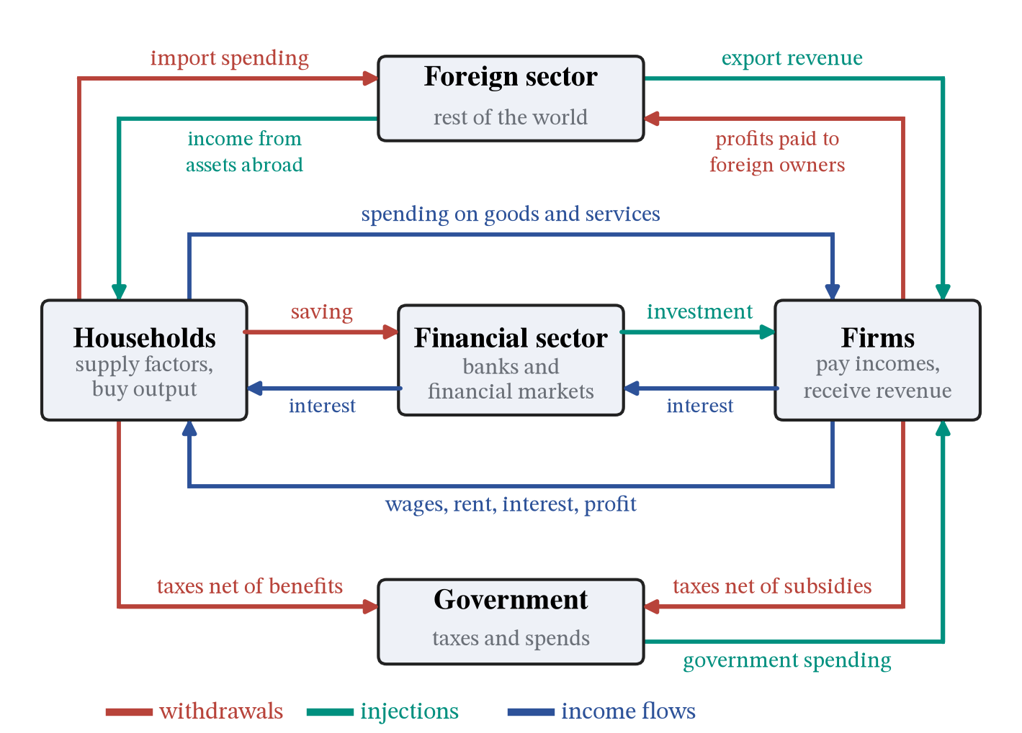
Figure 28. The five-sector circular flow, monetary flows only. Blue is the flow of income between households and firms, red marks money withdrawn from it and green marks money injected back. Taxes are drawn net of benefits and subsidies. The rest of the world connects through trade, on the outside, and through the income earned on cross-border ownership, on the inside. The matching real flows of goods, services and factors are not drawn.
The rest of the world connects to the flow through trade, with import spending leaving and export revenue arriving. It also connects through ownership. When a UK household buys shares in a foreign company, or a foreign firm buys a factory in the UK, that purchase is an exchange of one asset for another and is not income, so it does not appear in a circular flow of income. What does appear is the income the ownership goes on to generate. UK residents who own assets abroad receive dividends and interest from the rest of the world, so overseas investment income flows in to households. Foreign owners of UK firms receive the profits those firms make, so those profits flow out of firms and offshore. Both are recorded in the primary income part of the current account, which section 29 takes up, and they are why gross national income, what a country’s residents earn, can differ from gross domestic product, what is produced within its borders. Strictly, they add one more injection and one more withdrawal to (50). The A-level version leaves them out, which is harmless for most economies but misleading for one with heavy foreign ownership, where a large share of the profits generated at home is paid abroad.
Nominal GDP can rise because more is produced or because prices rose. Dividing by the GDP deflator removes the second, and for growth rates the correction is approximately a subtraction:
$$\text{real GDP}=\frac{\text{nominal GDP}}{\text{deflator}/100}, g_{real}≈g_{nominal}−\text{inflation} (51)$$
If nominal GDP rises by 6 per cent while the deflator rises by 4 per cent, real output has grown by about 2 per cent (exactly $1.06/1.04−1=1.9$ per cent).
GDP per capita adjusts for population, which is the minimum correction before comparing countries, and comparing them also needs a common currency. Market exchange rates are set mainly by traded goods and capital flows, and in poorer countries non-traded services such as haircuts and rents are much cheaper, so converting at market rates understates what incomes buy. If a basket costing £100 in the UK costs ₹4,000 in India, the PPP rate is ₹40 per pound; at a market rate of ₹105 per pound, Indian incomes converted at market rates would look about 2.6 times poorer than they are in terms of what they buy. International comparisons of living standards therefore use GDP per capita at PPP.
GDP is a measure of production, not of welfare. It omits unpaid household work and the informal economy, says nothing about distribution, counts the cleanup of a disaster as output, and ignores environmental depletion. Section 32 returns to broader measures.
ASSUMPTIONS.
The identity itself assumes nothing, which is both its strength and its limit.
The circular flow is simplified: each flow is one arrow between two sectors, when in reality every sector trades with every other, so the diagram shows the direction money moves rather than the full pattern of transactions. It draws the income that cross-border ownership produces but not the purchases of assets that created the ownership, because those are exchanges of wealth rather than flows of income.
Using GDP as a measure of welfare assumes market output is what matters.

20. Aggregate demand and the multiplier
DEFINITIONS.
Aggregate demand: total planned expenditure on domestic output at each price level.
Marginal propensity to consume: the fraction of each extra pound of disposable income that is spent.
Marginal propensities to save, to tax and to import (MPS, MPT, MPM): the fractions of each extra pound of national income that are saved, taken in tax and spent on imports; their sum is the marginal propensity to withdraw (MPW).
Autonomous expenditure: the part of planned spending that does not depend on income.
Multiplier: the number of pounds national income rises by for each extra pound of autonomous expenditure.
Accelerator: the relationship between investment and the change in output.
The simplest behavioural assumptions to add to the identity are:
$$C=C_{0}+cY_{d}, Y_{d}=(1−τ)Y, M=mY, I, G, X \text{taken as given} (52)$$
Households spend a fixed fraction $c$ of their take-home income plus an amount $C_{0}$ they would spend regardless; $c$ is the marginal propensity to consume, with $0<c<1$. Take-home income $Y_{d}$ is national income less the share $τ$ (the Greek letter tau) taken in tax, a rate between zero and one. Spending on imports is a fixed fraction $m$ of income, the marginal propensity to import. Investment, government spending and exports are treated as set outside the model, which is a strong assumption.
Substituting these into the identity (49), writing $A=C_{0}+I+G+X$ for the part of expenditure that does not depend on income, and collecting the terms in $Y$:
$$Y=A+\left[c(1−τ)−m\right]Y ⇒ Y^{*}=\frac{A}{1−c(1−τ)+m} (53)$$
$Y^{*}$ is the level of national income at which planned spending equals output. Figure 29 draws it: planned expenditure rises with income along a line of slope $c(1−τ)−m$, and equilibrium is where that line crosses the 45-degree line on which spending equals output. Below $Y^{*}$ planned spending exceeds output, stocks run down and firms expand; above it the reverse. The response of the equilibrium to a change in autonomous spending is
$$k=\frac{dY^{*}}{dA}=\frac{1}{1−c(1−τ)+m} (54)$$
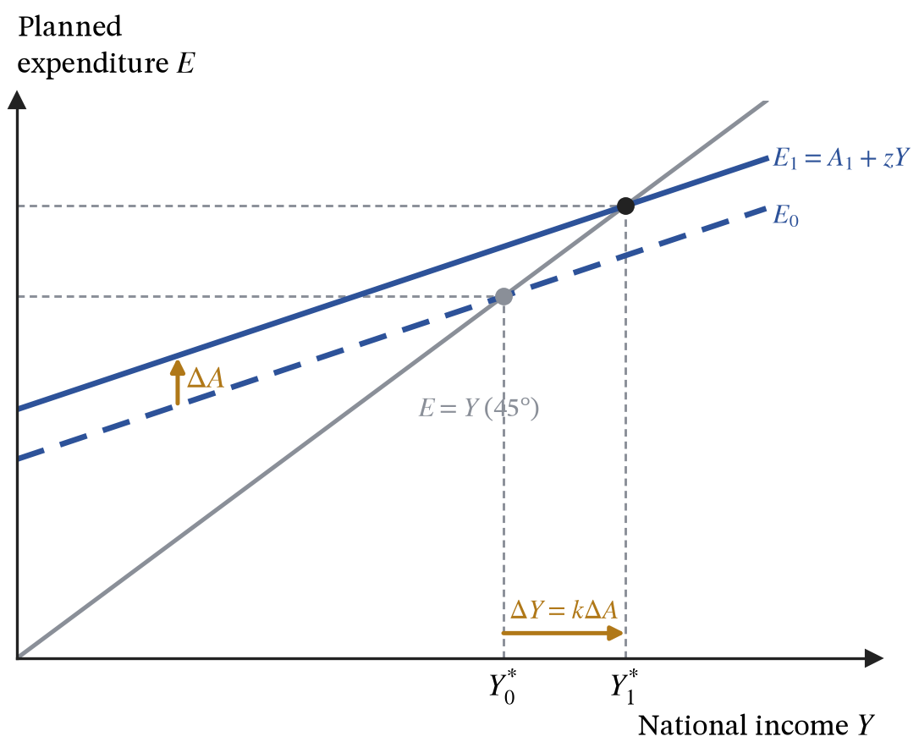
Figure 29. The Keynesian cross. Equilibrium income is where planned expenditure meets the 45-degree line. A rise in autonomous spending of $ΔA$ raises income by $kΔA$, more than the original injection.
The denominator is the fraction of each extra pound of national income that leaks out of the circular flow. Splitting it shows where the leaks go:
$$1−c(1−τ)+m=\underset{\text{MPS}}{\underset{⏟}{(1−c)(1−τ)}}+\underset{\text{MPT}}{\underset{⏟}{τ}}+\underset{\text{MPM}}{\underset{⏟}{m}} (55)$$
Of each extra pound of national income, $τ$ is taxed, a fraction $1−c$ of the remaining $1−τ$ is saved, and $m$ is spent abroad. So (54) is the familiar $k=1/(MPS+MPT+MPM)=1/MPW$: the multiplier is the reciprocal of the withdrawal rate.
Suppose $G$ rises by £1bn on a railway. That pound is income to construction firms and their workers. They pay tax on it, save some, and spend some on imports; what remains, $z=c(1−τ)−m$ per pound, is spent on domestic goods and becomes somebody else’s income, who repeats the process on a smaller sum. The rounds of spending are $1,z,z^{2},z^{3},…$, so the total income created by £1 of injection is the geometric series $1+z+z^{2}+⋯=1/(1−z)$, which is (54), and which converges because $0<z<1$. With $c=0.8$, $τ=0.25$ and $m=0.15$, the withdrawal rate is $0.15+0.25+0.15=0.55$ and the multiplier is $1/0.55=1.82$, so £1bn of spending eventually raises income by about £1.8bn.
Aggregate demand is the same total expenditure viewed as a function of the price level. A rise in the price level is not a fall in any good’s relative price: if every price rose together nothing would become cheaper than anything else, so the substitution argument of sections 1 and 8 cannot be borrowed. Three other mechanisms make autonomous spending depend on the price level. A lower price level raises the real value of money-denominated wealth, so consumption rises. It reduces the money needed for transactions, which puts downward pressure on interest rates, so investment and durable consumption rise. And it makes domestic goods more competitive against foreign ones at a given nominal exchange rate, so net exports rise. Writing autonomous spending as $A(P)$ with $A^{′}(P)<0$, equation (53) becomes the aggregate demand curve:
$$Y=kA(P) ⇒ \frac{dY}{dP}=kA^{′}(P)<0 (56)$$
AD slopes downward because each of the three channels lowers autonomous spending as the price level rises, and the multiplier amplifies each pound of that fall. A larger multiplier therefore makes AD flatter: the same rise in prices removes more output.
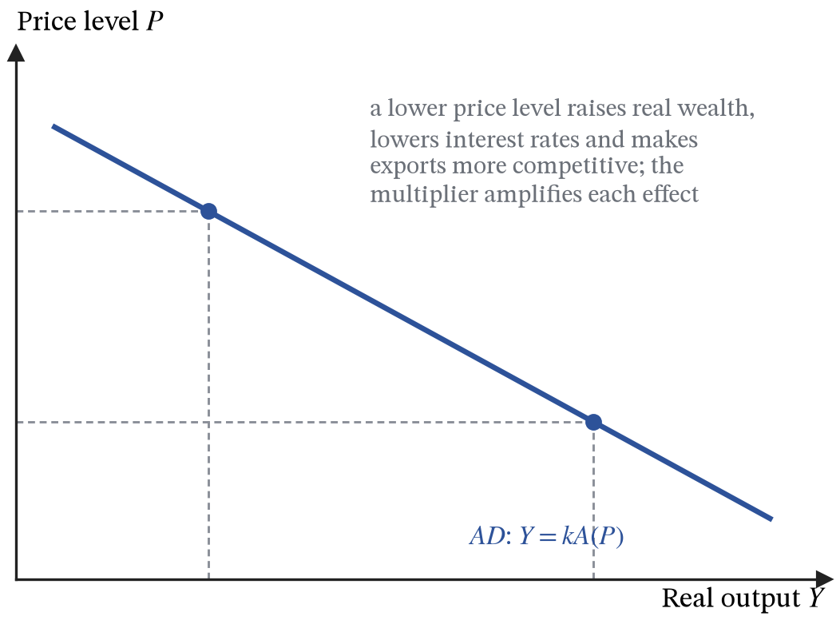
Figure 30. Aggregate demand, $Y=kA(P)$. A lower price level raises autonomous spending through real wealth, interest rates and net exports, and the multiplier amplifies the effect.
A shift of AD is any change in $C$, $I$, $G$ or $X−M$ not caused by the price level: consumer confidence, interest-rate decisions, fiscal policy, world income, the exchange rate. At any given price level, a rise in autonomous spending of $ΔA$ raises the output demanded by $kΔA$, so AD moves right by the multiplier times the change in autonomous spending; seen vertically, the same move is an upward shift, and section 23 calls it demand-pull. This is the one curve whose shift is easier to measure sideways than vertically.
Investment is the most volatile component of demand, and the accelerator is part of the reason. If firms want a capital stock proportional to output, investment depends on the change in output rather than its level. When output growth merely slows, the capital stock needed grows more slowly, so investment falls in absolute terms even though output is still rising. Investment therefore swings more than output and amplifies the cycle.
ASSUMPTIONS.
The multiplier in (54) assumes output can actually expand, that is, spare capacity and idle labour. With the economy already at capacity the extra demand cannot raise real output and raises prices instead, and the real multiplier collapses towards zero. Section 22 makes that explicit.
The propensities $c$, $τ$ and $m$ are assumed constant. In a recession, when households want to rebuild savings, $c$ can fall just as government spending rises.

21. Aggregate supply
DEFINITIONS.
Short-run aggregate supply: the relationship between the price level and output while money wages and other input prices are fixed.
Long-run aggregate supply: the output the economy can sustain once every price and wage has adjusted, which depends on factors and productivity and not on the price level at all.
Full employment output: the level of output consistent with stable inflation, which is where long-run aggregate supply sits.
Real wage: the money wage divided by the price level, $w/P$, which measures what a wage buys.
Short-run aggregate supply comes straight from section 4. A price-taking firm produces where $P=MC$, and (13) showed that $MC=w/MP_{L}$, where $w$ is the money wage. Across the whole economy, with the capital stock fixed in the short run,
$$P=\frac{w}{MP_{L}(L)}, Y=F(K_{0},L) (57)$$
Hold the money wage fixed, as it is in the short run by contract, by convention, or because expectations have not yet caught up. To produce more output firms must employ more labour; diminishing returns lower the marginal product of that labour; and with $w$ unchanged, a lower $MP_{L}$ means a higher marginal cost, which firms will cover only at a higher price. $SRAS$ slopes upward because of diminishing returns at a fixed money wage, the same mechanism that made the firm’s marginal cost curve slope upward, now summed across firms.
Long-run aggregate supply removes the fixed money wage. Rearranged, (57) says $w/P=MP_{L}(L)$: firms employ labour until the real wage equals its marginal product, which is the labour demand condition of section 15. Workers, for their part, decide how much to work by what a wage buys, so labour supply also depends on $w/P$. If the price level doubles and money wages double with it, the real wage is unchanged, so neither firms’ demand for labour nor workers’ supply of it has changed, and employment and output return to where they were. Long-run output is set where real labour demand meets real labour supply, given the capital stock and technology. None of that depends on the price level, so $LRAS$ is vertical at the full-employment level $Y_{FE}$.
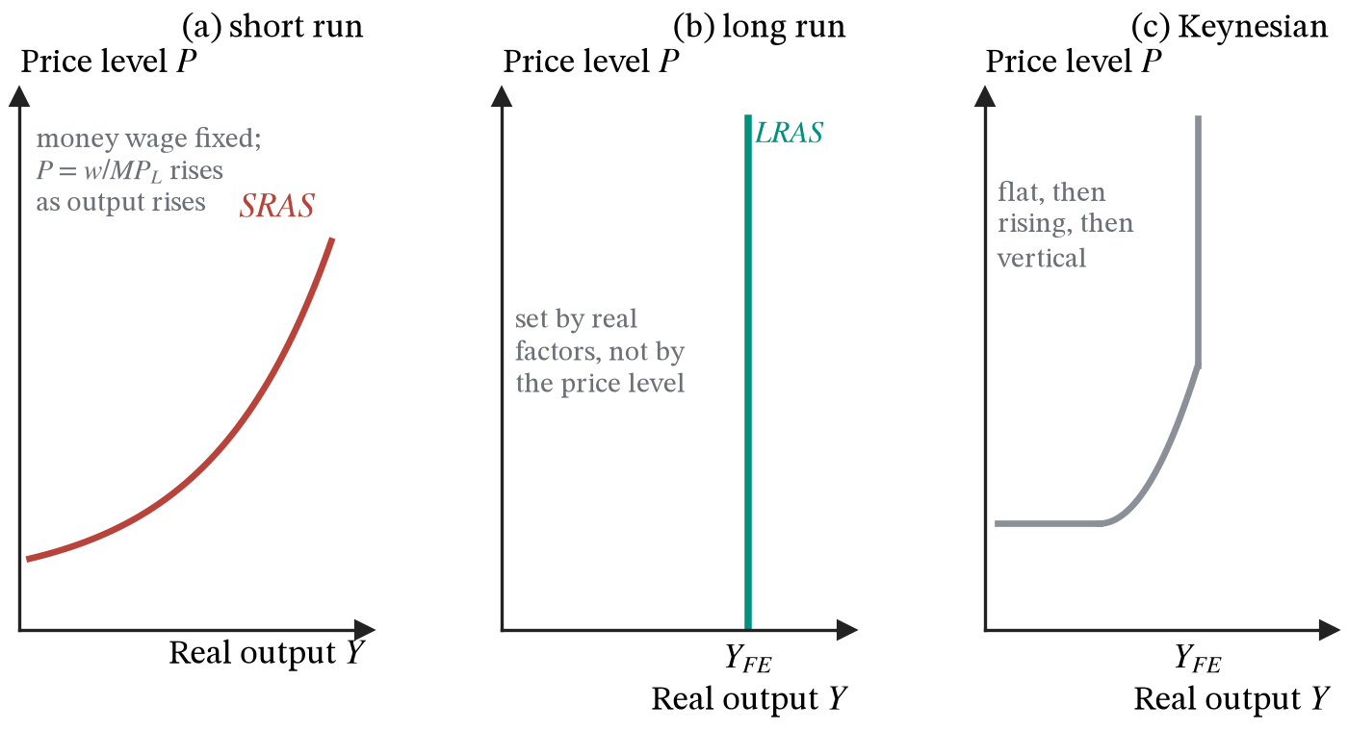
Figure 31. Short-run aggregate supply, long-run aggregate supply, and the Keynesian version shown separately for comparison.
$LRAS$ shifts only when the productive capacity of the economy changes: the size and skills of the labour force, the capital stock, technology, and the institutions and incentives that determine how well resources are allocated. This is the same event as an outward shift of the production possibility frontier in section 18, drawn on different axes.
The Keynesian $AS$ curve is a third position: flat while there is mass unemployment, because idle workers and machines can be brought back without bidding up wages or costs, then rising as bottlenecks appear, then vertical at full capacity. Which shape is assumed dictates the answer about the effect of demand policy, so state the assumption rather than letting the diagram make the argument.
ASSUMPTIONS.
$SRAS$: money wages fixed, diminishing returns to labour, capital and technology fixed.
$LRAS$: all prices and wages fully flexible, so that the real wage, and with it employment, is set in the labour market.
Firms are treated as price takers; with mark-up pricing the short-run curve slopes upward for the same reason, since the mark-up is applied to a marginal cost that rises with output.

22. Equilibrium, output gaps and the cycle
DEFINITIONS.
Macroeconomic equilibrium: the price level and output at which aggregate demand equals aggregate supply.
Output gap: actual output minus the sustainable level, negative when there is spare capacity and positive when the economy is overheating.
Business cycle: the movement of that gap through boom, slowdown, recession and recovery.
Trend growth: the rate at which sustainable output grows over time.
Recession: conventionally, two consecutive quarters of falling real GDP.
Equilibrium is where $AD=SRAS$, giving a price level and a level of real output together. The output gap measures how far that output sits from what the economy could sustain with its existing factors and technology:
$$\text{output gap}=Y−Y_{FE} (58)$$
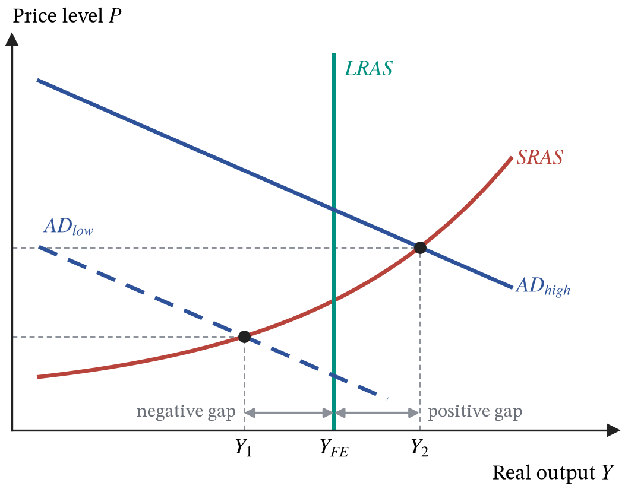
Figure 32. Macroeconomic equilibrium with a negative and a positive output gap.
A negative gap means production below capacity: unemployment above its natural rate, spare capacity, and downward pressure on inflation. A positive gap means the economy is producing beyond its sustainable level by working existing factors unusually hard, with labour shortages, bidding up of wages and rising inflation. Over time, $Y_{FE}$ itself grows as $LRAS$ shifts out, and the business cycle is the movement of actual output around that rising trend: a boom when output runs above it, a recession when output falls, and a recovery as the gap closes.
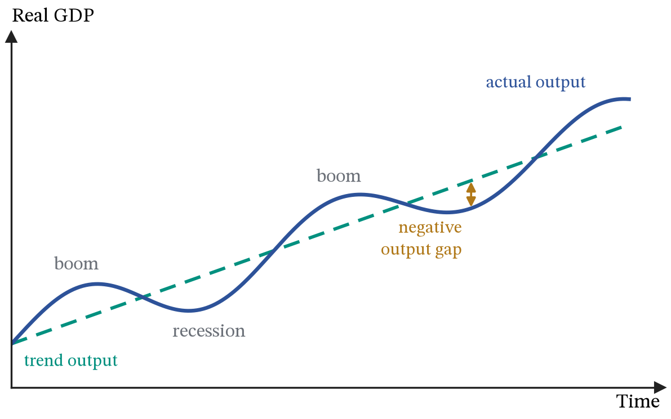
Figure 33. The business cycle. Actual output fluctuates around a rising trend of sustainable output, and the output gap is the vertical distance between them.
Left alone, the economy closes a negative gap by itself, and (57) shows how. Output below capacity raises unemployment, workers’ bargaining power weakens, and money wage growth slows. A lower $w$ lowers $w/MP_{L}$ at every level of output, so $SRAS$ moves down, the price level falls, and the movement down the AD curve raises output back towards $Y_{FE}$.
ASSUMPTIONS.
Self-correction depends on money wages actually falling, or at least rising more slowly than prices.
Keynes’s objection was not that this mechanism is wrong in theory but that it can take years, and that the unemployment in the meantime is real. That disagreement, about the speed of wage adjustment, is most of the difference between classical and Keynesian policy conclusions.
The trend is drawn as smooth. Section 28 explains why a long recession can lower the trend itself.

23. Inflation and unemployment
DEFINITIONS.
Inflation: a sustained rise in the general price level.
Deflation: a sustained fall.
Disinflation: a fall in the rate of inflation while prices are still rising.
Consumer Prices Index: the cost of a fixed, expenditure-weighted basket of goods, repriced each month.
Demand-pull inflation: caused by aggregate demand rising, so output rises too.
Cost-push inflation: caused by input costs rising, so output falls at the same time.
Unemployment: people out of work who are available for and seeking work; the unemployment rate is their number as a share of the labour force.
NAIRU: the unemployment rate consistent with stable inflation.
Inflation is a statement about a rate of change, not a level. The UK measure is the Consumer Prices Index: a fixed basket of goods, weighted by how much households actually spend on each, repriced each month. Falling inflation is not falling prices; that is deflation, a different condition. The index has known weaknesses: it holds the basket fixed while consumers substitute away from what is rising, it struggles with quality improvements and new products, and CPI excludes owner-occupied housing costs, which is why CPIH exists.
Sections 20 and 21 give two ways the price level can rise. Demand-pull inflation is an upward shift of AD: output and prices both rise, and it happens when the economy is at or near capacity. Cost-push inflation is an upward shift of SRAS caused by higher input costs, each unit of output now needing a higher price to be worth making: prices rise while output falls, which is stagflation and is the harder case for policy because the two targets pull in opposite directions.
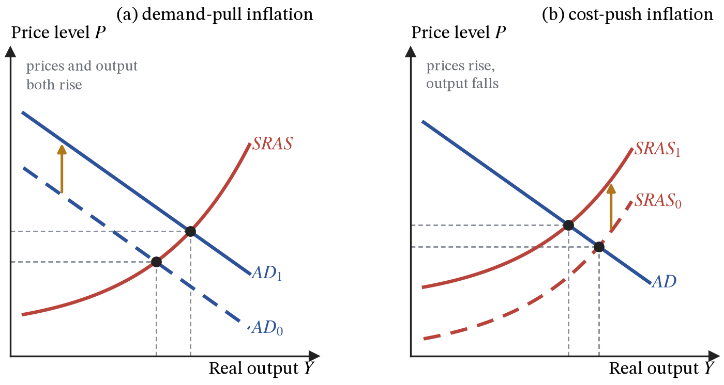
Figure 34. The two sources of inflation. Only cost-push reduces output at the same time.
The UK experience from 2021 to 2023 was mostly the second. Wholesale gas prices rose several-fold after supply disruption, energy is an input to almost everything, so unit costs rose across the economy and SRAS moved up. Raising interest rates could not produce more gas. It could only reduce demand, which is why that episode involved an explicit trade of lost output against lower inflation rather than a free correction.
Money gives a third account of the price level. The equation of exchange is
$$M_{S}V≡PY (59)$$
The money supply $M_{S}$, multiplied by the velocity of circulation $V$, the number of times each pound is spent in a year, must equal the total value of what was bought, the price level $P$ times real output $Y$. Like (49) it is an identity, true by the definition of $V$, and it predicts nothing on its own. The quantity theory adds two behavioural assumptions: that $V$ is stable and that $Y$ is fixed at capacity. Only then does $M_{S}$ rising by 10 per cent imply $P$ rising by 10 per cent. Both assumptions are contested, and $V$ moved sharply in the UK after 2009, so the monetarist conclusion is only as strong as those assumptions.
The UK measures unemployment two ways: the claimant count, which depends on benefit rules, and the Labour Force Survey using the ILO definition, which is the internationally comparable one. Neither captures underemployment or the economically inactive. The remedy follows from the cause:
Type | Cause | What actually helps
Cyclical | a negative output gap | demand-side policy
Structural | skills or location no longer match the jobs | training, mobility, regional policy
Frictional | normal churn between jobs | better matching and information
Real-wage | the wage held above its market-clearing level | wage flexibility, though not where employers have monopsony power (section 15)
Seasonal | predictable annual swings in demand | little, beyond smoothing incomes across the year
The Phillips curve began as an empirical relationship: low unemployment came with high inflation. The modern version adds expectations:
$$π=π^{e}−ω\left(u−u_{n}\right) (60)$$
$π$ is inflation, $π^{e}$ is the inflation that wage and price setters expect, $u$ is the unemployment rate, $u_{n}$ is the NAIRU, and $ω>0$ measures how strongly a tight labour market bids up wages and prices. With $ω=0.5$ and expected inflation of 2 per cent, holding unemployment one point below the NAIRU gives inflation of 2.5 per cent this year. That is the short-run trade-off, and it is real. But once inflation has run at 2.5 per cent, people come to expect it; with $π^{e}=2.5$, the same unemployment rate now brings 3 per cent inflation, and so on. Keeping unemployment below the NAIRU requires ever-rising inflation.
In the long run expectations are correct, $π=π^{e}$, and (60) then forces $u=u_{n}$: whatever the inflation rate, unemployment returns to the NAIRU. Each short-run Phillips curve is drawn for one value of $π^{e}$, and a rise in expectations shifts it up.
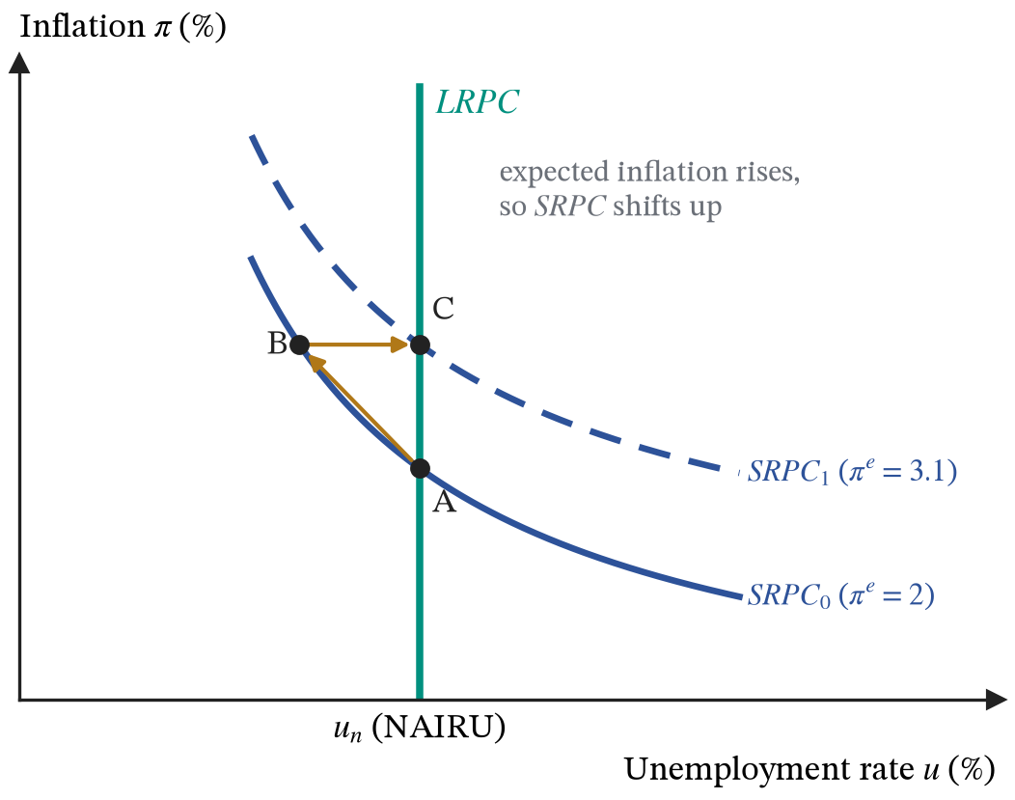
Figure 35. Short-run Phillips curves, each drawn for given expected inflation, and the vertical long-run curve at the NAIRU, where expectations are correct.
That vertical long-run curve is the Phillips-diagram version of vertical LRAS, and the NAIRU is determined by the structure of the labour market rather than by demand. Inflation is costly through menu and shoe-leather costs, through arbitrary redistribution from lenders to borrowers when it is unanticipated, through the uncertainty it creates for investment, and through lost competitiveness if it exceeds trading partners’ inflation. Deflation has costs of its own: it raises the real burden of debt, and when it comes from collapsing demand it gives buyers a reason to delay purchases, which weakens demand further. Deflation that comes from rapid productivity growth, as with computers and phones, lowers prices because goods have become cheaper to make, and carries none of those dangers.
ASSUMPTIONS.
The Phillips curve trade-off assumes expectations adjust slowly; if wage and price setters anticipated inflation at once, $π^{e}$ would equal $π$ immediately and there would be no short-run trade-off to exploit.
The quantity theory assumes a stable velocity and output fixed at capacity, and neither holds reliably.
The CPI assumes a fixed basket, so it overstates the rise in the cost of living when households switch away from goods whose prices are rising.

24. Money and banking
DEFINITIONS.
Money: anything generally accepted in payment for goods and services or in settlement of a debt.
Barter: direct exchange of goods for goods, with no money involved.
Double coincidence of wants: the requirement under barter that each party holds what the other wants, at the same moment.
Liquidity: how easily an asset can be turned into a means of payment without losing value.
Narrow money: notes, coin and commercial banks’ reserves at the central bank.
Broad money: narrow money plus bank deposits, which is most of what people actually spend.
Fractional reserve banking: keeping only a fraction of deposits as reserves and lending the rest out.
Reserve ratio: the fraction of deposits a bank holds back as reserves.
Money multiplier: the deposits each pound of reserves can support, equal to one divided by the reserve ratio.
A baker has bread today. A shepherd will have wool in the spring after shearing, and wants bread now. Barter cannot help them, because barter needs a double coincidence of wants and needs it at a single moment. Handing the bread over now against a promise of wool in the spring solves it, but creates something new in the process: a debt.
Suppose instead that the baker wants leather, not wool. A tanner has leather and wants bread. A chain can still be built, bread to the tanner, leather to the baker, wool to whoever wants it in the spring, but every extra person, good and harvest date makes the bookkeeping harder. With a hundred people and a dozen goods, what limits trade is no longer the goods. It is the record of who owes what to whom.
The way out is to stop recording debts in particular goods at all. Hand something of value into the system and receive a standardised claim that can be passed on; hand the claim back later and receive something of value. The claim is worth holding because everybody expects everybody else to go on accepting it. That is money. A banknote has no use of its own. It is a record of a claim on real output that has been made transferable, and its four jobs follow from that:
Function | What it does
Medium of exchange | removes the need for a double coincidence of wants
Unit of account | puts every price on one scale, so any two can be compared
Store of value | separates the decision to sell from the decision to buy
Standard of deferred payment | lets debts be written in fixed and enforceable terms
Not everything can do those jobs, which is why money has tended to converge on a short list of properties:
Property | Why money needs it
Durable | it has to survive being held and passed along
Portable | high value in a small weight, or carrying it costs more than it is worth
Divisible | it has to pay for small things as well as large ones
Uniform | one unit must be interchangeable with any other
Limited in supply | if anybody can make more, nobody will hold it
Generally accepted | the property that ultimately matters, and it rests on everyone else accepting it too
Money and banking are separate inventions, and the second happened largely by accident. The usual account, and a fair description of seventeenth-century London, runs in three steps.
Step one. Merchants hold gold, which is heavy to carry and risky to keep. Goldsmiths already have strongrooms, so merchants deposit their gold and take away a paper receipt promising the bearer so much gold on demand.
Step two. Settling a debt by handing over the receipt is easier than fetching the gold, and the person receiving it is just as happy to hold the receipt. Receipts begin circulating instead of being redeemed. A private promise has become a means of payment.
Step three. The goldsmith notices that the gold sits almost entirely still. On any normal day only a small fraction of it is called for. So rather than leave it idle he issues new receipts to borrowers, who pay him interest for them. There are now more receipts in circulation than there is gold in the vault:
Assets | £ | Liabilities | £
Gold in the vault | 1,000 | Receipts in circulation | 4,000
Loans to borrowers | 3,000
Total | 4,000 | Total | 4,000
The reserve ratio is 1,000 out of 4,000, or 25 per cent, and the receipts in circulation, which are the money supply, are four times the gold standing behind them. Nothing has been counterfeited and nobody has been defrauded. The depositor holds a claim he believes he can exercise whenever he likes, the borrower has purchasing power he did not have before, and the goldsmith earns interest on both. All three are satisfied at once, and they stay satisfied for as long as the depositors do not all arrive on the same morning.
Run the same logic through a system of banks rather than one goldsmith. Somebody deposits £1,000 of new reserves. The bank keeps a fraction $ρ$ of it and lends the rest. Whatever it lends is spent, and whoever receives the money banks it, so a second deposit of $(1−ρ)×$ £1,000 appears somewhere else in the system. That bank keeps $ρ$ of the new deposit and lends the rest, and the process repeats:
$$D=D_{0}+D_{0}(1−ρ)+D_{0}(1−ρ)^{2}+⋯=D_{0}\sum_{n=0}^{∞}{(}1−ρ)^{n} ⇒ D=\frac{D_{0}}{ρ} (61)$$
$D_{0}$ is the deposit that starts the process and $ρ$ the reserve ratio, so $(1−ρ)$ is the fraction handed on at each round. Because $(1−ρ)$ lies between zero and one the rounds shrink geometrically and the series sums to $1/ρ$. It is the same geometric series as the spending multiplier of section 20, run through banks instead of through incomes.
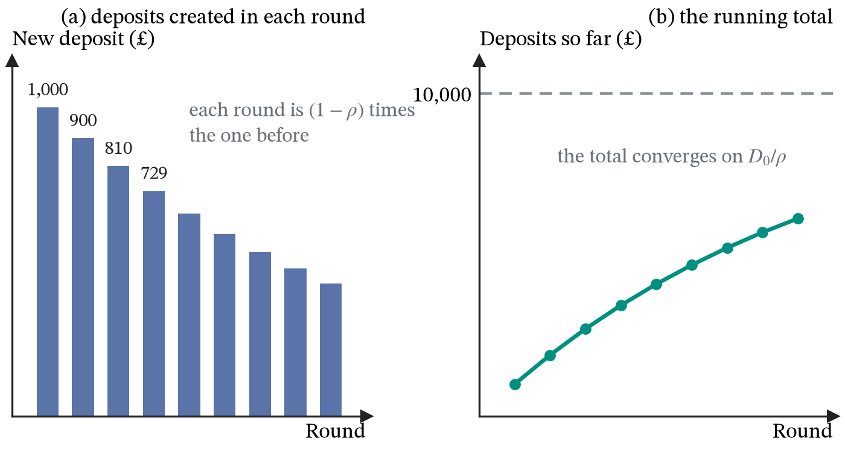
Figure 36. The money multiplier round by round, with a reserve ratio of 10 per cent and an opening deposit of £1,000.
Small reserve ratios imply very large multipliers:
Reserve ratio $ρ$ | Multiplier $1/ρ$ | Deposits from £1,000 of reserves | New money created
50 per cent | 2 | £2,000 | £1,000
25 per cent | 4 | £4,000 | £3,000
10 per cent | 10 | £10,000 | £9,000
5 per cent | 20 | £20,000 | £19,000
2 per cent | 50 | £50,000 | £49,000
Halving the fraction banks hold back doubles the deposits a given quantity of reserves can support, so small changes in how cautious banks are have large effects on how much money exists. At a 2 per cent ratio, forty-nine of every fifty pounds in the economy were created by somebody taking out a loan.
Notes and coin come to roughly 3 per cent of the money supply in a developed economy, and the share has been drifting down for years as card payments have displaced cash. The two ratios are not quite the same object, since $ρ$ is a fraction banks choose to hold back while 3 per cent is what currency has ended up as a share of the total, but they point at the same fact: of the money you can actually spend, something like 97 pence in every pound is a bank deposit.
The story so far runs from reserves to deposits: the central bank supplies reserves and banks lend a multiple of them. Modern banking reverses the causation. Banks are not held back by a shortage of reserves; they create deposits by lending, when they find a borrower they judge creditworthy at a profitable rate, and the Bank of England supplies whatever reserves the system then needs at Bank Rate. The multiplier is a ceiling that rarely binds rather than a mechanism that drives anything. It is on the specification, so learn it, and learn its status. The money that section 25 puts on the horizontal axis of the money market is therefore mostly bank deposits created by lending, not notes issued by the state.
ASSUMPTIONS.
Every pound lent is assumed to come back to the banking system as somebody else’s deposit. In practice some is held as cash and leaves the process, which lowers the multiplier.
Banks are assumed to lend out everything above the reserve ratio, and borrowers are assumed to want the loans. Neither holds in a downturn, when banks keep buffers well above the minimum and firms do not want to borrow at any rate.
The reserve ratio is assumed fixed.

25. Monetary policy
DEFINITIONS.
Monetary policy: the use of interest rates and the quantity of money to meet the inflation target.
Bank Rate: the interest rate the Bank of England pays on commercial banks’ reserves, which it sets and which is its main instrument.
Real interest rate: the nominal interest rate minus expected inflation, which measures the true cost of borrowing.
Transmission mechanism: the chain running from Bank Rate through market rates and spending to output and inflation.
Quantitative easing: central bank purchases of assets, used to lower longer-term yields once Bank Rate is close to zero.
The Bank of England’s Monetary Policy Committee is set a symmetric CPI inflation target of 2 per cent, with a letter to the Chancellor required if inflation misses by more than one percentage point either way. Symmetric means undershooting is a failure too. Its instrument is Bank Rate, the rate it pays on the reserves commercial banks hold with it.
Bank Rate is not discovered by a market. The Bank announces it, and it holds because no bank will lend reserves to another for less than the Bank itself pays on them, while the Bank stands ready to lend reserves at that rate to any bank that needs them. Market rates on loans, mortgages and savings are set as margins over it. What the market then decides is the quantity of money. Households and firms choose how much of their wealth to hold as money rather than as interest-bearing assets:
$$M_{D}=θY−ϕi (62)$$
$M_{D}$ is the quantity of money demanded, $Y$ is national income, and $i$ is the nominal interest rate. Demand for money rises with income, because more transactions have to be financed, by $θ>0$ for each extra £1; it falls with the interest rate, because interest forgone is the price of holding money, by $ϕ>0$ for each percentage point. With the Bank setting $i$ at Bank Rate, the quantity of money adjusts to whatever is demanded at that rate:
$$M=θY−ϕ i_{B}, \frac{dM}{di_{B}}=−ϕ (63)$$
Each percentage point on Bank Rate $i_{B}$ reduces the quantity of money people want to hold, and the bank lending that creates it, by $ϕ$. The supply of money is horizontal at the rate the Bank has chosen, as section 24 anticipated: banks create deposits by lending, and the Bank supplies the reserves to support them at Bank Rate.
Exam questions usually draw the money supply as a vertical line instead, as if the Bank fixed a quantity of money and let the rate settle where that quantity is willingly held. The two diagrams describe the same equilibrium, a point on the money demand curve; they differ only in which variable the Bank chooses. To get a lower interest rate in the vertical-supply picture, the Bank must supply more money. In the horizontal one it lowers the rate and the quantity follows. The second is how the Bank of England operates, and the first is a convention worth being able to draw.
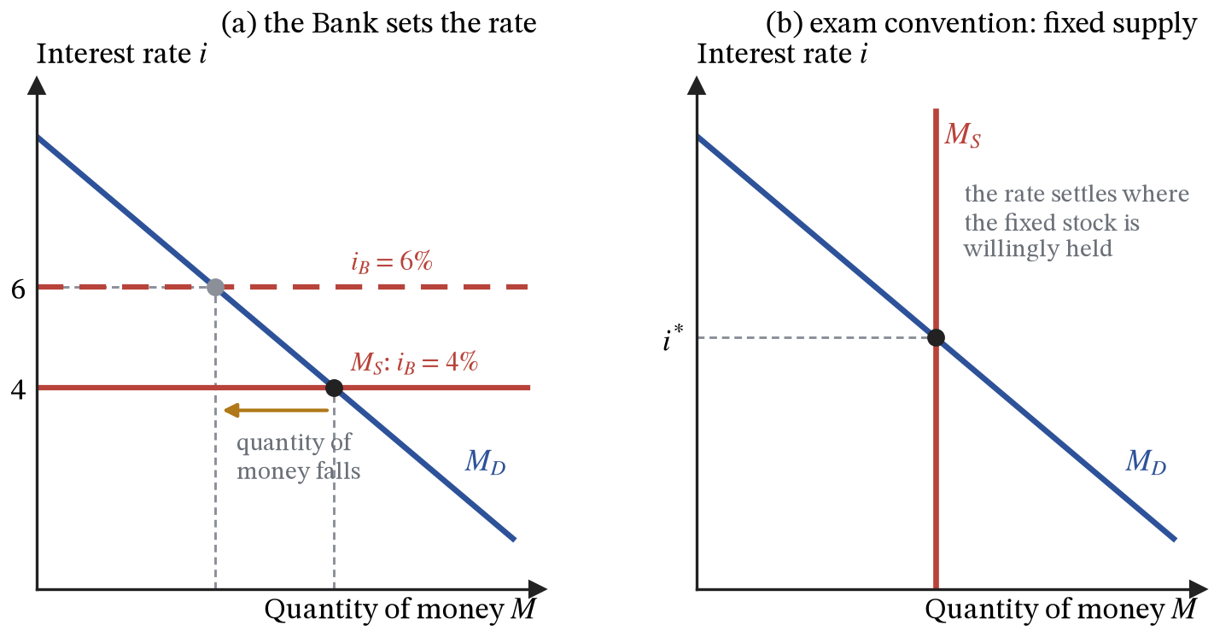
Figure 37. Two views of the money market. (a) How the Bank of England operates: it sets Bank Rate, and the quantity of money adjusts to demand at that rate. (b) The exam convention: a fixed money supply, with the rate settling where that quantity is willingly held.
What matters for spending is the real interest rate, the nominal rate less the inflation borrowers expect:
$$r=i−π^{e} (64)$$
A mortgage at 5 per cent when prices are expected to rise by 3 per cent costs 2 per cent a year in real terms. Because expectations move slowly, a change in Bank Rate changes real rates almost one for one in the short run, which is what gives monetary policy its grip.
The policy works through a chain of links. Bank Rate rises → banks’ own funding costs rise, so mortgage, loan and deposit rates follow → borrowing becomes dearer and saving more attractive, so households cut spending on durables and housing and firms postpone investment projects whose expected return no longer clears the higher hurdle → $AD$ moves down → output falls and inflationary pressure eases.
Two further channels run alongside it. Higher rates make sterling assets more attractive, so capital flows in, the pound appreciates, exports lose competitiveness, and import prices fall, which reduces inflation directly as well as through demand. And the announcement itself moves expectations: if firms and unions believe the Bank will act, they moderate price and wage setting before output has moved at all, which is why credibility is treated as an instrument in its own right.
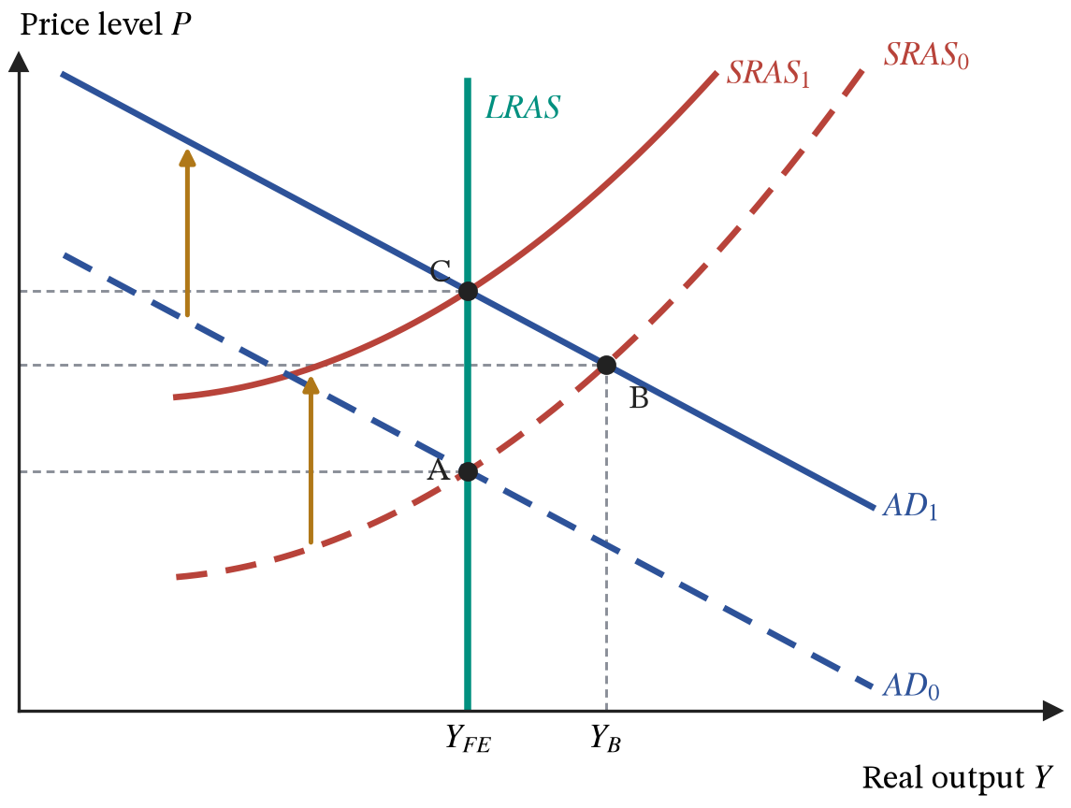
Figure 38. A demand expansion from full employment. Output rises from A to B in the short run, but once money wages adjust the economy settles at C, with a higher price level and output back at capacity.
Starting at full employment at A, a demand expansion moves the economy up the short-run supply curve to B, where output is above capacity. Tight labour markets then raise money wages, $SRAS$ moves up, and the economy arrives at C: the same output as at A and a higher price level. In the long run demand policy determines the price level and not real output. Only the policies of section 28 move $Y_{FE}$.
Monetary policy works with long and variable lags, conventionally around eighteen months to two years in the UK, so the MPC must set rates against a forecast rather than against today’s data. When Bank Rate is already near zero it cannot usefully be cut further, which is why quantitative easing was used after 2009: the Bank created reserves to buy government bonds, raising their prices and so lowering long-term interest rates, which Bank Rate influences only indirectly. Because the Bank pays Bank Rate on all reserves, the extra reserves QE created did not push short-term rates below the level the Bank had set. Its distributional effect is awkward: it works partly by raising the price of assets, which are held disproportionately by the already wealthy.
ASSUMPTIONS.
Each link of the transmission chain is an assumption rather than a fact. The first assumes pass-through: that market rates follow Bank Rate substantially and quickly. The second assumes consumption and investment respond to real interest rates, which is truer of housing than of most other spending. The third assumes the upward-sloping $SRAS$ of section 21, so that lower demand shows up partly in prices and not only in lost output.
The exchange-rate and expectations channels add two more: that capital moves freely across borders, and that the Bank’s announcements are believed.

26. Fiscal policy
DEFINITIONS.
Fiscal policy: the use of government spending and taxation to affect aggregate demand.
Automatic stabilisers: features of the existing tax and benefit system that dampen the cycle with no decision being taken.
Budget deficit: the excess of spending over receipts in a year, a flow; the primary deficit excludes interest payments on the debt.
National debt: the accumulated total of past deficits, a stock.
Structural deficit: the part of the deficit that survives when the output gap closes.
Crowding out: the displacement of private spending by government borrowing or by government use of scarce resources.
Laffer curve: the relationship between a tax rate and the revenue it raises.
Fiscal policy acts on the same diagram through $G$ and, via disposable income, through $C$. Some of it happens without anyone deciding anything: in a downturn, tax receipts fall as incomes fall and benefit payments rise as unemployment rises, so disposable income falls by less than output does. These are the automatic stabilisers, and they are the reason the tax rate $τ$ appears in the denominator of the multiplier (54): the higher it is, the more of any shock the budget absorbs. Discretionary policy is a deliberate change in rates or spending plans.
The deficit is a flow and the debt a stock. A falling deficit still adds to debt. The deficit also splits into a cyclical part, which disappears as the output gap closes, and a structural part, which does not, and only the structural part says anything about whether the fiscal position can be sustained.
The multiplier is the case for using fiscal policy in a slump, and the main objection to it is crowding out. Financial crowding out works through the market for loanable funds, where saving supplies funds and investment demands them, both depending on the real interest rate. Suppose saving is $S=100+20r$ and investment is $I=160−10r$, in £bn with $r$ in per cent. With a balanced budget the market clears where $100+20r=160−10r$, at $r=2$ per cent and investment of £140bn. Now let the government borrow £30bn. Demand for funds becomes $I+30$, the market clears at $r=3$ per cent, and private investment falls to £130bn. Of the £30bn borrowed, £10bn came from crowded-out investment and £20bn from extra saving.
$$\frac{\text{fall in investment}}{\text{government borrowing}}=\frac{10}{20+10}=\frac{1}{3} (65)$$
The fraction crowded out is the responsiveness of investment to the interest rate divided by the combined responsiveness of saving and investment, the same algebra as the tax incidence of (46). Borrowing is “paid for” by whichever side of the funds market responds less.
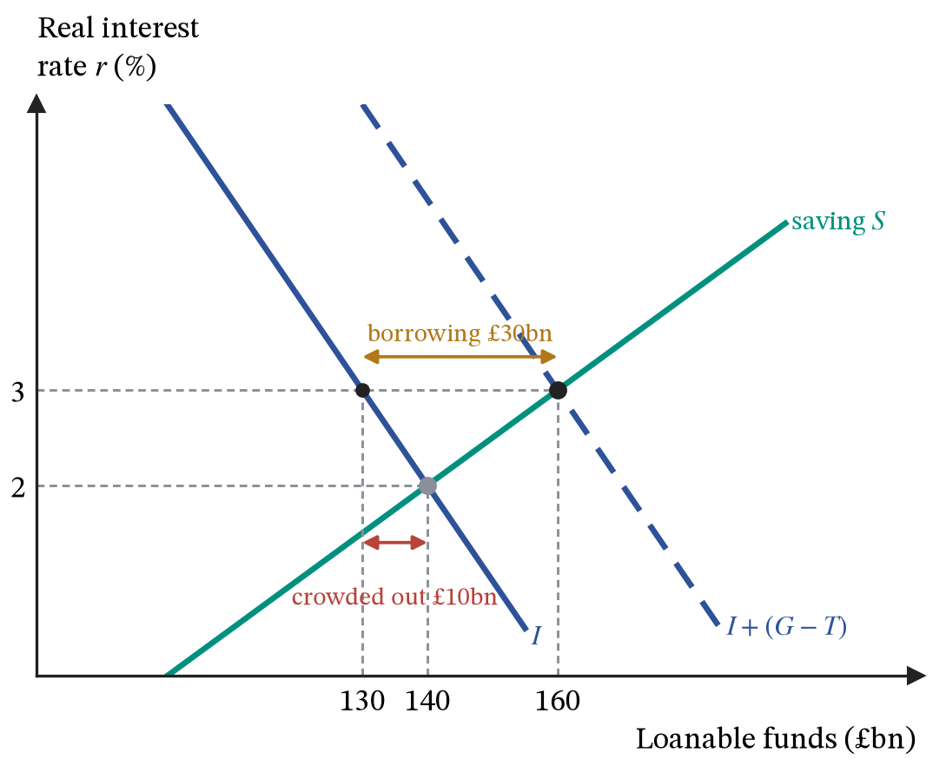
Figure 39. The market for loanable funds. Government borrowing of £30bn raises the demand for funds, lifts the real interest rate from 2 to 3 per cent, and crowds out £10bn of private investment.
Resource crowding out is more direct: if the economy is at capacity, the workers and materials the government buys are taken from private use, so real output cannot rise and the extra spending shows up in prices. Both objections weaken when there is spare capacity and idle labour, and when the central bank holds interest rates down, which is why the strength of the fiscal multiplier depends on the state of the economy rather than being a constant.
Whether a debt is sustainable depends on the interest rate, growth and the primary balance together. Let $b$ be debt as a share of GDP, $r$ the real interest rate on the debt, $g$ the growth rate of real GDP, and $ψ$ the primary surplus (taxes less spending other than interest) as a share of GDP. Each year interest adds $rb$ to the ratio, growth of the denominator removes roughly $gb$, and the primary surplus pays down $ψ$:
$$Δb≈(r−g) b−ψ (66)$$
The debt ratio is stable when $ψ=(r−g)b$. With debt at 100 per cent of GDP, close to the UK’s level in the mid-2020s, a real interest rate of 2 per cent and growth of 1.5 per cent, stabilising the ratio needs a primary surplus of 0.5 per cent of GDP. If $r$ is below $g$, as it was for most of the 2010s, the ratio can fall even while the government runs a primary deficit; if $r$ rises above $g$, the same policy makes the ratio climb. That is why a rise in interest rates changes the fiscal arithmetic so sharply, and why markets’ confidence in a government’s plans feeds back into $r$ itself.
Set against monetary policy, fiscal policy has a different set of strengths, and which one is the right instrument depends on the situation rather than on principle:
 | Monetary policy | Fiscal policy
Instrument | Bank Rate, asset purchases | government spending and taxation
Who decides | the MPC, independent of government | the Treasury, politically accountable
Speed of decision | eight meetings a year, fast | tied to the Budget cycle, slow
Speed of effect | 18 to 24 months | faster where projects are ready to run
Targeting | economy-wide and blunt | can be aimed at regions, sectors or groups
Main limit | the zero lower bound | crowding out and debt sustainability
Taxes also change the incentive to earn the income being taxed, which is the content of the Laffer curve. Revenue is zero at a zero rate and also at a 100 per cent rate, at which nobody declares taxable income, so it must peak somewhere between. Where it peaks depends on how strongly the tax base responds. Suppose the base shrinks as the share people keep, $1−τ$, falls, so that $Y(τ)=Y_{0}(1−τ)^{ε}$, where $Y_{0}$ is the base with no tax and $ε$ is the elasticity of the base with respect to $1−τ$. Revenue is $T(τ)=τY_{0}(1−τ)^{ε}$, and
$$\frac{dT}{dτ}=Y_{0}(1−τ)^{ε−1}\left[(1−τ)−ετ\right]=0 ⇒ τ^{*}=\frac{1}{1+ε} (67)$$
The bracket is the product rule again: raising the rate gains revenue on the existing base and loses it on the base that shrinks. If the base barely responds, $ε=0.25$, revenue peaks at a rate of 80 per cent; if it responds strongly, $ε=2$, the peak is at 33 per cent. The curve’s shape is not in dispute. Its peak is an empirical question about $ε$, which differs between taxes and between groups of taxpayers.
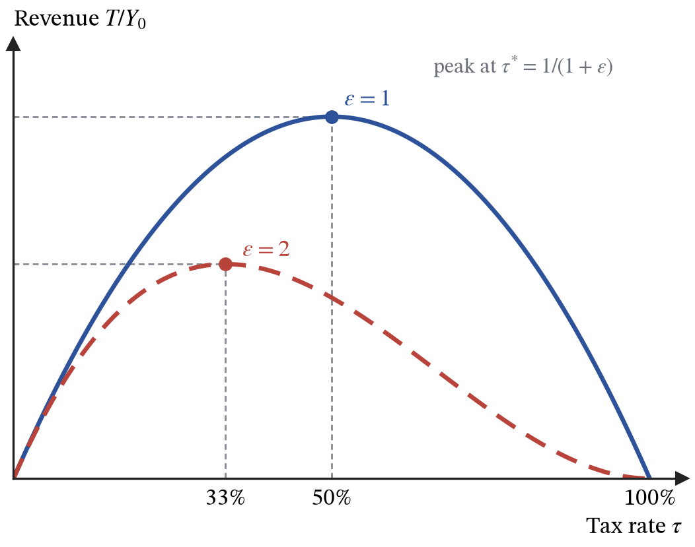
Figure 40. The Laffer curve for two values of the elasticity of the tax base. Revenue peaks at $τ^{*}=1/(1+ε)$, at 50 per cent when $ε=1$ and at 33 per cent when $ε=2$.
ASSUMPTIONS.
The fiscal multiplier assumes spare capacity and a central bank that does not offset the stimulus with higher rates; with either missing, crowding out does most of the work.
The loanable funds example takes the saving and investment schedules as given; in a recession, the extra income generated by the multiplier also raises saving, so less investment is displaced.
The government is assumed able to borrow at a stable rate, which depends on markets continuing to believe the debt is sustainable.
Discretionary policy assumes the downturn is recognised, the measure passed and the money spent while it is still needed, and those lags often exceed the length of a recession.

27. Inequality and redistribution
DEFINITIONS.
Equality means everyone has the same income or wealth; equity means a distribution judged to be fair, which need not be equal.
Income is a flow received over a period; wealth is a stock of assets owned at a moment.
Absolute poverty: income too low to buy the basic necessities of life.
Relative poverty: income below a fraction of the typical income in a society; the UK measure is below 60 per cent of median household income.
Lorenz curve: the share of total income received by the poorest fraction of the population, plotted against that fraction.
Gini coefficient: a measure of inequality from 0 (complete equality) to 1 (one person has everything).
Average tax rate: tax paid as a share of income; marginal tax rate: the share of an extra pound taken in tax.
Progressive tax: the average rate rises with income; proportional: it is constant; regressive: it falls.
Section 12 measured the size of the pie and said nothing about how it is divided. The division can be drawn. Rank the population from poorest to richest and let $ℓ(p)$ be the share of total income received by the poorest fraction $p$. If everyone had the same income, the poorest 20 per cent would have 20 per cent of income, and $ℓ(p)=p$, the 45-degree line. With any inequality the curve sags below that line, because the poorest 20 per cent receive less than 20 per cent. The Gini coefficient measures the sag. It is the area between the line of equality and the Lorenz curve, A in Figure 41, as a fraction of the whole triangle under the line of equality, which has area one half:
$$\text{Gini}=\frac{A}{A+B}=\frac{1/2−\int_{0}^{1}{ℓ}(p) dp}{1/2}=1−2\int_{0}^{1}{ℓ}(p) dp (68)$$
The integral is the area $B$ under the Lorenz curve, the same use of an integral to add up a curve as the surplus of (35). A Lorenz curve $ℓ(p)=p^{2}$, in which the poorest half of the population receives a quarter of income, has $\int_{0}^{1}{p^{2}}dp=1/3$ and a Gini coefficient of $1−2/3=1/3$. A more unequal distribution, $ℓ(p)=p^{3}$, gives $1−2/4=1/2$. UK disposable income has had a Gini coefficient of roughly 0.3 to 0.35 in recent years. Wealth is far more unequally distributed than income, because wealth accumulates from income that is saved and passed on.
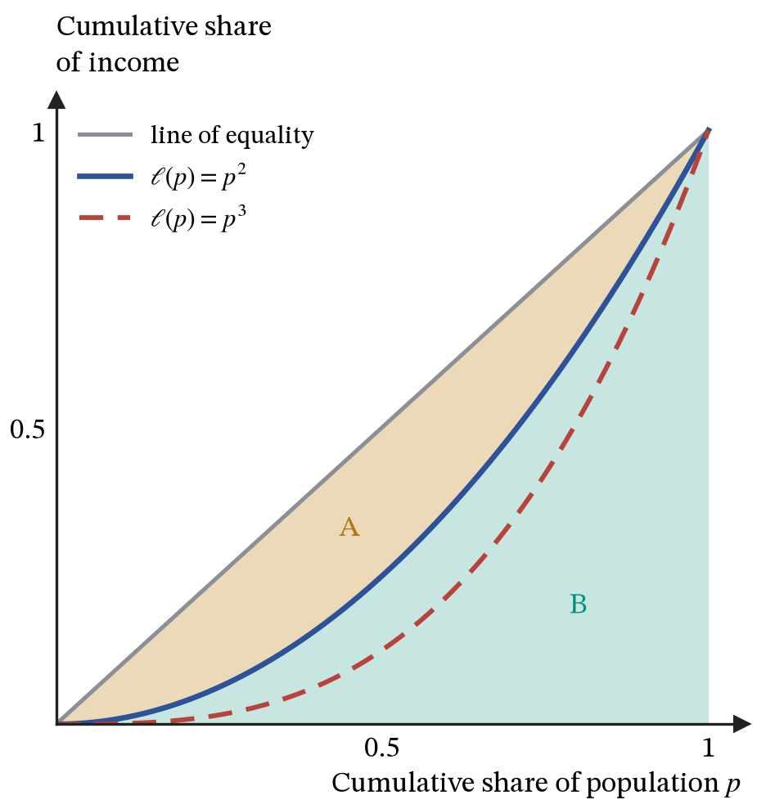
Figure 41. Lorenz curves. The Gini coefficient is area A divided by the whole triangle A + B; the curve $ℓ(p)=p^{2}$ gives a Gini of 1/3 and $ℓ(p)=p^{3}$ gives 1/2.
Inequality in market incomes comes from differences in what people own and in what their labour earns. Section 15 explained the second: wages reflect marginal revenue products, so differences in skills, education and the demand for particular work produce differences in pay, and employer power can push wages below marginal revenue product. Ownership of capital and land, and its transmission between generations, explains much of the rest. Technological change that raises the productivity of skilled workers more than others, and globalisation that exposes some workers to competition from abroad, have widened market-income inequality in many rich countries.
Governments redistribute through taxes and transfers. Whether a tax is progressive is a question about its average rate, and section 3’s lemma about marginal and average quantities settles it. If $T(Y)$ is the tax paid on income $Y$, the average rate is $T/Y$ and the marginal rate is $dT/dY$, and by the quotient rule
$$\frac{d}{dY}\left(\frac{T}{Y}\right)=\frac{1}{Y}\left(\frac{dT}{dY}−\frac{T}{Y}\right) (69)$$
The average rate rises with income, making the tax progressive, exactly when the marginal rate is above the average rate. A tax with a tax-free allowance and a single rate above it is therefore progressive: with an allowance of £12,570 and a rate of 20 per cent, someone earning £20,000 pays £1,486, an average rate of 7.4 per cent, while someone earning £50,000 pays an average rate of 15 per cent, even though both face the same marginal rate of 20 per cent. Confusing the two rates is the commonest error in this topic. Indirect taxes such as VAT are regressive in their impact, because lower-income households spend a larger share of their income.
Redistribution has costs as well as benefits. Higher marginal tax rates weaken the incentive to work, train and invest, the Laffer argument of section 26 applied to a single tax, and benefits that are withdrawn as earnings rise create high effective marginal rates for the low-paid. How much efficiency to give up for how much equity is a value judgement, not a theorem, and economics can measure the trade-off but cannot settle it.
ASSUMPTIONS.
The Lorenz curve ranks households by income in one period; incomes that vary over a lifetime look more unequal in a single year than over a whole life.
The tax example ignores National Insurance and the withdrawal of the personal allowance at high incomes.

28. Supply-side policy and growth
DEFINITIONS.
Supply-side policy: measures intended to raise the productive capacity of the economy, moving long-run aggregate supply out.
Market-based measures work by sharpening incentives and removing obstacles; interventionist measures work by providing what markets under-provide.
Total factor productivity (TFP): the part of output growth not explained by more labour or more capital, which captures technology and the efficiency with which inputs are combined.
Hysteresis: a lasting effect of a temporary shock, such as a recession that permanently lowers potential output.
Everything in sections 20, 25 and 26 moves aggregate demand and therefore moves output only while money wages are sticky. Supply-side policy aims at $LRAS$ itself. An outward shift of $LRAS$ raises sustainable output and, for a given AD curve, lowers the price level, so it improves both targets at once. Because $LRAS$ is vertical, it can only move sideways, and a move to the right means more capacity.
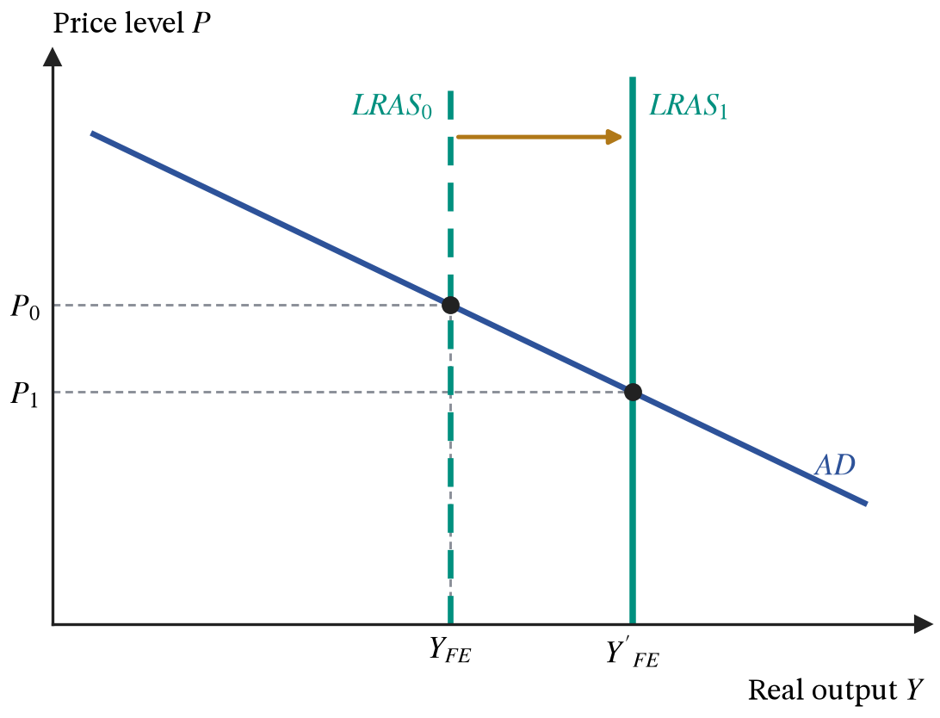
Figure 42. An outward shift of long-run aggregate supply. Sustainable output rises from $Y_{FE}$ to $Y_{FE}^{′}$ and, with aggregate demand unchanged, the price level falls.
Market-based measures include cutting marginal income tax rates and corporation tax to raise the return to work and investment, deregulating product markets to sharpen competition, reducing trade barriers, privatisation, and reforms to labour law or benefit tapers intended to raise participation. Interventionist measures, which are section 16 applied at national scale, include education and training, infrastructure, subsidies to research and development, and support for regional development.
Growth can be split into its sources. Suppose output is produced from capital and labour by $Y=AK^{1/3}L^{2/3}$, where $A$ is total factor productivity. Taking logarithms gives $lnY=lnA+1/3lnK+2/3lnL$, and differentiating with respect to time turns each logarithm into a growth rate:
$$g_{Y}=g_{A}+1/3 g_{K}+2/3 g_{L} (70)$$
$g_{Y}$, $g_{A}$, $g_{K}$ and $g_{L}$ are the growth rates of output, productivity, capital and labour. The weights are the exponents, and in a competitive economy they equal the shares of income paid to capital and labour, roughly a third and two thirds in the UK. If output grows by 2 per cent while capital grows by 3 per cent and labour by 1 per cent, capital accounts for 1 percentage point, labour for 0.67, and the remaining 0.33 points is TFP growth, measured as what is left over. Subtracting $g_{L}$ from both sides gives growth in output per worker, $g_{Y}−g_{L}=g_{A}+1/3(g_{K}−g_{L})$: it comes either from productivity or from more capital per worker. Capital per worker runs into the diminishing returns of section 3, because each extra machine adds less when workers already have plenty, so only TFP growth can raise output per head indefinitely.
The choice in section 18 between consumer goods and capital goods was the choice between output now and capacity later. Investment, education and research are that choice made at national scale: they cost consumption today and shift the frontier outward for the following decade. Supply-side measures act slowly, often cost money up front, and many of them, especially the market-based ones, raise measured inequality while raising output. A policy can be correct about efficiency and still require a separate answer on distribution.
The separation between demand and supply is not complete. A deep or long recession can lower potential output itself: workers who stay unemployed for long periods lose skills and attachment to the labour market, firms cancel investment that would have added to the capital stock, and research is cut. This is hysteresis, and it means demand policy that shortens a recession can protect $LRAS$ as well as closing the output gap. The UK’s productivity has grown much more slowly since the 2008 financial crisis than before it, and how much of that slowdown is hysteresis is still disputed.
ASSUMPTIONS.
Supply-side policy assumes the binding constraint is capacity rather than demand, so in a recession raising potential output does little for actual output.
Growth accounting assumes competitive factor markets, so that factor shares measure the contributions of capital and labour; TFP is then whatever is left over, including measurement error.
Market-based measures assume incentives are what hold output back; interventionist measures assume the government can identify and deliver what markets under-provide. Both work slowly, so their effects are hard to separate from everything else that happens over the same decade.

29. Exchange rates and the balance of payments
DEFINITIONS.
Exchange rate: the price of one currency in terms of another.
Appreciation and depreciation: a rise and a fall in that price under a floating regime; revaluation and devaluation are the same changes made deliberately under a fixed regime.
Marshall-Lerner condition: a depreciation improves the trade balance only if the two demand elasticities sum to more than one.
J-curve: the path by which the balance worsens before it improves, because elasticities are low at first.
Current account: trade in goods and services plus primary and secondary income.
Financial account: transactions in assets, which must offset the current account.
An exchange rate is a price, so it is determined the way section 10 determines any price, in a market with a demand side and a supply side. Sterling is demanded by anyone who needs to pay in pounds: foreign buyers of UK exports, foreign investors buying UK assets, and speculators expecting appreciation. Sterling is supplied by anyone converting out of it: UK importers, UK investors buying foreign assets, and speculators going the other way.
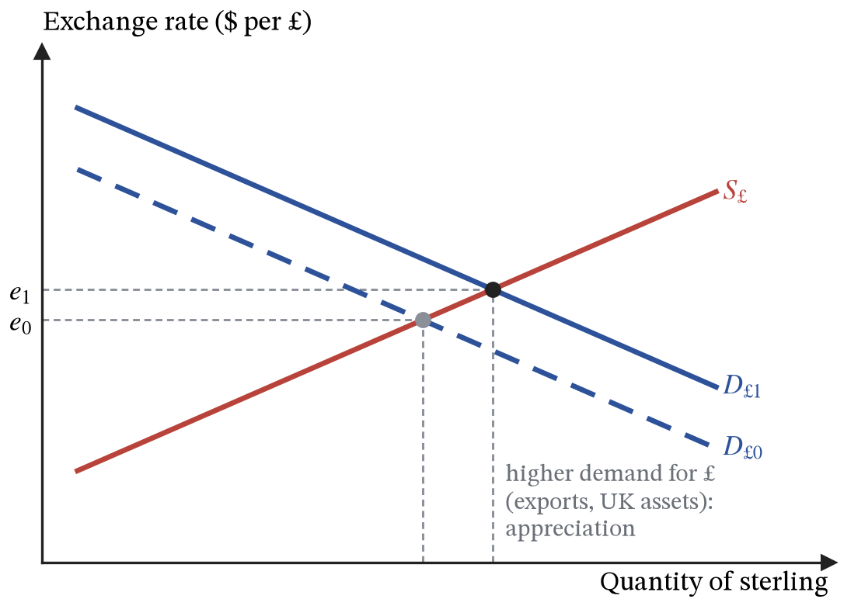
Figure 43. The market for sterling. A rise in demand for pounds appreciates the currency.
Higher UK interest rates relative to abroad attract capital inflows and appreciate the pound, which is the exchange-rate channel of section 25. Higher UK inflation relative to trading partners makes UK goods less competitive and depreciates it. A stronger current account position, faster relative growth, and shifts in speculative sentiment all move it. Under a floating regime the rate is left to the market. Under a fixed regime the central bank must buy and sell reserves to hold a parity, and if capital moves freely across borders it loses control of domestic interest rates in doing so, since any gap between its rate and foreign rates would draw in or drive out capital until the parity broke.
A depreciation makes exports cheaper in foreign currency and imports dearer in sterling, but whether it improves the trade balance depends on how much quantities respond. Write $e$ for the exchange rate in dollars per pound, $P_{X}$ for the sterling price of UK exports and $P_{M}^{*}$ for the dollar price of imports, both held fixed in their own currencies. Foreign buyers pay $eP_{X}$ for UK exports and UK buyers pay $P_{M}^{*}/e$ for imports, and the trade balance in pounds is
$$TB=P_{X}X−\frac{P_{M}^{*}}{e}M (71)$$
where $X$ and $M$ are the volumes of exports and imports. A 1 per cent fall in $e$ lowers the foreign price of exports by 1 per cent, so export volume rises by $|PED_{X}|$ per cent; it raises the sterling price of imports by 1 per cent, so import volume falls by $|PED_{M}|$ per cent, but every unit still imported costs 1 per cent more. Starting from balanced trade, with exports and imports each worth $V$, differentiating (71) and collecting the three effects gives
$$\frac{ΔTB}{V}=\left(|PED_{X}|+|PED_{M}|−1\right)×\left(−\frac{Δe}{e}\right) (72)$$
A depreciation, $Δe<0$, improves the balance only if $|PED_{X}|+|PED_{M}|>1$: that is the Marshall-Lerner condition. The minus one is the import bill rising on the units still bought; the two elasticities are the volume responses. With both elasticities at 0.6, a 10 per cent depreciation improves the balance by $(1.2−1)×10=2$ per cent of trade, even though each demand is inelastic. With both at 0.3, the same depreciation worsens it by 4 per cent. What matters is the sum, not whether each demand is elastic.
Elasticities are low immediately after a depreciation, because contracts are in place and buyers take time to switch, so the sum is often below one at first and above it later. The balance therefore typically deteriorates before it improves. That path is the J-curve, and it is an application of the point in section 11 that elasticity rises with time.
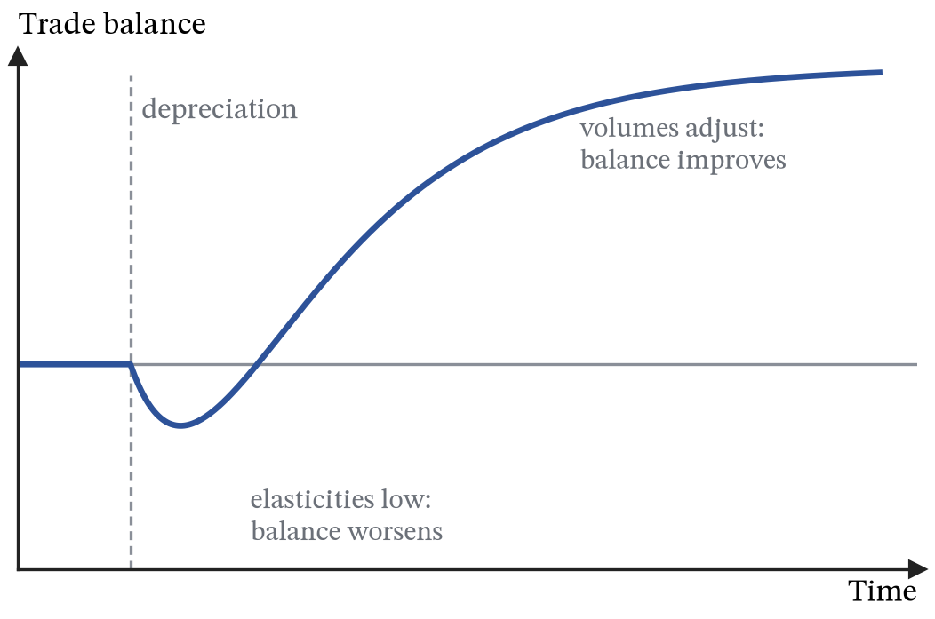
Figure 44. The J-curve. After a depreciation the trade balance first worsens, while elasticities are low, and then improves as volumes adjust.
The balance of payments records all transactions with the rest of the world. The current account covers trade in goods and services, primary income (profits, interest and dividends earned abroad) and secondary income (transfers). The capital and financial account records transactions in assets. The two must sum to zero, apart from errors in measurement, because a country that buys more goods than it sells must be selling assets or borrowing to pay for the difference. This is another accounting identity, so a current account deficit is not in itself evidence of anything wrong; what matters is what the offsetting inflow is financing and whether it is likely to continue.
ASSUMPTIONS.
The market for sterling is treated like any other market, which assumes the exchange rate floats freely.
The Marshall-Lerner condition assumes export and import prices in their own currencies stay put when the exchange rate moves, so the whole change passes through to buyers; in practice firms absorb part of it in their margins. It also starts from balanced trade; with an initial deficit, the condition needed is slightly stricter.
The balance of payments must balance as an identity, but that says nothing about whether a given deficit can go on being financed.

30. Trade and comparative advantage
DEFINITIONS.
Absolute advantage: producing more of a good with the same resources.
Comparative advantage: producing a good at a lower opportunity cost, which is what determines the pattern of trade and has nothing to do with being better at anything.
Specialisation: concentrating resources on the good in which the comparative advantage lies.
Terms of trade: the rate at which one good exchanges for another, which must lie between the two opportunity costs if both sides are to gain.
Trade follows comparative advantage, not absolute advantage, and comparative advantage is the opportunity cost of section 18 applied across countries. Suppose that with the same resources the UK can make 60 loaves or 30 shirts, while Portugal can make 40 loaves or 40 shirts. Portugal makes fewer loaves and more shirts than the UK in absolute terms, but the relevant numbers are the ratios:
$$\text{UK: }1\text{ shirt costs }2\text{ loaves}; \text{Portugal: }1\text{ shirt costs }1\text{ loaf} (73)$$
Each figure is what a country gives up to make one shirt: the UK sacrifices $60/30=2$ loaves, Portugal $40/40=1$. These are opportunity costs in the sense of (48), applied to countries, and in those terms shirts are cheaper in Portugal and loaves are cheaper in the UK.
The UK makes more loaves, 60 against 40, so it has the absolute advantage in loaves. Portugal makes more shirts, 40 against 30, so Portugal has the absolute advantage in shirts. In this example the comparative advantage happens to point the same way, and that is a coincidence of these particular numbers rather than a general rule. Suppose instead that Portugal could make 100 loaves or 40 shirts. It would still hold an absolute advantage in shirts, and now in loaves too, but a shirt would cost it 2.5 loaves against the UK’s 2, so its comparative advantage would have moved to loaves and the UK’s to shirts. Specialisation would run the other way round. What a country makes more of tells you nothing about what it should make; only what it gives up to make it does.
Portugal can make a shirt for 1 loaf but sell it for 1.5 loaves. The UK can only make a shirt at a cost of 2 loaves but can buy one for 1.5. Each country is getting the good it is worse at making for less than making it would cost, which is why the trading rate has to sit between the two opportunity costs, and why the gain disappears if the opportunity costs are the same.
Suppose both countries begin by splitting their resources evenly between the two goods, then let each move resources towards the good it gives up least to make, then let them trade 24 loaves for 16 shirts, which is the rate of 1.5 loaves per shirt:
 | Loaves | Shirts
Without trade, resources split evenly
UK produces and consumes | 30 | 15
Portugal produces and consumes | 20 | 20
World total | 50 | 35
After specialising
UK, now making only loaves | 60 | 0
Portugal, now making only shirts | 0 | 40
World total | 60 | 40
After trading 24 loaves for 16 shirts
UK consumes | 36 | 16
Portugal consumes | 24 | 24
Total output rises: the world ends up with 60 loaves rather than 50 and 40 shirts rather than 35, from the same workers, land and machines as before. The extra output comes only from each country’s resources being pointed at what that country sacrifices least to produce.
The UK ends with 36 loaves and 16 shirts against 30 and 15 without trade, so it has more of both. Portugal ends with 24 and 24 against 20 and 20, so it also has more of both. Neither country has given anything up, and no third party paid for it. That is why the case for trade does not rest on one country being better at anything.
Complete specialisation is not required for any of this. The gain appears as soon as resources move in the right direction, so partial specialisation delivers a smaller version of the same result. Straight-line frontiers are what push the example all the way to complete specialisation; with the bowed frontier of section 18, the opportunity cost of loaves would rise as the UK made more of them, and specialisation would stop at the point where the two countries’ opportunity costs had converged on the trading rate.
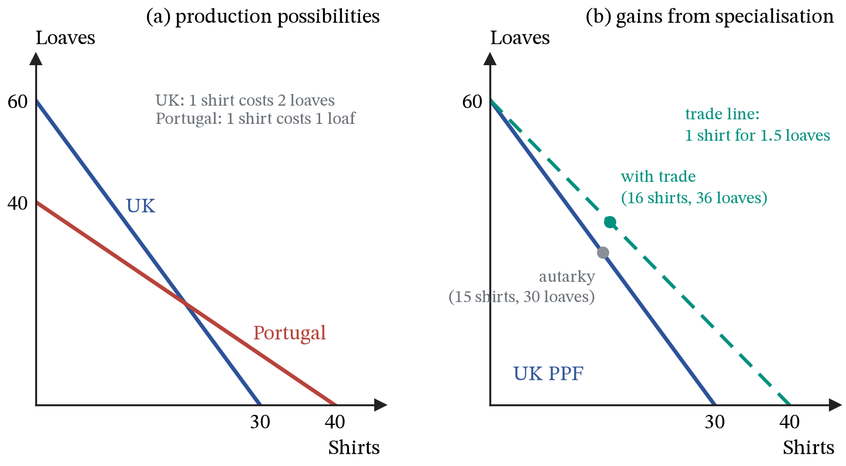
Figure 45. Comparative advantage. (a) The two production possibility frontiers. (b) The UK specialises in loaves and trades at 1.5 loaves per shirt, moving from its autarky point (30 loaves, 15 shirts) to consumption of 36 loaves and 16 shirts, beyond its own frontier.
ASSUMPTIONS.
Constant opportunity costs, so both frontiers are straight lines.
No transport costs.
Factors mobile between industries within a country but not between countries.
Full employment, so the resources one industry releases are absorbed by another.
Relax the last two and the model still shows an aggregate gain, but the adjustment falls on particular workers in particular places, which is why the politics of trade is harder than its economics.

31. Protection and integration
DEFINITIONS.
Tariff: a tax on imports.
Quota: a legal limit on the quantity imported.
Producer subsidy: a payment per unit to domestic producers.
Quota rent: the gap between the world price and the domestic price on the units allowed in, which goes to whoever holds the licence.
Production distortion: the loss from making at home what could have been bought more cheaply abroad.
Consumption distortion: the loss from units buyers valued above their cost and no longer buy.
Terms of trade index: 100 times the index of export prices divided by the index of import prices.
Trade creation: a shift from higher-cost domestic production to lower-cost imports from a trading-bloc partner; trade diversion: a shift from lower-cost imports from outside the bloc to higher-cost imports from inside it.
Take a country small enough that it cannot move the world price, so it can buy or sell any quantity at $P_{w}$. Domestic demand and domestic supply are the curves of sections 8 and 9, and the gap between them at the world price is filled from abroad:
$$\text{imports}=Q_{D}\left(P_{w}\right)−Q_{S}\left(P_{w}\right) (74)$$
If the world price were above the domestic equilibrium price the sign would flip and the country would export instead.
Suppose domestic demand is $P=20−0.1Q$ and domestic supply $P=4+0.1Q$, which would clear at a price of 12 without trade. The world price is 8. At that price domestic firms supply 40, domestic buyers want 120, and 80 units are imported.
A tariff is an indirect tax on imports, so section 17 applies: the supply of imports moves up by the tariff, and since that supply is perfectly elastic at the world price, the whole tariff lands on the buyer. With $t=2$ the domestic price rises to 10. Domestic production rises from 40 to 60, consumption falls from 120 to 100, and imports are squeezed from 80 to 40. The government collects $2×40=80$.
A quota capping imports at 40 produces the identical price and the identical quantities. Only the shaded rectangle differs. Under the tariff it is government revenue; under the quota it is the gap between the world price and the domestic price on 40 imported units, and it goes to whoever holds the licence to import them. The state raises nothing, which is one reason quotas are harder to defend than tariffs.
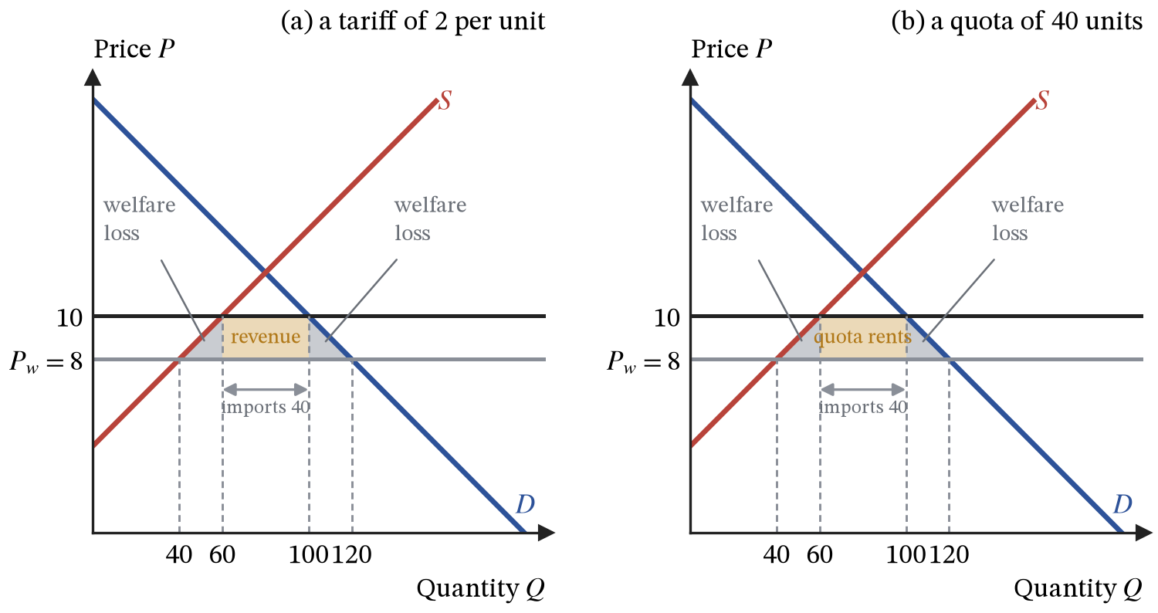
Figure 46. A tariff and a quota. The price effect is the same; only the destination of the shaded rectangle differs.
Both grey triangles are genuine losses rather than transfers. The left one is a production distortion: units 40 to 60 are now made domestically at a marginal cost above 8 when they could have been bought for 8. The right one is a consumption distortion: units 100 to 120 were worth more to buyers than the 8 they cost, and are no longer bought. Each has area $\frac{1}{2}×20×2=20$, so the tariff destroys 40 in total.
A producer subsidy reaches the same domestic output by a different route. Paying domestic firms 2 per unit moves domestic supply down by 2, so at the unchanged world price they now supply 60. Consumers are untouched: the price is still 8 and consumption is still 120, so imports fall to 60 rather than to 40. The cost is $2×60=120$, paid by taxpayers, and the only welfare loss is the production distortion of 20. The consumption distortion never arises, because nobody was priced out of the market.
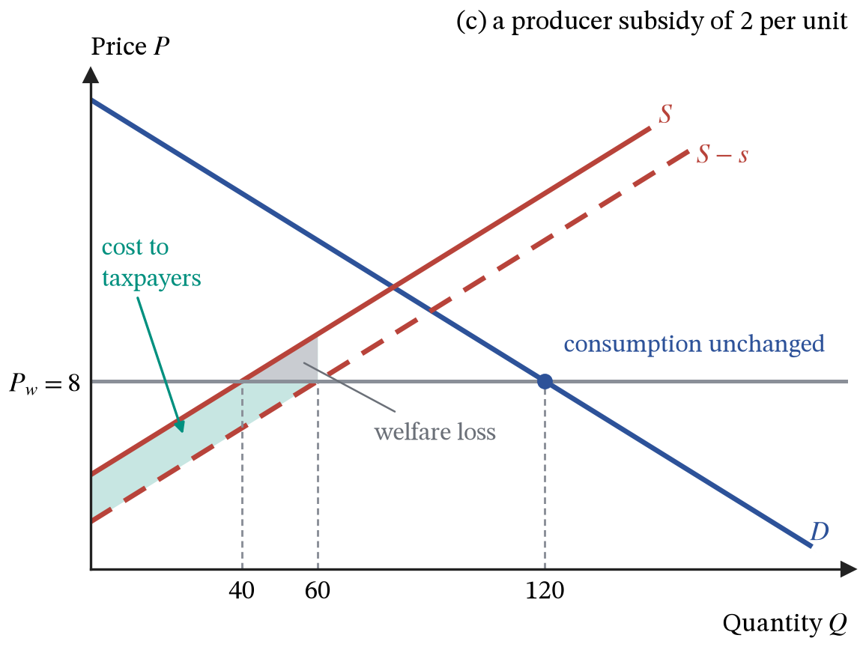
Figure 47. A producer subsidy. Domestic output rises as far as the tariff pushed it, but consumers pay the world price throughout.
 | Tariff of 2 | Quota of 40 | Subsidy of 2
Price to consumers | 10 | 10 | 8, unchanged
Domestic output | 60 | 60 | 60
Consumption | 100 | 100 | 120, unchanged
Imports | 40 | 40 | 60
Transfer | 80 to the government | 80 to licence holders | 120 from taxpayers
Welfare loss | 40 | 40 | 20
If the objective is to support domestic producers, the subsidy achieves the same domestic output as the tariff at half the welfare loss, because it distorts only the production margin and leaves the consumption margin alone. Its cost also appears in the Budget rather than being hidden in shop prices.
Countries also lower barriers selectively, by joining trading blocs. In ascending order of integration, a preferential trade agreement cuts tariffs on some goods between members; a free trade area removes them on trade between members while each keeps its own tariffs on outsiders; a customs union adds a common external tariff; a common market adds free movement of labour and capital; and a monetary union adds a single currency and so a single monetary policy.
The tariff example shows why joining a bloc can lower welfare. Keep the tariff of 2 on imports from the rest of the world, whose price is 8, and form a customs union with a partner whose cost is 9. The partner’s goods now enter tariff-free at 9, cheaper than the world’s 8 plus the tariff, so every import switches to the partner, and the domestic price falls from 10 to 9. Two things happen. The lower price creates trade: domestic production falls to 50 and consumption rises to 110, removing parts of both distortion triangles worth $\frac{1}{2}×10×1=5$ each. But the 40 units the country already imported now come from a producer whose cost is 9 rather than 8, which wastes 1 on each of them, a trade-diversion loss of 40. Net welfare falls by 30. Had the partner’s cost been 8.5, trade creation would have been worth 22.5 and diversion would have cost 20, a small net gain. A bloc raises welfare when it mainly replaces costly domestic production and lowers it when it mainly replaces cheaper imports from outside.
The terms of trade measure what a country’s exports buy:
$$\text{terms of trade}=100×\frac{\text{index of export prices}}{\text{index of import prices}} (75)$$
If export prices rise by 10 per cent while import prices rise by 20 per cent, the index falls to $100×110/120=91.7$: each unit of exports now buys about 8 per cent fewer imports, a deterioration. A depreciation worsens the terms of trade in this way, since it raises import prices in sterling, which is the “minus one” in (72). Countries that export a few primary commodities face large swings in their terms of trade whenever commodity prices move, which section 32 takes up.
ASSUMPTIONS.
The country is small enough to take the world price as given, so none of the burden is pushed onto foreign exporters; a large country’s tariff would also move the world price and capture some of it.
There is no retaliation, no infant industry that grows competitive behind the barrier, and no strategic or security value in domestic production. The arguments for protection that survive scrutiny all work by attacking one of these assumptions, which is why they have to be argued rather than asserted.
The customs union example looks only at one market; blocs also bring larger markets, more competition and economies of scale, which a single-market calculation leaves out.

32. Growth and development
DEFINITIONS.
Economic development: a broad improvement in living standards, including health, education and the freedom to make choices, as well as income.
Human Development Index (HDI): a composite of life expectancy, education and income per head, each scaled between 0 and 1.
Poverty trap: a situation in which low income itself prevents the saving and investment needed to escape low income.
Primary product dependency: reliance on a few agricultural or mineral exports.
Foreign direct investment (FDI): investment by a foreign firm in productive assets, such as a factory, in another country.
Official development assistance: aid from governments, as grants or loans on favourable terms.
Growth is a rise in real GDP; development is a rise in living standards more broadly, and the two can diverge. A country can grow quickly while its gains go to a few, or while life expectancy and schooling stagnate. Section 19 showed that comparing incomes across countries needs PPP. The Human Development Index goes further and combines three dimensions:
$$\text{HDI}={\left(I_{\text{health}}×I_{\text{education}}×I_{\text{income}}\right)}^{1/3} (76)$$
Each index runs from 0 to 1: life expectancy, years of schooling, and the logarithm of income per head at PPP, each measured against fixed minimum and maximum values. The HDI is their geometric mean, the cube root of the product, rather than their average, and that choice has economic content. With an average, a shortfall in health could be fully offset by more income. With a geometric mean it cannot: a country with indices of 0.9, 0.9 and 0.3 has an average of 0.7 but an HDI of $(0.9×0.9×0.3)^{1/3}=0.62$, so uneven development is penalised. The income index uses the logarithm because each extra pound matters less to a rich country than to a poor one, the diminishing marginal utility of section 1 applied to nations.
The barriers to development are the failures of earlier sections at a national scale. Low incomes leave little to save, so investment and the capital stock stay low, and with them income: a poverty trap in which section 18’s choice between consumption now and capacity later is not really available. Poor health and limited schooling hold down the productivity of labour. Weak institutions, insecure property rights and corruption deter the investment that growth accounting (70) says is needed, and lower the efficiency captured by TFP. Dependence on primary products exposes export earnings to the terms-of-trade swings of section 31, and borrowing in foreign currency turns a depreciation into a heavier debt burden.
Strategies divide roughly as the supply-side policies of section 28 did. Market-oriented strategies emphasise openness to trade, so that resources follow comparative advantage as in section 30, export-led growth, FDI that brings capital and technology together, microfinance that gives small borrowers access to credit, and secure property rights. Interventionist strategies emphasise public investment in infrastructure, health and education, protection of infant industries, and aid. The fastest-growing economies of the last half-century, in East Asia, combined heavy investment in education with openness to export markets, which is one reason the debate between the two approaches is less sharp than its labels suggest. Aid can fill the savings gap and fund health and schooling, but it can also support governments that would otherwise reform, and its effects are hard to measure.
ASSUMPTIONS.
The HDI’s weights and its limits for each dimension are choices, not facts, and different choices rank countries differently.
The poverty trap assumes saving depends on current income; access to foreign capital through FDI, borrowing or aid can break the link.

33. Back to the frontier
Section 18 drew the production possibility frontier and said two things about it: everything inside is waste, and everything outside is impossible this year.
Demand-side policy, in sections 20 to 26, moves the economy towards the boundary or away from it. A negative output gap is a point inside the frontier: the workers and machines exist and are not being used. Fiscal and monetary expansion can close that gap, which is a real achievement and the reason both instruments exist. What neither can do is push production past the boundary for long, because once the economy is on it the extra spending meets a fixed quantity of resources and raises prices instead. That is what Figure 38 shows, and it is the main limit on demand management. The one qualification is hysteresis, in section 28: a long stay inside the frontier can pull the frontier itself inward, so closing a gap quickly protects capacity as well as using it.
Two things relax the constraint the frontier imposes. Innovation, in section 28, raises what a given quantity of resources can produce: better technology, better skills, better organisation. It is the only source of growth in output per head that does not eventually run into the diminishing returns of section 3, because every other route adds more of a factor to a fixed stock of the others. Trade, in sections 30 and 31, does not change what a country can produce at all, and still lets it consume outside its own frontier. Specialising by comparative advantage and then exchanging is, in its effect, indistinguishable from acquiring a better technology for turning loaves into shirts.
Where on the frontier an economy ends up, and who receives what it produces, are separate questions, and section 27 showed that economics can measure the answers but not choose between them. Scarcity forces choice, choice at the margin decides what gets made and who gets it, and the only ways out of the constraint are to use resources better or to trade with someone who uses them differently.

Equations (49) and (50) are definitions and cannot be tested. A statement such as “households spend a fixed fraction of disposable income” is a behavioural claim: it could be wrong, and it is what generates predictions. Almost all macroeconomic reasoning consists of feeding behavioural equations into an identity, so keeping track of which is which shows which parts of an argument could fail.

